Discovery MAT - Music Curriculum Statement
Quotes that guide us:
‘Music is a universal language that embodies one of the highest forms of creativity.’ National Curriculum

“It is in learning music that many youthful hearts learn to love.’ Matthieu Ricard

Why is it important to teach music? (Intent)
Listening and producing music is something that brings people joy and that in itself is important. Music also plays a huge role in brain development. Studies have shown that music activities particularly in Early Years facilitate many different aspects of development and learning, providing one of the most effective influences on young people’s brain development at this key age. It has been shown to activate all three cortices (motor, visual and auditory) of children’s brains. It helps develop creativity and can also support children with their mental health and well-being. Our objective at Discovery MAT is to develop an understanding and acceptance of the validity and importance of all types of music, and an unbiased respect for the role that music may wish to be expressed in any person’s life.

Key Concepts:
- That there have been different styles of music, and these have varied throughout history and vary throughout the world.
- Music can affect what we think and feel and support our brain development.
- We are all musicians, and we can use our voices, instruments, technology to communicate and bring joy.
- Pitch, duration, dynamics, tempo, timbre, texture, volume and structure are key components to consider when listening to and creating music.
- Music notation is a form of communication and a way to capture music in a written form.
Curriculum Design (Implementation)
We currently use the National Curriculum to guide us to support our planning. Whenever possible and most appropriate we link Music learning to our topic work. The Trust Music Coordinator has worked to develop the Music Progression Map, which breaks down the National Curriculum objectives into the small steps needed to build towards the key end goals. Covid has been a significant factor in the recent teaching of Music lessons, and as a Trust we aim to develop the teaching of music further through more regular and consistent whole class music lessons, as we begin to head towards normality again. One way in which we have begun to successfully ensure this, is through securing an external whole class music teacher from Plymouth Youth Music Service, who has been teaching multiple year groups across our schools, how to play different instruments.

We also provide a wide range of opportunity for our children to perform to an audience across all year groups; the Foundation Stage’s Nativity, Year 6 end of year production, each class assembly and the school choirs who have the opportunity to perform in the wider community. The elements of music are taught in the classroom lessons so that children are able to use some of the language of music to dissect it, and understand how it is made, played, appreciated and analysed. In the classroom students learn how to play an instrument, from all four main instrument groups of wind, strings, percussion and keyboards. In doing so understand the different principle of each method of creating notes, as well as how to read basic music notation. They also learn how to compose focussing on different dimensions of music, which in turn feeds their understanding when listening, playing, or analysing music. Composing or performing using body percussion and vocal sounds is also part of the curriculum, which develops the understanding of musical elements without the added complexity of an instrument.
Our Music curriculum aims to give the children the opportunity to:
- perform, listen to, review and evaluate music across a range of historical periods, genres, styles and traditions, including the works of the great composers and musicians
- learn to sing and to use their voices, to create and compose music on their own and with others, have the opportunity to learn a musical instrument, use technology appropriately and have the opportunity to progress to the next level of musical excellence
- understand and explore how music is created, produced and communicated, including through the interrelated dimensions: pitch, duration, dynamics, tempo, timbre, texture, structure and appropriate musical notations

Knowledge Focused
The Music Progression Map, breaks down the National Curriculum objectives which produces the small steps needed to build towards the key end goals. This also ensures clear progression of knowledge and skills throughout the year groups and across the school. It highlights key language to be taught in the year groups, which teachers can implement throughout their planning and assessing.

What we do well as a Trust (Impact)
As well as discrete lessons Music lends itself to being a cross curricular subject in every way. Therefore, we link our music sessions to our topics to give it a context and to use it to deepen our understanding of a topic. Music is often played in lessons to create atmosphere, particularly in across subjects such as Art & Design. Music will also develop an understanding of culture and history, both in relation to students individually, as well as ethnicities from across the world. During our ‘Celebrating Diversity’ house day for example (an opportunity for children across all year groups to come together in four houses) one of the many activities was music centred and focused on listening to music from different ethnicities. Children can enjoy music, in as many ways as they choose - either as listener, creator or performer. They can dissect music and comprehend its parts. They can sing and feel a pulse. Within Discovery MAT, children can listen to and discuss a wide range of composers, including during whole-school assemblies. All the children also get to perform to the rest of the school and to parent/carers as a class during their class assemblies. As part of the Plymouth Youth Music Service coming to teach whole class lessons over a substantial time to learn an instrument, the music teachers will perform to give the children further opportunities to listen to high quality live performances.

Music National Curriulum & EYFS Framework
EYFS | Key Stage 1 | Key Stage 2
Nursery Development Matters Statements  - Increasingly be able to use and remember sequences and patterns of movements which are related to music and rhythm. (PD)  - Listen with increased attention to sounds. (EAD)  - Respond to what they have heard, expressing their thoughts and feelings. (EAD)  - Remember and sing entire songs. (EAD)  - Sing the pitch of a tone sung by another person (‘pitch match’). (EAD)  - Sing the melodic shape (moving melody, such as up and down, down and up) of familiar songs. (EAD)  - Create their own songs or improvise a song around one they know. (EAD)  - Play instruments with increasing control to express their feelings and ideas. (EAD)  Reception Development Matters Statements  - Listen attentively, move to and talk about music, expressing their feelings and responses. (EAD)  - Watch and talk about dance and performance art, expressing their feelings and responses. (EAD)  - Sing in a group or on their own, increasingly matching the pitch and following the melody. (EAD)  - Explore and engage in music making and dance, performing solo or in groups. (EAD)  Early Learning Goal  - Sing a range of well-known nursery rhymes and songs. (EAD)  - Perform songs, rhymes, poems and stories with others, and (when appropriate) try to move in time with music. (EAD) | Pupils should be taught to:  - use their voices expressively and creatively by singing songs and speaking chants and rhymes  - play tuned and untuned instruments musically  - listen with concentration and understanding to a range of high-quality live and recorded music  - experiment with, create, select and combine sounds using the inter-related dimensions of music | Pupils should be taught to sing and play musically with increasing confidence and control. They should develop an understanding of musical composition, organising and manipulating ideas within musical structures and reproducing sounds from aural memory.  Pupils should be taught to:  - play and perform in solo and ensemble contexts, using their voices and playing musical instruments with increasing accuracy, fluency, control and expression  - improvise and compose music for a range of purposes using the inter-related dimensions of music  - listen with attention to detail and recall sounds with increasing aural memory  - use and understand staff and other musical notations  - appreciate and understand a wide range of high-quality live and recorded music drawn from different traditions and from great composers and musicians  - develop an understanding of the history of music

Music Curriulum Overview
EYFS | ALL ABOUT ME | WOODLAND EXPLORERS | TO INFINITY AND BEYOND | THINGS THAT GROW | TRAINS, PLANES AND CARS | ON THE SEVEN SEAS
 | Good to be me – Sing Up!  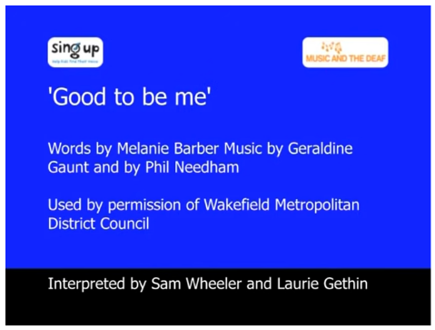  -To sing in a group.  Vocal | The Lark Ascending – Vaughan Williams  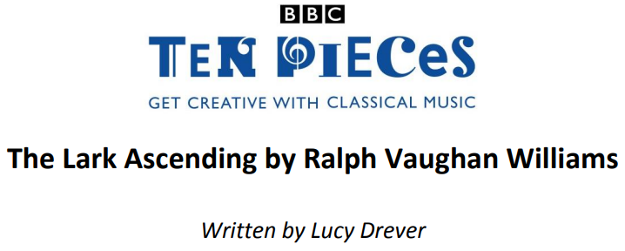  -To create their own song.  Vocal  Percussion | 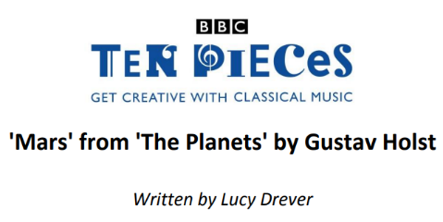  Mars' from 'The Planets' by Gustav Holst  -To listen attentively to the music. | 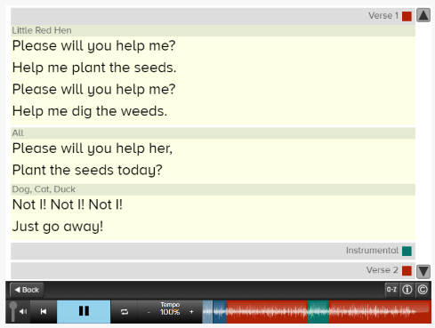  Help me plant the seeds – Nick Perrin  -To express their thoughts and feelings using instruments. | 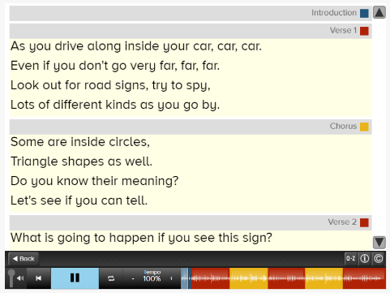  Travel Signs – Donna Minto  -To explore and engage in music-making. | 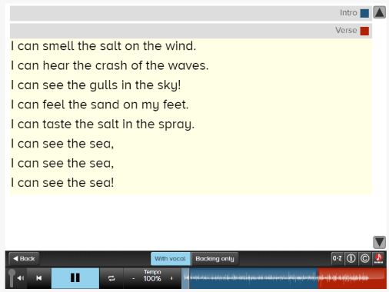  On The Seashore – Kate Stiltz; Jimmy Jarman  -To sing in a group
Y1 | AMAZING ME | WEATHER WATCHERS | WHAT’S IN THE TOY BOX? | OUR LOCAL AREA | WOMEN IN HISTORY | KENYA:  TOO HOT TO HANDLE!
 | -How music effects mood  Personal likes and dislikes  Beat  Pulse  Rhythm  Timbres  Pitch  Tempo  Dynamics  Final piece:  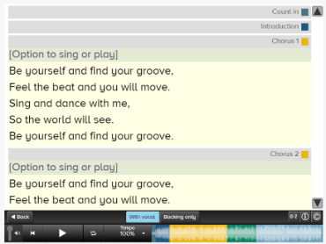  The ‘Be Yourself’ Beat | Recorder  B note  Final pieces:  Little Fly  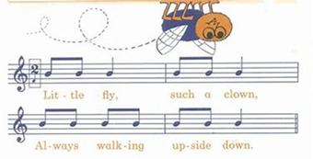  Milkman |   Antonio Vivaldi – ‘Winter’ from ‘The Four Seasons’  Final Piece:  Own Composition and matching graphic score | Plymouth local artists  Contact local live artists and get them to come in and perform for the children. | Listen to a range of modern female artists.  Which ones do the children like?  Embed vocabulary  Beat  Pulse  Rhythm  Timbres  Pitch  Tempo  Dynamics | Perform actions with a song.  Final Piece  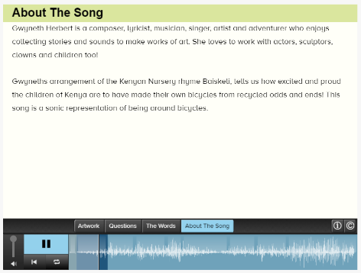  Baiskeli (Kenyan Nursery Rhyme) - Gwyneth Herbert
Y2 | Our Great Britain | British Bridges | Greenland:  Below Zero | UK Climate | World Explorers | Commotion in the Ocean
 | Recognise timbre and structural changes in music  Recognise instrumentation (what is being played)  Sing with accuracy and control  Final Piece:  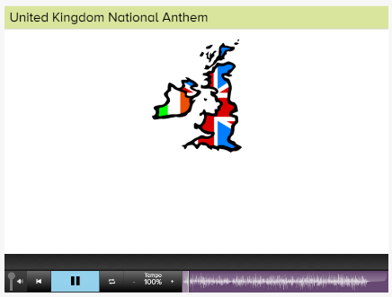  The British National Anthem | Use musical vocabulary to describe.  Beat  Pulse  Rhythm  Timbres  Pitch  Tempo  Dynamics  Sing short songs from memory  Final piece:  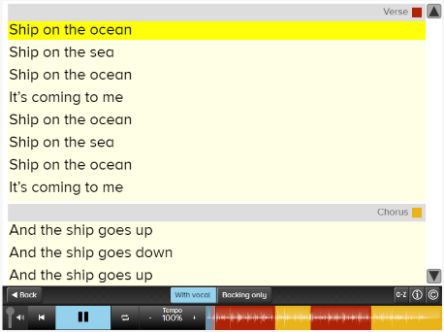  Ship on the Ocean - Mike Reinstein & Reina James-Reinstein |  | Recorder  B A notes  Final pieces  Traffic Jam | 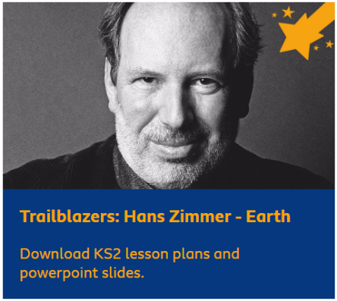  Earth – Hans Zimmer  -To create and perform a musical journey using tuned or untuned instruments.  -Create simple melodies from five or more notes.  -To begin to explore musical notation.
Y3 | Prehistoric Britain | Master of Disaster | Dinosaurs and Fossils | Food and Farming | Egyptians | Plymouth Hoe:  Our City!
 | ENO Opera  Graphic score  Musical Vocabulary  - Finish This  - Imagine This  - Interpret This | ENO Opera  Graphic score  Instrument  - Create This  - Annotate This  - Rehearse This  - Record This |  | 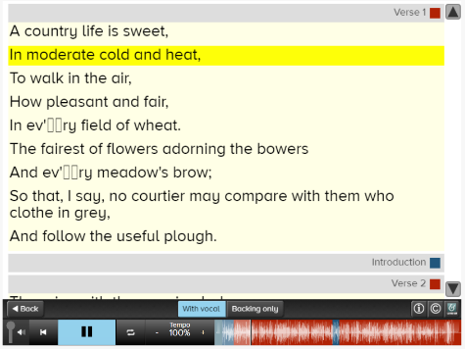  The Useful Plough - Benjamin Britten  -To use percussion to create a piece of music and record using musical notations.  Percussion | Recorder  B A G Notes  Final pieces  Joe Joe  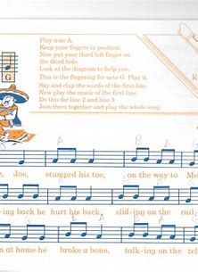  Hot cross buns  Eye of the tiger | 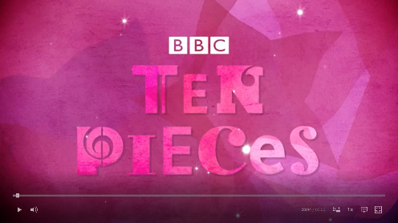  ‘No Place Like’ – Kerry Andrew  -To write a song about Plymouth.  -To perform with confidence in small groups.  -To use percussion instruments to keep a steady beat.  Percussion
Y4 | Shang Dynasty | Journey Through North America | Ancient Greece | Australia | Ancient Rome | Inventions Which Changed the World
 | Types of instruments.  Categorising instruments.  Brass  Woodwind  String  Percussion  Stand-alone lesson | 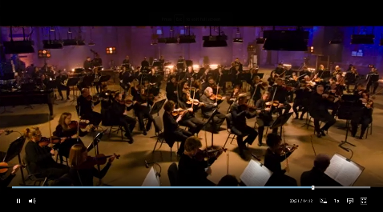  Mambo - Leonard Bernstein (see BBC Ten Pieces)  -To discuss the stylistic features of this piece of music.  -To create a four-layered piece of music inspired by this piece of music.  Opportunity for Charanga | Musical timeline  Stand-alone lesson |  | 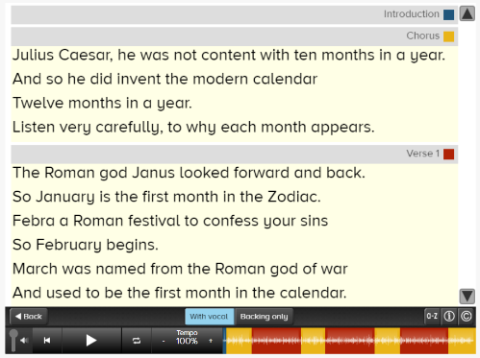  The Roman Calendar – Donna Minto  -To use instruments, including voice to play along with the song.  -To perform the song in a group and give feedback to other groups using musical vocabulary.  Vocal | Recorder  B A G E  Final pieces  Eye of the tiger  Elephants  In 2 parts
Y5 | Romans in Britain | Space:  Out of this World | Anglo Saxons and Vikings | Our Changing World | Ancient Maya | Amazon Rainforest
 | Recorder and vocal  B A G E D  Final piece:  Mocking Bird |   Mars – Gustav Holst  -To compose and perform an individual 30 second piece of music about a planet. Inspired by Holst – the planets.  -To use musical notation to write a piece of music about a planet.  Charanga online music writing | A Viking House – Donna Pinto  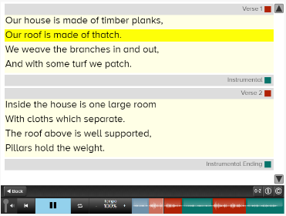  -To work as a group to perform this piece of music.  -To learn the song and sing it as part of an ensemble.  -To discuss and evaluate this piece of music.  Vocal |  | Musicians throughout history  Stand-alone lesson
Y6 | Dartmoor | Tudors:  Port of Plymouth | British Empire & Industrial Revolution | Biomes of the world | 20th Century Conflict
 | 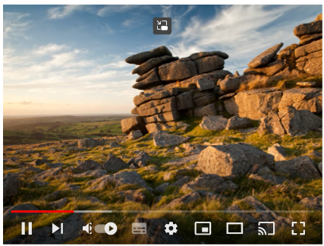  Dartmoor Folk Music  -To find out about the history of folk music on Dartmoor.  -To listen to / appreciate a variety of Folk music.  -To compose a piece of Folk Music.  Research | Greensleeves  -To appreciate and listen to Tudor music.  -To sing a Tudor Song.  -To create a piece of Tudor music which is recorded using music notation.  Vocal | Recorder  Final Piece:  Old Macdonald | SATS PREPARATION | Year 6 Production Rehearsals

 | Music Curriculum Progression
Listening & Appreciation | EYFS | Year 1 | Year 2 | Year 3 | Year 4 | Year 5 | Year 6
 | Listen attentively, move to and talk about music, expressing their feelings and responses.  Sing in a group or on their own, increasingly matching the pitch and following the melody.  Sing a range of well-known nursery rhymes and songs: Performing songs, rhymes, poems and stories with others, and – when appropriate – try to move in time with music. | Recognise and understand the difference between pulse and rhythm.  Understand that different types of sounds are called timbres.  Recognise basic tempo, dynamic and pitch changes e.g. faster, slower, louder, quieter, higher, lower.  Notice and describe the differences between two pieces of music, commenting on their personal likes and dislikes.  Listen to and repeat short, simple rhythmic patterns such as clapping patterns.  Listen and respond to other performers by playing as part of a group. | Recognise timbre changes in music they listen to.  Recognise structural features in music they listen to.  Listen to and recognise instrumentation (the arrangement or composition of music for instruments).  Begin to use musical vocabulary to describe music.  Listen to and repeat a short, simple melody by ear.  Suggest improvements to their own and others’ work. | Discuss the stylistic features of different genres, styles and traditions of music using musical vocabulary.  Understand that music from different parts of the world has different features.  Describe the timbre, dynamic and textural details of a piece of music.  Begin to show an awareness of metre (rhythmic pattern/beats/bars).  Begin to use musical vocabulary when discussing improvements to their own and others’ work. | Begin to recognise basic motifs in music.  Identify gradual dynamic and tempo changes within a piece of music.  Recognise and discuss the stylistic features of different genres, styles and traditions of music using musical vocabulary.  Identify common features between different genres, styles and traditions of music by noticing similarities.  Recognise, name and explain the effect of the interrelated dimensions of music.  Identify scaled dynamics e.g. crescendo and decrescendo within a piece of music.  Use musical vocabulary to discuss the purpose of a piece of music.  Use musical vocabulary when discussing improvements to their own and others’ work. | Recognise and confidently discuss the stylistic features of different genres, styles and traditions of music using musical vocabulary.  Represent the features of a piece of music using graphic notation, justifying their choices with reference to musical vocabulary.  Compare, discuss and evaluate music using detailed musical vocabulary.  Develop confidence in using detailed musical vocabulary to discuss and evaluate their own and others’ work. | Discuss musical eras in context, identifying how they have influenced each other and discuss the impact of different composers on the development of musical styles.  Recognise and confidently discuss the stylistic features of music and relate to other aspects of the arts.  Represent changes in pitch, dynamics and texture using graphic notation and colour, justifying their choices with reference to musical vocabulary.  Identify the ways in which features of a song can complement one another to create a coherent overall effect.  Use musical vocabulary correctly when describing and evaluating the features of a piece of music.  Evaluate how the venue, occasion and purpose affects the way a piece of music sounds.

 | Music Curriculum Progression
Composing & improvisation | EYFS | Year 1 | Year 2 | Year 3 | Year 4 | Year 5 | Year 6
 | Explore and engage in music making.  Create their own songs or improvise a song around one they know. | Select and create short sequences of sound with voices and instruments to represent a given character, story, situation or idea.  Combine instrumental and vocal sounds within a given structure.  Create simple melodies using a few notes.  Choose dynamics, tempo and timbre for a piece of music.  Create a simple graphic score to represent a composition.  Begin to make improvements to their work as suggested by the teacher. | Select and create longer sequences of appropriate sounds with voices or instruments to represent a given idea or character.  Successfully combine and layer several instrumental and vocal patterns within a given structure.  Create simple melodies from five or more notes.  Choose appropriate dynamics, tempo and timbre for a piece of music.  Use letter name and graphic notation to represent the details of their composition.  Begin to suggest improvements to their own work. | Compose a coherent piece of music in a given style with voices, bodies and instruments.  Combine melodies and rhythms to compose a multi-layered composition in a given style (pentatonic).  Suggest and implement improvements to their own work, using musical vocabulary.  NOTATION: Use letter name and rhythmic notation (graphic or staff) and key musical vocabulary to label and record their compositions. | Compose a coherent piece of music in a given style with voices, bodies and instruments.  Begin to improvise musically within a given style.  Develop melodies using rhythmic variation, transposition, inversion and looping.  Create a piece of music with at least four different layers and a clear structure.  Use letter name, graphic and rhythmic notation and key musical vocabulary to label and record compositions.  Suggesting improvements to others’ work using musical vocabulary. | Compose a detailed piece of music from a given stimulus with instruments as well as their voice and body.  Improvise coherently within a given style.  Combine rhythmic patterns (ostinato) into a multi-layered composition to add musical interest.  Select, discuss and refine musical choices both alone and with others, using musical vocabulary with confidence.  Suggest and demonstrate improvements to own and others’ work.  NOTATION: Use staff notation to record rhythms and melodies. | Improvise coherently and creatively within a given style, incorporating given features.  Compose a multi-layered piece of music from a given stimulus with instruments as well as their voice and body.  Compose an original song, incorporating lyric writing, melody writing and the composition of accompanying features, within a given structure.  Develop melodies using rhythmic variation, transposition and changes in dynamics, pitch and texture.  Record own composition using appropriate forms of notation or technology.  Constructively critique their own and others’ work using musical vocabulary.

 | Music Curriculum Progression
Performing | EYFS | Year 1 | Year 2 | Year 3 | Year 4 | Year 5 | Year 6
 | Explore and engage in music making and dance, performing solo or in groups.  Perform songs, rhymes, poems and stories with others, and (when appropriate) try to move in time with music.  Play instruments with increasing control to express their feelings and ideas. | Use voices to join in with well-known songs from memory.  Remember and maintain a role within a group performance.  Move to music with instruction to perform actions.  Participate in performances to a small audience.  Stop and start playing at the right time. | Use voices expressively when singing, including the use of basic dynamics.  Sing short songs from memory, with melodic and rhythmic accuracy.  Copy louder rhythmic patterns on untuned percussion instruments, keeping a steady pulse.  Perform expressively using dynamics and timbre to alter sounds as appropriate.  Use their voice to copy short melodic patterns by ear ad play short melodic patterns from letter notation. | Sing songs in a variety of musical styles with accuracy and control, demonstrating and developing vocal technique.  Sing and play in time with peers, with some degree of accuracy and awareness of their part in the group performance.  Perform from basic staff notation, incorporating rhythm and pitch and be able to identify these symbols using musical terminology. | Sing longer songs in a variety of musical styles from memory, with accuracy, control, fluency and a developing sense of expression including control of subtle dynamic changes.  Sing and play in time with peers with accuracy and awareness of their part in the group performance.  Play melody parts on tuned instruments with accuracy and control and develop instrumental technique.  Play syncopated rhythms with accuracy, control and fluency. | Sing songs in two or more parts, in variety of musical styles from memory, with accuracy, fluency, control and expression.  Work as a group to perform a piece of music, adjusting dynamics and pitch according to graphic score, keeping in time with others and communicating with the group.  Perform with accuracy and fluency from graphic and simple staff notation.  Play a simple chord progression with accuracy and fluency. | Sing songs in two or more secure parts from memory, with accuracy, fluency, control and expression.  Work as a group to perform a piece of music, keeping in time with others and communicating with the group.  Perform with accuracy and fluency from graphic and staff notation and from their own notation.  Perform by following a conductor’s cues and directions.

 | Music Curriculum Progression
History of Music (KS2) | EYFS | Year 1 | Year 2 | Year 3 | Year 4 | Year 5 | Year 6
 |  |  |  | Understand that music from different times has different features. | Recognise and discuss the stylistic features of different genres, styles and traditions of music using musical vocabulary. | Confidently discuss the stylistic features of different genres, styles and traditions of music and explaining how these have developed over time. | Discuss musical eras in context, identifying how they have influenced each other and discussing the impact of different composers on the development of musical styles.

Dimensions of Music
Year Group | EYFS | Year 1 | Year 2 | Year 3 | Year 4 | Year 5 | Year 6
Pitch  the quality of a sound governed by the rate of vibrations producing it; the degree of highness or lowness of a tone | To understand that what ‘high’ and ‘ low’ notes are. | To understand that pitch means how high or low a note sounds.  To understand that 'tuned' instruments play more than one pitch of notes. | To know that some tuned instruments have a lower range of pitches and some have a higher range of pitches.  To understand that a melody is made up from high and low pitched notes played one after the other, making a tune. | To know that the group of pitches in a song is called its 'key' and that a key decides whether a song sounds happy or sad.  To know that some traditional music around the world is based on five-notes called a 'pentatonic' scale.  To understand that a pentatonic melody uses only the five notes C D E G A. | To know that a bass line is the lowest pitch line of notes in a piece of music, and a walking bassline (where patterns of notes go up then down again) is common in rock and roll.  To know that a glissando in music means a sliding effect played on instruments or made by your voice.  To know that 'transposing' a melody means changing its key, making it higher or lower pitched. | To understand that a minor key (pitch) can be used to make music sound sad.  To understand that major chords create a bright, happy sound.  To know that a 'bent note' is a note that varies in its pitch, eg the pitch may slide up or down.  To understand that varying effects can be created using only your voice, for example by changing the pitch, dynamic or tempo of the sounds made. | To know that the Solfa syllables represent the pitches in an octave.  To understand that 'major' key signatures use note pitches that sound cheerful and upbeat.  To understand that 'minor' key signatures use note pitches that can suggest sadness and tension.  To know that a melody can be adapted by changing its pitch.
Duration  how long or short a note, phrase, section, or composition lasts | To recognise that different sounds can be long or short. | To know that rhythm means a pattern of long and short notes. | To know that 'duration' means how long a note, phrase or whole piece of music lasts.  To know that the long and short sounds of a spoken phrase can be represented by a rhythm. | To know that different notes have different durations, and that crotchets are worth one whole beat.  To know that written music tells you how long to play a note for. | To know that combining different instruments playing different rhythms creates layers of sound called ‘texture’.  To know that playing ‘in time’ requires playing the notes for the correct duration as well as at the correct speed.  To know that a motif in music can be a repeated rhythm. | To know that ‘poly-rhythms’ means many different rhythms played at once.  To know that the duration of a note or phrase in music can be shown using a repeated symbol or the size of a symbol on a graphic score. | To understand that all types of music notation show note duration, including the Kodaly method which uses syllables to indicate rhythms.  To understand that representing beats of silence or ‘rests’ in written music is important as it helps us play rhythms correctly.  To know that a quaver is worth half a beat.
Dynamics  the volume of the music – how loud or soft a passage should be played | To understand that instruments can be played loudly or softly. | To know that dynamics means how loud or soft a sound is.  To understand that sounds can be adapted to change their mood. | To know that dynamics can change the effect a sound has on the audience. | To know that the word 'crescendo' means a sound getting gradually louder. | To know that changing the dynamics of a musical phrase or motif can change the texture of a piece of music. | To understand that varying effects can be created using only your voice, for example by changing the pitch, dynamic or tempo of the sounds made. | To know that a melody can be adapted by changing its dynamics.
Tempo  the speed at which a passage of music is or should be played. | To recognise music that is ‘fast’ or ‘slow’.  To understand that we can match our body movements to the speed (tempo) or pulse (beat) of music. | To know that the ‘pulse’ is the steady beat that goes through music.  To know that tempo is the speed of the music. | To understand that the tempo of a musical phrase can be changed. | To understand that the tempo of a musical phrase can be changed to achieve a different effect. | To know that playing in time means all performers playing together at the same speed. | To understand that a slow tempo can be used to make music sound sad.  To understand that varying effects can be created using only your voice, for example by changing the pitch, dynamic or tempo of the sounds made. | To know that a melody can be adapted by changing its dynamics, pitch or tempo.
Timbre  the character or quality of a musical sound or voice as distinct from its pitch and intensity | To know that different instruments can sound like a particular character. | To know that 'timbre' means the quality of a sound; e.g. that different instruments would sound different playing a note of the same pitch.  To know that my voice can create different timbres to help tell a story. | To know that musical instruments can be used to create 'real life' sound effects.  To understand an instrument can be matched to an animal noise based on its timbre. | To understand that the timbre of instruments played affect the mood and style of a piece of music. | To know that grouping instruments according to their timbre can create contrasting ‘textures’ in music.  To understand that both instruments and voices can create audio effects that describe something you can see | To understand that human voices have their own individual timbre, and that this can be adapted by using the voice in different ways. | To know that timbre can also be thought of as 'tone colour' and can be described in many ways e.g. warm or cold, rich or bright.
Texture  The way in which the tempo, melody and harmony are combined, affecting the quality of the sound of the music | To know that music often has more than one instrument being played at a time. | To know that music has layers called 'texture'. | To know that a graphic score can show a picture of the layers, or 'texture', of a piece of music. | To know that many types of music from around the world consist of more than one layer of sound. | To know that combining different instruments and different rhythms when we compose can create layers of sound we call 'texture'.  To understand that harmony means playing two notes at the same time, which usually sound good together. | To understand that a chord is the layering of several pitches played at the same time.  To know that poly-rhythms means many rhythms played at once. | To understand that texture can be created by adding or removing instruments in a piece and can create the effect of dynamic change.  To know that a counter-melody is different to harmony because it uses a different rhythm as well as complementary notes.
Structure  the arrangement or order of the parts or sections of the music | To recognise the chorus in a familiar song. | To know that a piece of music can have more than one section, e.g. verses and a chorus. | To understand that structure means the organisation of sounds within music, e.g. a chorus and verse pattern in a song. | To know that in a ballad, a 'stanza' means a verse.  To know that music from different places often has different structural features. | To know that deciding the structure of music when composing can help us create interesting music with contrasting sections.  To understand that an ostinato is a musical pattern that is repeated over and over; a vocal ostinato is a pattern created with your voice.  To understand that musical motifs (repeating patterns) are used as a building block in many | To know that a loop is a repeated rhythm or melody, and is another word for ostinato. To know that 12-bar Blues is a sequence of 12 bars of music, made up of three different chords. | To know that a chord progression is a sequence of chords that repeats throughout a song.  To know that a ‘theme’ in music is the main melody and that ‘variations’ are when this melody has been changed in some way.
Notation  any system used to visually represent aurally perceived music played with instruments or sung by the human voice through the use of written, printed, or otherwise-produced symbols | To know that signals can tell us when to start or stop playing. | To understand that music can be represented by pictures or symbols. | To know that 'notation' means writing music down so that someone else can play it To know that a graphic score can show a picture of the structure and / or texture of music. | To understand that 'reading' music means using how the written note symbols look and their position to know what notes to play. | To know that ‘performance directions’ are words added to music notation to tell the performers how to play. | To know that simple pictures can be used to represent the structure (organisation) of music.  To understand that in written staff notation, notes can go on or between lines, and that the lines show the pitch of the note. | To know that 'graphic notation' means writing music down using your choice of pictures or symbols but 'staff notation' means music written more formally on the special lines called 'staves'.  To know that chord progressions are represented in music by Roman numerals.

