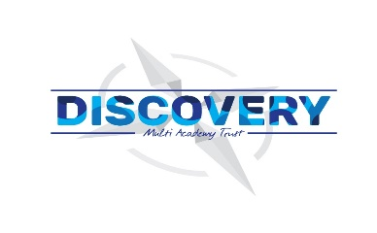
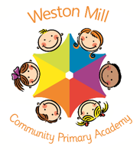
Weston Mill Community Primary Academy
Autumn Term Learning
Year 4 ~ 2024-2025

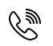

Autumn Term
On the reverse, please find an outline of your child’s learning for Autumn Term 1 and 2.
We will be focusing on settling back into school after a great summer break. We are so pleased to see the children getting on well in their new classes and the progress they have been making so far.
How you can help:
Reading, times tables and spellings are the main areas you can make a huge difference with at home, and these are what we expect the children to complete as homework each week. Reading books are changed when the children have completed their REN (Renaissance Reading Program) reading quiz. Children should try to read with an adult every day; a good guide about 15 minutes per day. It is even more helpful if you can ask them questions about what they have been reading, or to predict what they think will happen next.
Each week, your child will be given a list of spellings for their age group. The spelling sheet contains the spellings and also some quick activities linking to the spellings such as how many syllables the words have or a sentence with a blank space for the spelling. Children are tested once a week, on a Friday. You can really support your child by helping them to learn their spellings at home. A few minutes each evening or as you are walking to or from school will make all the difference.
Children in Y4 will be expected to learn all the times tables up to 12x12 by the end of the year. Each week, the children will have a short times tables test and when they have completed three of these with only a few errors, they will move onto their next times table. When they have learnt up to the 12x table, they will have a grid format which helps them remember all their tables. Children have access to a website called Times Tables Rockstars which they will have their password for, and it helps them to practice their tables in an engaging way. You can also help by listening to the children recite their tables or asking questions for the children to answer.

Reminders / Upcoming Trips and Visits
*Please join our Facebook page for regular updates about school events and your child’s learning.
*Letters have been sent home regarding our Y4 residential to Nethercott Farm. This will take place in March 2025.

If you have any questions or would like more information about how to support your child’s learning, please speak to your child’s class teacher at the start/end of the day. For any other questions, please call or email the school office on 01752 365250 or westonmill.desk@discoverymat.co.uk.

PE
The children will continue to participate in PE sessions each week. Our topic this term follows the ‘Cambridge PE’ curriculum, focusing on core skills. On our PE day, Year 4, children will be required to come into school in their PE kit. The children will be going inside and outside and will need suitable outside kit including trainers or plimsolls. School PE kit is a white t-shirt, black shorts/jogging bottoms, their school jumper or cardigan, socks and trainers or plimsolls. Our usual PE days will be Monday (indoors) and Thursday (outdoors).

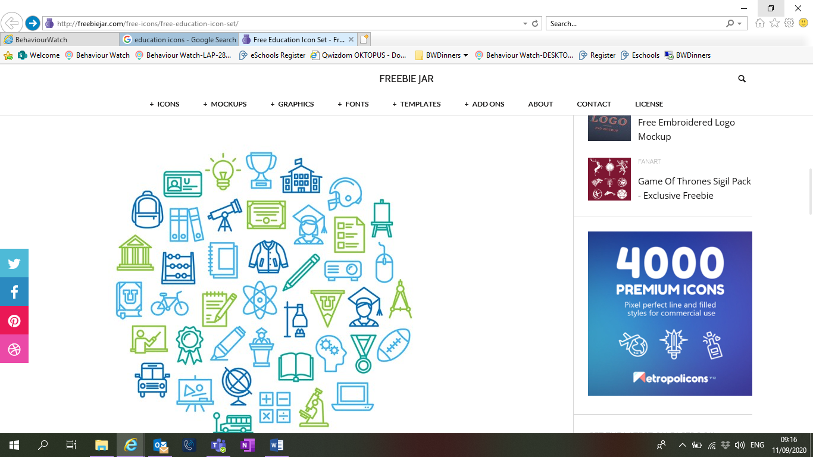
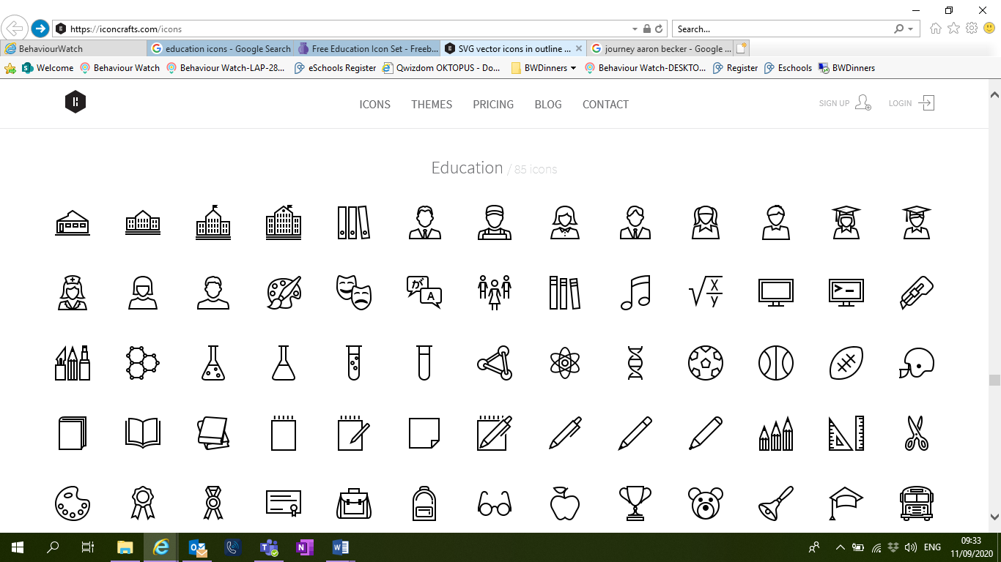

TERM 1: Shang Dynasty
BIG QUESTION: What caused the fall of the Shang Dynasty?

DESTINATION: To create a quiz based on the Shang Dynasty.

ENGLISH: Year 4 will begin by writing their own narratives based using inspiration from the book The Whale. Following this, children will use the same text to support them to write a newspaper report.
MATHS: This term the children will focus on place value, then addition and subtraction. We will continue to have weekly times tables practice and tests.

COMPUTING: In computing this term, we will be creating a storyboard in Word/Publisher relating to the Shang Dynasty.

PSHE: We will be learning about how to manage our feelings, health and wellbeing.
RE: We will be looking at the religion Christianity. We will find out what is the ‘Trinity’ and why is it important for Christians?

FRENCH: We will be continuing to learn French this term.
HISTORY: We will be studying the early civilisation - Shang Dynasty. This include locating China, creating timelines and research the contribution of this ancient culture to modern civilisations. We will investigate their amazing inventions.
DT: We will be researching Shang Dynasty transportation, then making and evaluating our own chariots.
PE:
Games- ball handling
Gymnastics

TERM 2: Journey through North America

BIG QUESTION: How does water travel through North America?

DESTINATION: To explain and present the process of the Water Cycle.
ENGLISH: Year 4 will begin by writing their own narratives based using inspiration from the book Leaf. Following this, children will use the same text to support them to write an information report.
MATHS: During Term 2, pupils will learn about calculating area. Following this the topic will be multiplication and division. Again, children will continue to have weekly times tables practice and tests.
SCIENCE: We will be learning about the states of matter – liquid, solid and gas, through comparing materials. We will also learn about how states of matter can change and the water cycle.

COMPUTING: For our National Online Safety unit we will look at online relationships and online reputation.

RE: What do Hindus believe God is like?

MUSIC: Mambo - Leonard Bernstein. We will discuss the stylistic features of this piece of music and attempt to create a four-layered piece of music inspired by Mambo.

GEOGRAPHY: Year 4 will research human and physical features of North America incusing countries, mountain ranges, and rivers. These will be used to compare to the geography of the United Kingdom.
ART: Children will look at the artist Monet. We will use his landscapes to inspire our own designs, drawn using pastels.

