**Autumn Term**On the reverse, please find an outline of your child’s learning for Autumn Term 1 and 2.

We will be focusing on settling into school, learning new routines and making friends. We are so pleased to see the children coming in happily and so enthusiastic about exploring and learning.

**How you can help: Please see below and attached home learning activity sheets for further ideas.**

**Personal Social and Emotional Development** – Encourage talk about thoughts and feelings.

**Literacy** – At the end of week 2 we will send home a picture book for you to share with your child. Please encourage them to tell the story using the pictures. This will support the development of their story language and love of reading. As the children progress through their phonics learning we will send home a Read Write Inc book that the children will be able to begin to read to you.

**Communication and Language** – Sing songs, read books, and make time to talk, taking turns to listen.

**Maths** – Count objects at home and in the community. Look for patterns and shapes in the world. Play mathematical games involving dice, counting, number matching and identification.

**Understanding the World** – Talk about the changes your child is noticing in the world around them (e.g. look for signs of Autumn). Talk about family and special family events they have experienced (e.g. birthdays, holidays, get-togethers).

**Physical Development** – Spend time exploring movement (e.g. running, stepping, climbing, balancing). Encourage your child to dress and undress themselves, including taking shoes on and off.

**Expressive Arts and Design** – Look for colours in the environment. Sing, dance and retell stories.

You can also encourage your child to use counting objects at home and look for numbers and shapes in the world around them (e.g. on the walk to school). Children are very interested in the world around them ask them what they can see and what might be different throughout the time of day and seasons. Mathematical games involving dice, counting, number matching and identification (e.g. bingo, dominoes, snakes and ladders) can also be fun!

**Weston Mill Community Primary Academy   
Autumn Term Learning   
Reception ~ 2024-2025**

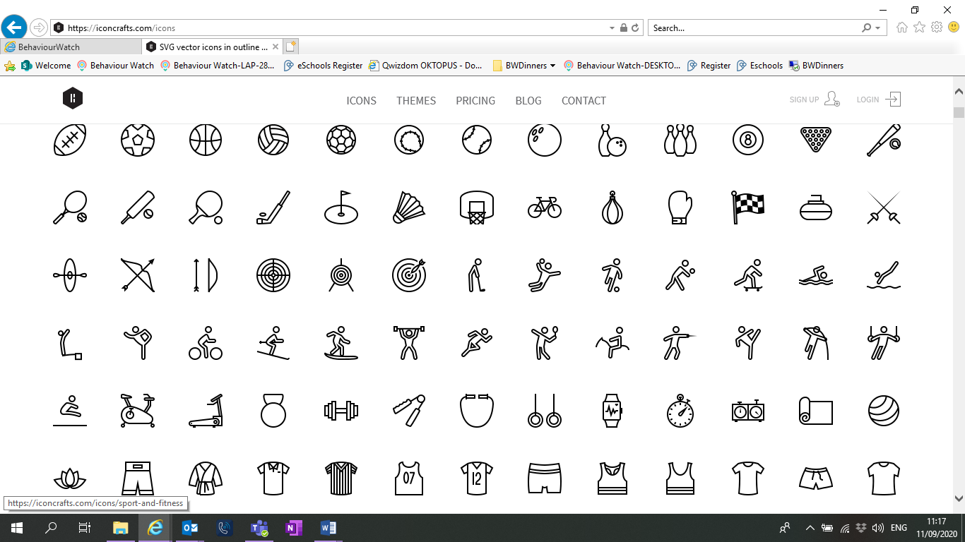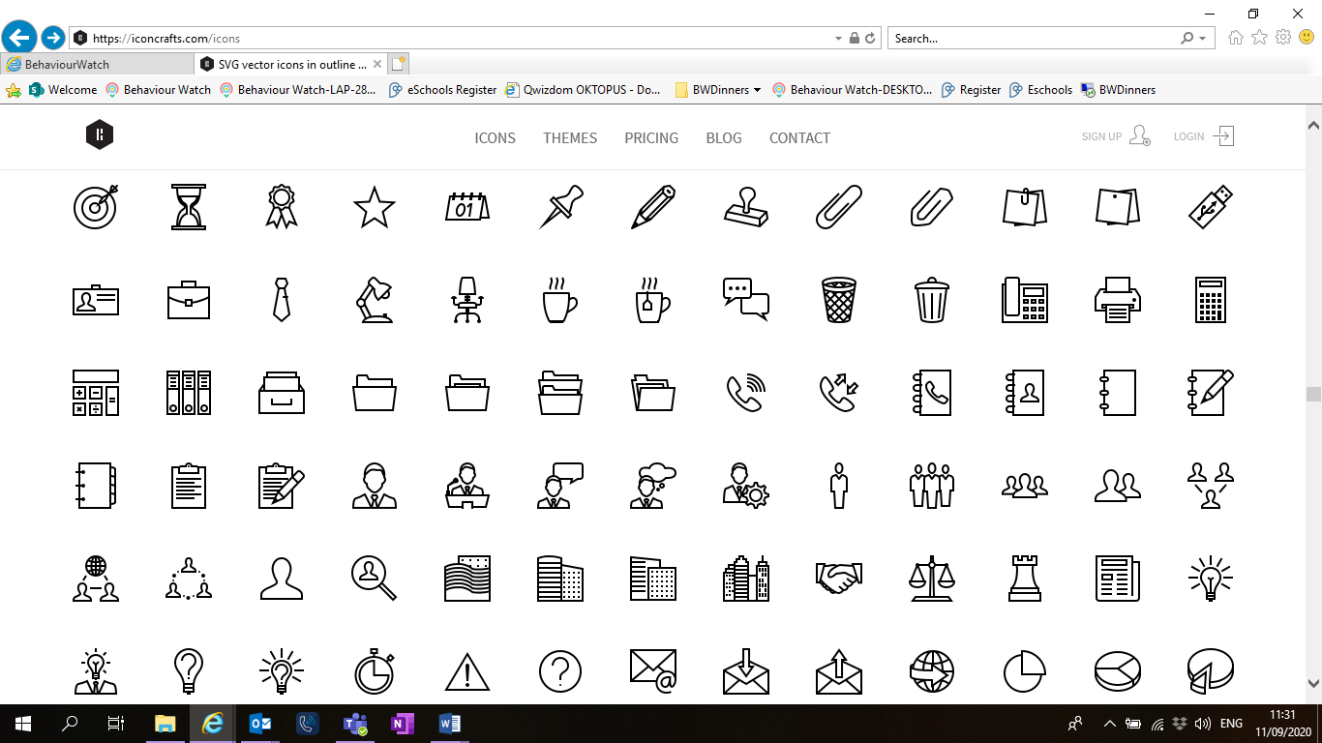

Reminders / Upcoming Trips and Visits  
*Please join our Facebook page for regular updates about school events and your child’s learning.

* We will be having a ‘wow’ dress up day exploring people who help us in our community. The children can come to school dressed as their favourite person from the community or what they would like to be when they grow up e.g. firefighter, doctor, vet, shopkeeper and so on. Our Wow day is Thursday 24th October.
* In term 2 we will be going on a woodland walk and arranging a visit to the local care home to sing carols to the residents. Details and dates to follow. 

If you have any questions or would like more information about how to support your child’s learning, please speak to your child’s class teacher at the start/end of the day. For any other questions, please call or email the school office on **01752 365250** or [westonmill.desk@discoverymat.co.uk](mailto:westonmill.desk@discoverymat.co.uk).

PE   
The children will participate in PE sessions each week. **On our PE day, Wednesday, children will be required to wear their PE kit in school for the whole day.** The children will be inside and will need suitable outside kit, including trainers or plimsolls. School PE kit is a white t-shirt, black or blue shorts and trainers or plimsolls. As well as our PE session the children will take part in other indoor and outdoor activities during the week, which will be completed in school uniform. With the changeable weather please ensure your child has a named waterproof coat in school daily. As part of our learning we will be getting outside in nature and exploring the local area. Please could your child have a labelled pair of wellies that could be stored in school, for use during Welly Walk Time and outdoor learning activities. **Please ensure all uniform, PE kit and wellies are named.**

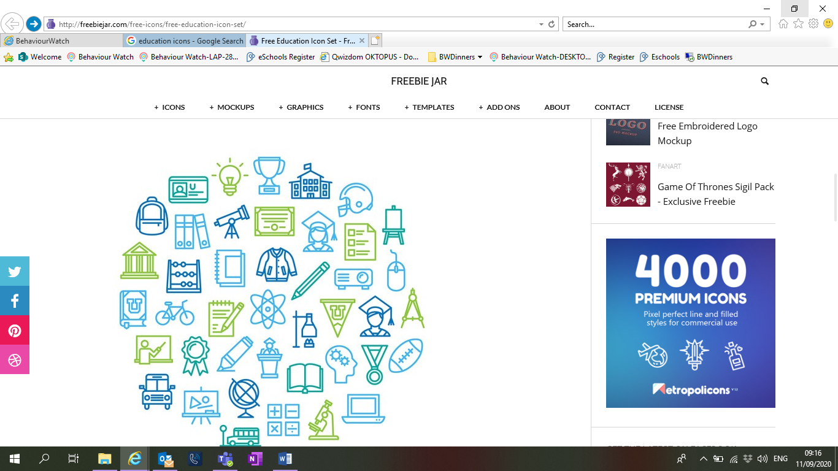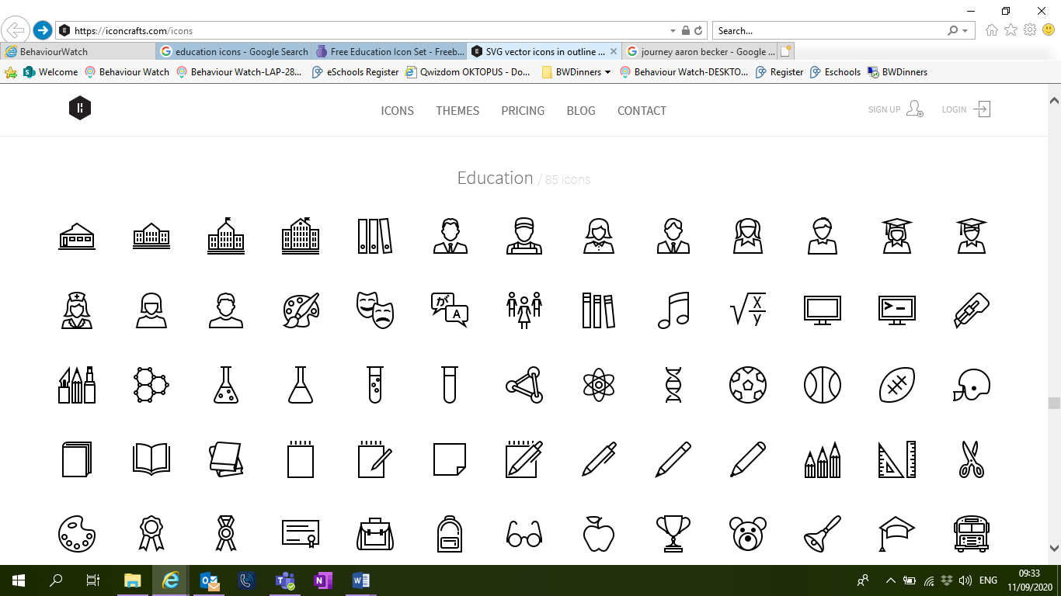

PHYSICAL DEVELOPMENT –

* Put on our jumpers/cardigans and coats independently and ‘having a go’ at zips and buttons.
* Participate in PE.
* Use a comfortable pencil grip.

PERSONAL, SOCIAL AND EMOTIONAL DEVELOPMENT –

* Getting to know our new friends and teachers.
* Discussing the school’s Ready, Respectful and Safe Rules and behavioral expectations in our setting.
* Independently managing morning routines (e.g. putting our book bags in our tray).

EXPRESSIVE ARTS AND DESIGN –

* Using our imaginations, and different media and materials to engage in craft activities.
* Learning familiar songs and nursery rhymes.
* Using small world to tell stories.

TERM 2: Woodland Explorers

Books:

‘The Gruffalo’ by Julia Donaldson

‘Little Red Riding Hood’ Ladybird

‘Percy the Park Keeper’ by Nick Butterworth

UNDERSTANDING THE WORLD –

* Identify and observe different trees, weather, woodland animals.
* Talk about celebrations, Diwali, Bonfire Night, and Christmas.

UNDERSTANDING THE WORLD –

* Talk about ourselves, families, and communities in our ‘All About Me’ topic.
* Recognise differences within my own community and the wider world.
* Name body parts and where they are. Think scientifically about our senses and how we use them.

PERSONAL, SOCIAL AND EMOTIONAL DEVELOPMENT –

* Play lots of Circle Time activities and games focusing on feelings.
* Explore feelings through stories and characters.

EXPRESSIVE ARTS AND DESIGN –

* Explore and use a range of artistic effects to express themselves with a focus on colour mixing. Create natural sculptures and pictures using things form the woods. Performing our Nativity songs and dances to family

TERM 1: All About Me

Books:

‘Going to School’ by Usborne First Experiences

‘Owl Babies’ by Martin Waddell

‘This is How we Do It’ by Matt Lamothe

‘Hey Wall: A story of Art and Community’ by Susan Verde

PHYSICAL DEVELOPMENT –

* PE – Continuing to develop our gross motor skills.
* Use a range of tools to develop our fine motor skills.

COMMUNICATION AND LANGUAGE –

* To use vocabulary associated with woodland.
* Ask questions to find out about woodland.

habitat and develop their enquiry skills.

* Develop storylines in their pretend play using new vocabulary.

LITERACY –

* Continuing our daily ‘Read, Write, Inc’ sessions.
* Form lower case letters and begin to write labels and captions.
* Recount a familiar fairytale.

MATH –

* Finding, subitising, and representing 1, 2, 3, 4, and 5.
* 1 more and 1 less than a numbers to 5.
* Composition of numbers to 5.
* Circle and triangles.

COMMUNICATION AND LANGUAGE –

* Listen to lots of songs and stories with increasing attention and joining in with group singing and storytelling.
* Show an understanding of and respond to simple instructions.
* Talk about important people, places, and events in my community.
* Use new vocabulary in different contexts.

LITERACY –

* Daily ‘Read, Write, Inc’ sessions during which we will be learning the sounds of letters, learning how to form letters, and beginning to blend to read simple words.
* Engage in extended conversations about stories such as: the setting and characters. We will be making predictions about what we think might happen next.

MATHS –

* Begin to recognise numerals from 0-10.
* Count to 10 and beyond.
* Match, sort and compare amounts.
* Explore patterns and repeating patterns.