**Weston Mill Community Primary Academy   
Autumn Term Learning   
Year 1 ~ 2024-2025**

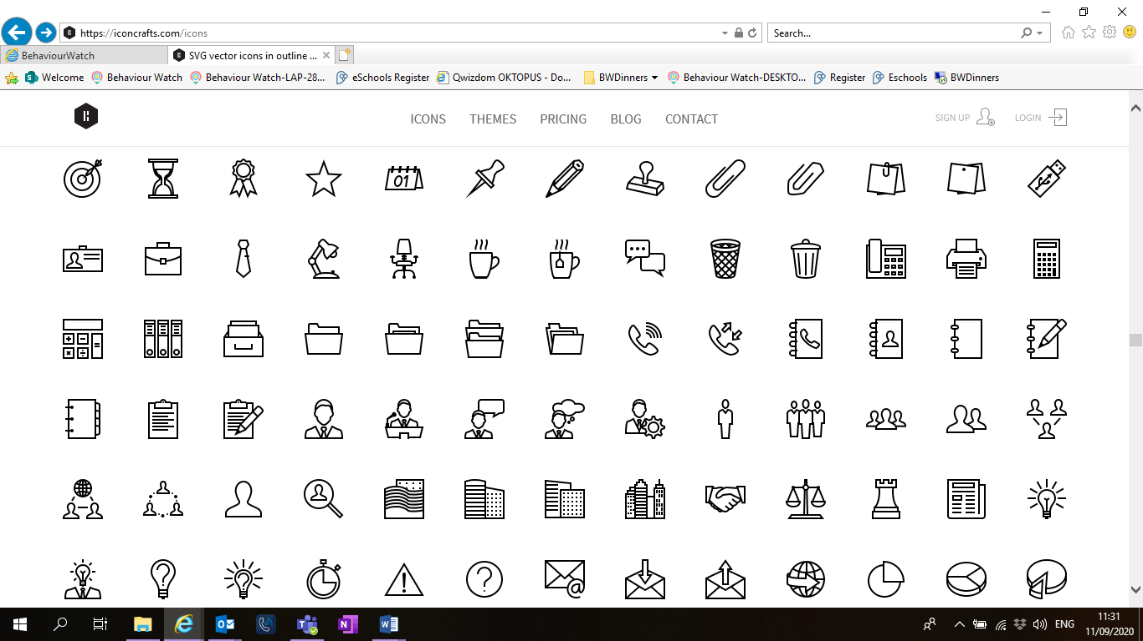

**Autumn Term**On the reverse, please find an outline of your child’s learning for Autumn Term 1 and 2.

We will be focusing on settling back into school after a great summer break. We are so pleased to see the children getting on well in their new classes and the progress they have been making so far.

How you can help:  
Reading, times tables and spellings are the main areas you can make a huge difference with at home, and these are what we expect the children to complete as homework each week. Reading books are changed each week and they have a Reading Diary that they can bring backwards and forwards from school to track their reading at home. Year 1 children will bring home books from their Read Write Inc phonics lessons set at their current reading level. Children should try to read with an adult every day. It is even more helpful if you can ask them questions about what they have been reading, or to predict what they think will happen next.

Each week, your child will be given a list of spellings for their age group. They are tested once a week, on a Friday. You can really support your child by helping them to learn their spellings at home. A few minutes each evening or as you are walking to or from school will make all the difference.

Children in Y1 will be expected to learn the 2s, 5s and 10s times tables by the end of the year. You can jump in 2s together or count in 5s high fives, clap in 10s anything that gets them counting. Children in Year 1 will take part in the government phonics screening check in early June. This will test their sound knowledge and blending skills as they read real and nonsense words.

Reminders / Upcoming Trips and Visits  
*Please join our Facebook page for regular updates about school events and your child’s learning.

We will be making junk models in Florence Price class, if you have any old cardboard boxes, kitchen roll tubes, plastic bottles etc please send them in with your child. Thank you.

If you have any questions or would like more information about how to support your child’s learning, please speak to your child’s class teacher at the start/end of the day. For any other questions, please call or email the school office on **01752 365250** or [westonmill.desk@discoverymat.co.uk](mailto:westonmill.desk@discoverymat.co.uk).

PE   
The children will continue to participate in PE sessions each week. Our topic this term follows the ‘Cambridge PE’ curriculum, focusing on core skills. **On our PE day, Year 1, children will be required to come into school in their PE kit.** The children will be going inside and outside and will need suitable outside kit including trainers or plimsolls. School PE kit is a white t-shirt, black shorts/jogging bottoms, their school jumper or cardigan, socks and trainers or plimsolls. Hoodies **must not** be worn. Our usual PE days will beTuesday **and** Friday.

TERM 1: Amazing me!  
  
BIG QUESTION What makes me special?

DESTINATION To create my passport, including facts about my life

ENGLISH Year 1 will be studying the book Old Bear by Jane Hissey. We will be studying the narrative and then writing our own messages pretending to be one of the toys from the story.

MATHS: This term the children will be working on number and place value. We will be sorting and counting objects. As well as finding one more and one less from a number.

SCIENCE In Science this term, the children will be investigating all about animals including humans, including identifying different types of animals (fish, amphibians, reptiles, birds and mammals)

COMPUTING In computing this term, we will be looking at online relationships and who we can trust.

PSHE We will be learning about what is the same about us and what is different.

MUSIC in music this term we will be studying the Be Yourself beat. Looking at how the music makes us feel and how music can effect mood.

Art in art this term we will create sculptures of ourselves using different materials.

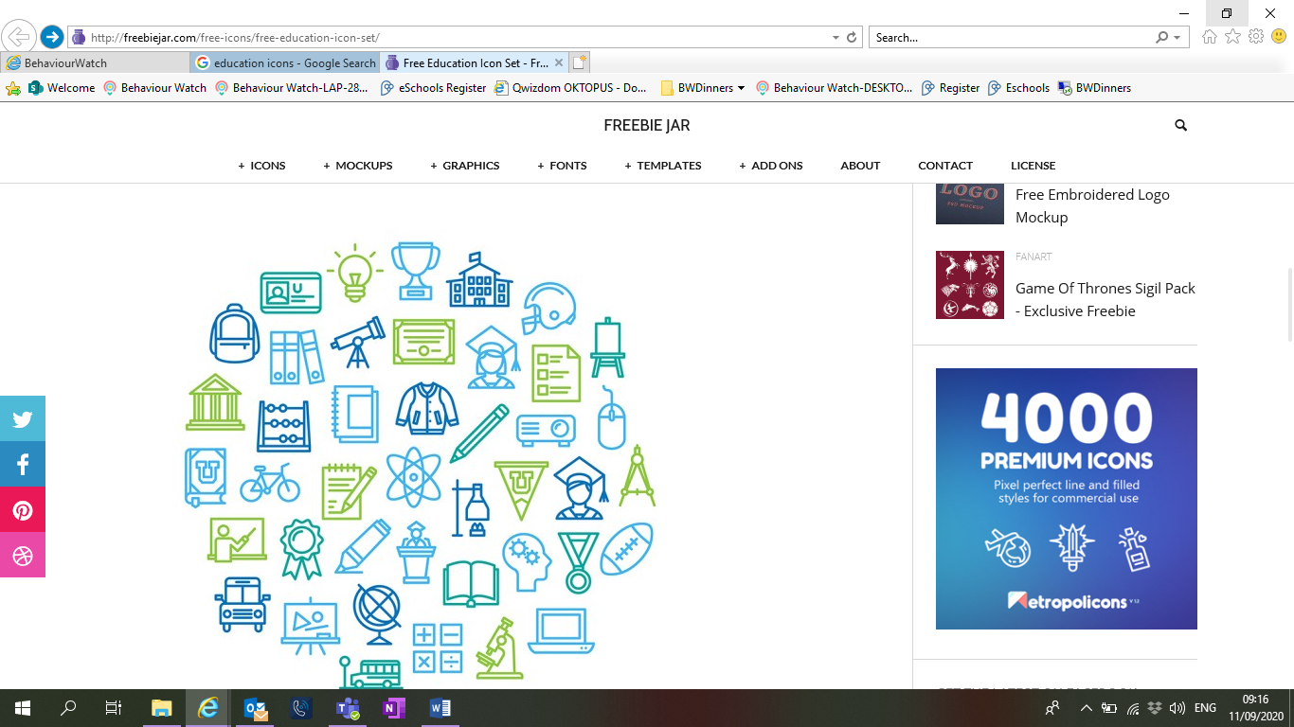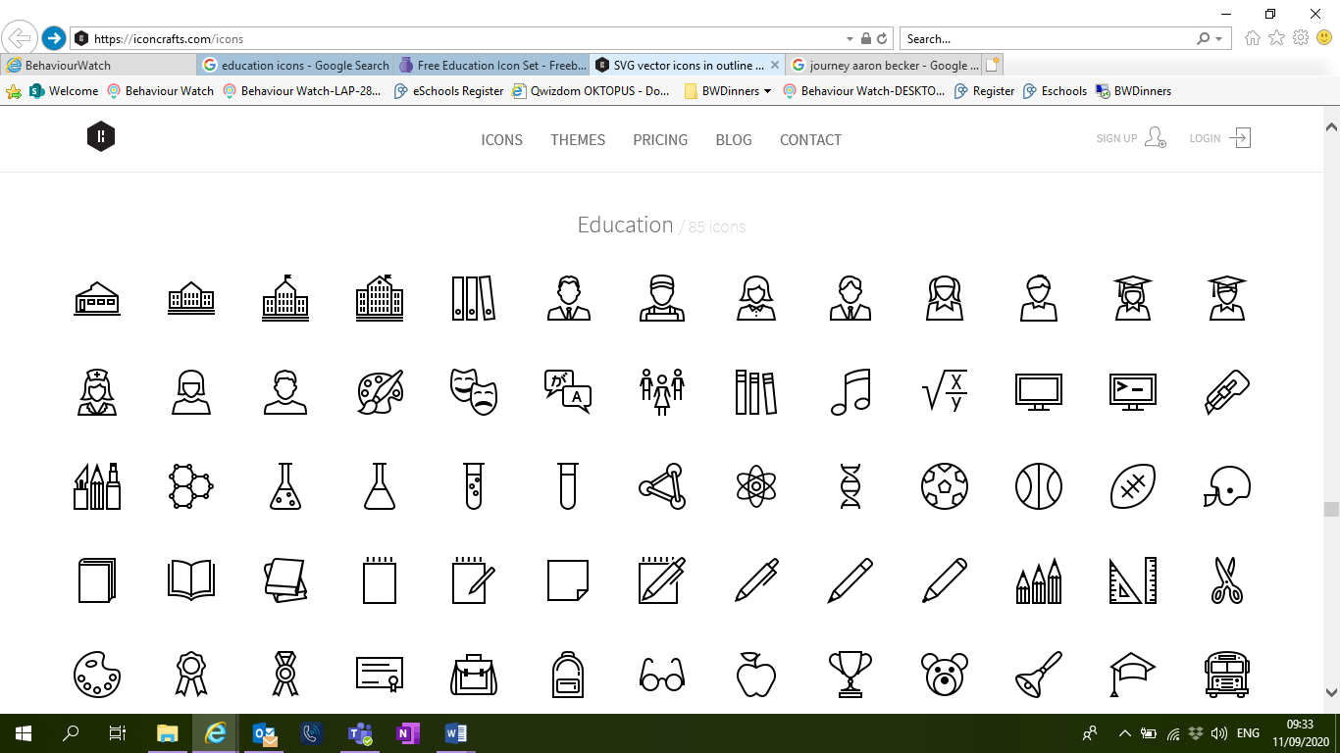

HISTORY We will be studying changes in our living memory and creating our own family trees. We will create a timeline of events that have happened in our lives so far including birth, walking and starting school.

DT We will be looking at cooking and nutrition. What a healthy diet looks like and where our food comes from.

PE In PE this term the children will be learning dance, they will use a range of balance and movement skills.

TERM 2: Weather watchers  
BIG QUESTION: What is the weather like where we live?  
DESTINATION: Perform music and poems to our parents.

ENGLISH: In English this term we will be studying the story of Rapunzel. We will be exploring this traditional tale and then writing a retelling of the narrative.

MATHS: This term the children will be working on addition and subtraction. They will be learning how to represent and use number bonds and subtraction facts within 10. As well as solving one step problems using addition and subtraction.

SCIENCE: During the children’s Science learning this term they will be learning about seasonal changes. They will learn the names of the seasons and how to describe them. The will investigate rainfall.

COMPUTING: The children will use ‘paint’ to create a seasonal picture independently. Exploring colour and shape.

PSHE: We will be learning about who is special to us and why.

MUSIC: The children will listen to the classical composer Vivaldi and their work ‘Winter’. They will use this to inspire their own composition about the seasons.

ORACY: The children will be learning the importance of talk rules and speaking in full sentences.



GEOGRAPHY: The children will observe local weather and keep a weather diary. The will then identify seasonal and daily weather patterns and how the weather changes on a daily basis.

DT: The children will design and make their own rain gauge using recycled materials. They will evaluate how effective their gauge is.

PE: In PE this term the children will be learning gymnastics. They will learn a variety of moves and holds.