Weston Mill Community Primary Academy

SEN Information Report 2026/27

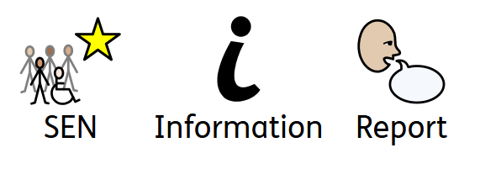

Last Reviewed: 28.08.26
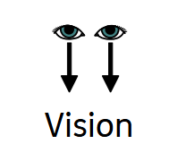
Vision Statement

We believe in developing a child intellectually, creatively, emotionally, physically, spiritually, culturally and morally.

This will take place in the caring and supportive environment of a school that aspires to be outstanding and that is proud to be at the heart of the local and wider community, raising standards of attainment for all pupils.

We want our children to be confident, happy and healthy individuals, successful learners and responsible citizens to ensure that no child is treated less favourably than others.


What is SEN?

The special educational needs code of practice (2015) says that:

“A pupil has SEN where their learning difficulty or disability calls for special educational provision, namely provision different from or additional to that normally available to pupils of the same age”.

This means that a child may need:

- Specific resources to help them in the classroom.
- To be part of a small group with an adult to help them with their work, their social skills or their emotional well being.
- To work with someone specially trained to help them in the area that they need. (Usually someone outside school).
- Have an IEP (individual education plan) which will contain a simple summary of what is important to the child and how they would like to be supported. This will be shared with parents to set targets and review regularly.

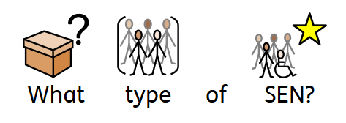
What kind of SEN is supported?

There are four areas where a pupil may have a difficulty that means they are considered to have SEN.

They are:
 |  | 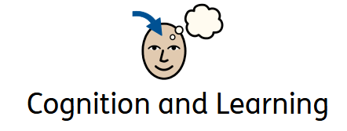 | 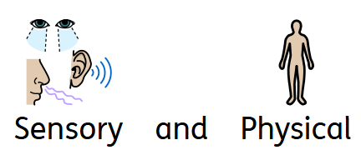
Includes Speech and Language needs, developmental language disorder (DLD) and social communication difficulties - including Autism. | Includes learners who display behaviours that challenge, anxiety, ADHD (attention, deficit, hyperactivity disorder) or attachment disorder. | Includes specific learning difficulties such as Dyslexia. Can be where a pupil is learning at a slower pace or has a developmental delay that impacts learning. | Includes hearing difficulties, visual difficulties, mobility difficulties and sensory processing difficulties. Can also include medical conditions such as epilepsy.

A child may have difficulty in one area or more than one area. Some children may be in care (CIC or LAC) and require support from school and the care team working around them.

We use the Assess, Plan, Do, Review cycle (graduated approach) to work with parents, children and staff in ensuring children are getting the right support, at the right time.

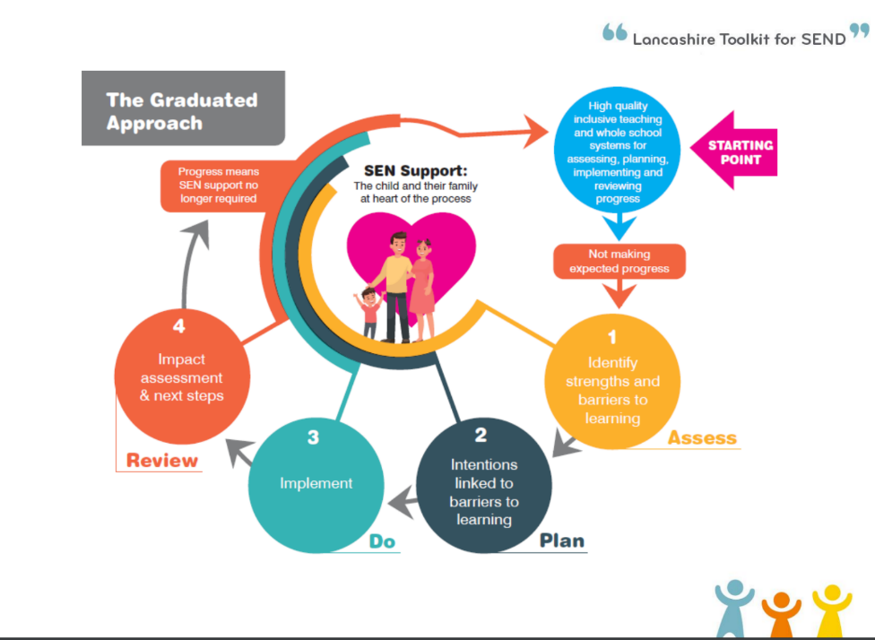
The educational support for a child is often described in three distinct stages – Universal Provision or “Ordinarily Available Provision”, Targeted Support and Specialist Support. We use Assess, Plan, Do, Review at all stages of support.
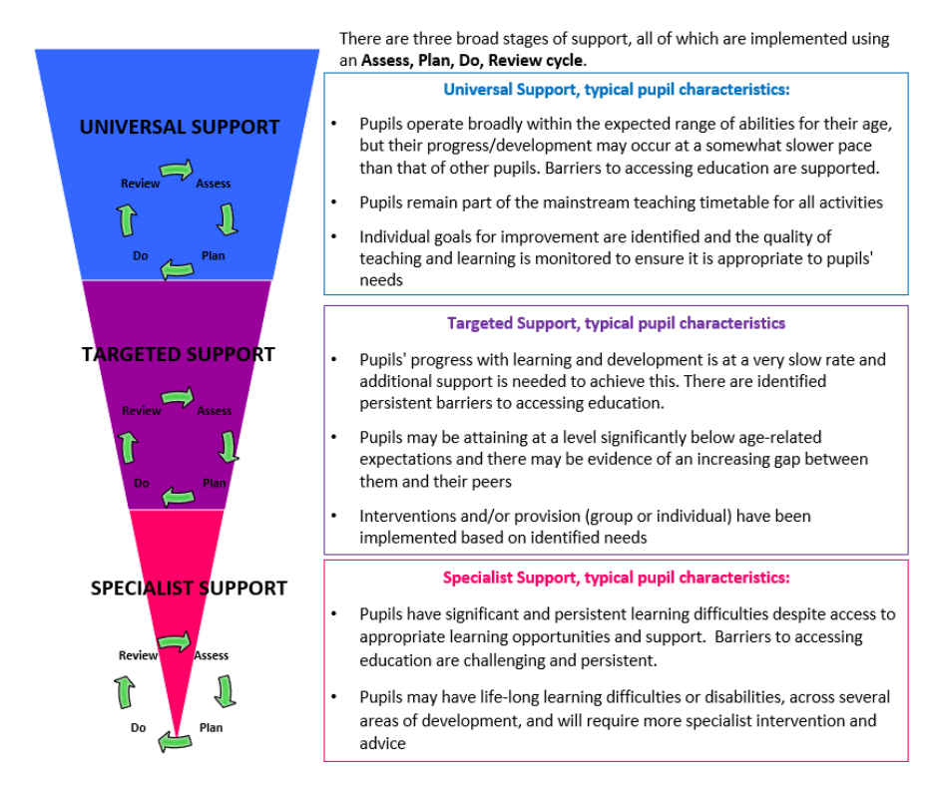


Who is responsible for the pupils with SEN?
Inclusion belongs to everybody at our school but our SENCo provides a point of contact and is qualified specially to ensure SEND pupils are well supported and able to thrive.

Miss Harris is our Special Educational Needs Coordinator (SENCO) and she can be contacted through the school office or via email, l.harris@discoverymat.co.uk
Miss Harris works full time and is a member of our senior leadership team.


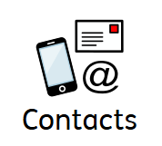

Who can I contact for advice and support for my family?

- At Weston Mill, Miss Harris (Above) is responsible for family support referrals.

- We work closely with the family hubs who provide a range of services that can support families. Family Hubs | PLYMOUTH.GOV.UK

- PIASS – Plymouth Information Advice and Support for SEND can provide impartial and confidential information and support for parents and carers. Plymouth Information Advice and Support for SEND. - Supplying you with information, advice and support

- MHST (Mental health support team) is an NHS service that support children’s mental health through early intervention. They work with us at school but parents can also refer. Mental Health in Schools Support Team (MHST) | Livewell Southwest

- The Neurodiversity Wellbeing Team – 01752 435404

- Parents can also self-refer to CAMH’s and Livewell Speech and Language.
CAMHS Early Help Pathway | Livewell Southwest
Speech & Language | Livewell Southwest

- Your GP can also support with queries around SEND support.


How will the school know my child needs special educational provision?

- Little or no progress in learning is being made.
- Persistent difficulty with accessing the classroom
- Persistent difficulty with communication or emotional regulation

School Staff will know this because:
- They continually assess the children as part of their daily teaching. If needed, some children will then receive additional support as part of a group or on their own with an adult.
  - They meet termly to look at the progress all pupils are making and identify any who are not making progress or who have made slow progress, so that they can support them.
  - They will review support and interventions regularly to make sure progress is being made.
  - Teachers will meet regularly with the SENCo and will raise any concerns with both parents and the SENCo.
  - Some pupils will have a learning plan which will be shared with parents, reviewed and renewed. This is part of the graduated approach and can be referred to as the assess, plan, do, review cycle.
- Parents will alert school with their concerns.
- Other professionals will alert school with their concerns.


How can I let the school know I am concerned about my child?

- First, talk to your child’s teacher. If appropriate, they will talk to the SENCo about your concerns.
- The teacher will let you know what will happen next.
- If you are still concerned about your child’s learning or behaviour you can book a meeting with the SENCo.
- You could also ask to see the Headteacher or the Assistant Head of School.

How will the school let me know if they have any concerns about my child’s learning?

- The class teacher will talk to you.
- Any concerns will be shared at Parent’s Evenings.
- The SENCo may contact you
- You will be invited to a meeting in school with relevant staff



What kind of help could my child receive?

In class

All children are included in classroom learning and the wider curriculum with scaffolding and provisions to support as required. A small number of children may require bespoke and individualised provision which is planned carefully. This can include:

• Resources that are personalised to the child.
Equipment and resources can be secured where there is evidence of need either as part of the graduated approach or following advice of an outside agency. Some examples of resources include coloured overlays/paper to support children with visual processing difficulties, sensory tools such as fidget items or weighted blankets to support focus and engagement in the classroom and visuals to support routines and understanding. Assistive technology such as speech to text software, word prediction programmes and scan reading pens can be secured by school to support independence in reading and writing. Laptops and tablets are also available to support children with recording difficulties.

• Small group work and interventions can be timetabled, for example: English, Maths, spellings, handwriting/fine motor, social skills, Emotional Literacy, Art groups or Lego groups.

• Individual learning time with an adult.

• School based Speech and Language sessions – we use a programme called NELI.

• Emotional literacy support assistant or learning mentor.

• Social Skills (lunch time support) to develop positive interactions for children identified by staff.


From our Teaching Assistants

  - Social skills groups
  - Motor skills groups
  - Sensory Integration Support
  - Emotional literacy support groups (managing emotions, self esteem, friendships, anxiety and bereavement).
  - Nurture Breakfast
  - Wellbeing Check in’s
  - Wellbeing groups
  - Access to an alternate space during lunchtime


External Professionals

- Multi-agency support team (MAST)
- Communication Interaction Team (CIT)
- Plymouth Advisory Team for Sensory Support (PATSS)
- Educational Psychologist (EP)
- Plymouth Information Advice and Support Service (PIASS, formally Parent Partnership)
- School Nurse
- Child and Adolescent Mental Health Service (CAMHS)
- Mental Health Support Team (MHST)
- NHS Speech and Language Team
- Other specialist provisions

More information about the Local Authority’s Local Offer for children and young people with SEN and their families as well as the above services can be found on the Plymouth Online Directory.
SEND Local Offer Homepage - Plymouth Online Directory

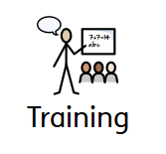
How are the adults in school helped to work with children with SEN?

The SENCO is a qualified teacher who has the skills and experience to work with and support staff and children with SEN. Staff training takes place regularly to help all staff understand and teach children with SEN. Training could be delivered by the SENCO or other external professionals such as Speech and Language Therapists. Individual teachers and support staff attend training courses run by outside agencies that are relevant to the needs of the children.

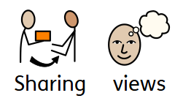
How do parents/carers and children with SEN share their views and concerns and work with the school?

- Surveys and Questionnaires.
- Parent Evenings.
- Learning Plan Reviews.
- Regular meetings, including EHATs (Early Help Assessment Tool) and TAMs (Team Around Me).
- Annual Reviews for pupils with EHCPs (Education, Health and Care Plans).

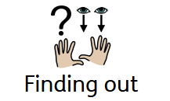
If I have a query about the support my child receives, what do I do?

- Talk to your child’s teacher.
- Book a meeting with the SENCO.
- Ask to meet the Headteacher or the Assistant Head of School.


If I am not happy with the support my child is getting what can I do?

- Talk to your child’s teacher.
- Ask to meet with the SENCO.
- Ask to meet with the Headteacher or Assistant Head of School.
- Request support from PIAS Plymouth Information Advice and Support for SEND. - Supplying you with information, advice and support
- Request a copy of the Discovery Mat’s Complaints Policy from the school office.

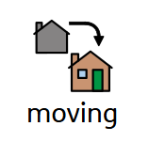
What happens when my child moves from class to class or to another
school?

All children make visits to their new class and teacher in the summer term. Class teachers meet to pass on information about all pupils and their individual needs.

The SENCO makes sure that all information about your child’s support is updated on a Provision Map - a tool used to track support in place for children across the school. New teachers can access this at any time to learn about your child’s needs and provisions.

Some children will have a transition book/social story to take home over the holidays with pictures and information about their new class or school.

The new class teacher will be part of the learning plan reviews in the summer term and pupils will have the opportunity to update their strengths and what they need in school to help them. The SENCO oversees these and ensures they are accurate. Additional visits may be arranged to reassure more anxious children.

If moving schools’; appropriate information about a child is passed on with parental permission. When moving to secondary school; appropriate information about a child is passed via a Transition Portal.

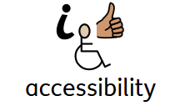
How accessible is the school for my child with SEN?

The school is set out across two floors with classrooms situated on both floors.

- 4 stairways and a lift provide access to the first floor.
- There are designated parking spaces for Blue Badge Holders.
- Weston Mill Community Primary’s accessibility plan is available on our website.


Where can I find information about the school’s approach to pupils with SEN?

Full details can be found in the school’s Inclusion Policy, which is available on the school website

Weston Mill Community Primary Academy - Policies



Thank you to all the parents, families and carers from Weston Mill Community Primary who take part in our meetings, parent questionnaires, and parents’ evenings. With your continued support we can be impactful in meeting the needs of our children with SEN.
The staff seem to really know what works for my child and the regulation space is fantastic for movement.
Parent feedback 2026.
It has been great that the SENCo is available on the playground every morning, we feel supported and comfortable because not everything has to be a big, scary meeting.
Parent feedback 2026.

