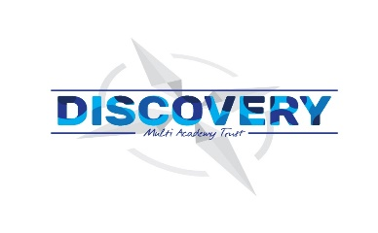

**Weston Mill Community Primary Academy   
Autumn Term Learning   
Year 3 ~ 2024-2025**

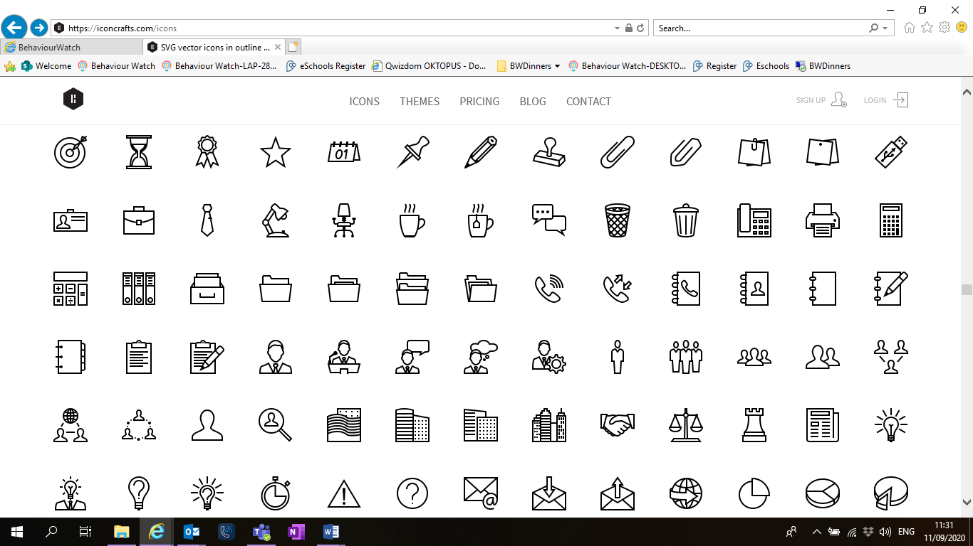

**Autumn Term**On the reverse, please find an outline of your child’s learning for Autumn Term 1 and 2.

We will be focusing on settling back into school after a great summer break. We are so pleased to see the children getting on well in their new classes and the progress they have been making so far.

How you can help:  
Reading, times tables and spellings are the main areas you can make a huge difference with at home, and **these are what we expect the children to complete as homework each week.** Reading books are changed when the children are ready to change their books in school and they have a Reading Diary that they can bring backwards and forwards from school to track their reading at home. Children are still using the Renaissance Reading program. Children should try to read with an adult every day; a good guide is 30 mins per day. It is even more helpful if you can ask them questions about what they have been reading, or to predict what they think will happen next.

Each week, your child will be given a list of spellings for their age group. They are tested once a week, on a Friday. You can really support your child by helping them to learn their spellings at home. A few minutes each evening or as you are walking to or from school will make all the difference.

Reminders / Upcoming Trips and Visits  
*Please join our Facebook page for regular updates about school events and your child’s learning.

* Prehistoric Day (dress up) Wednesday 18th September
* Aquarium visit Wednesday 6th November

If you have any questions or would like more information about how to support your child’s learning, please speak to your child’s class teacher at the start/end of the day. For any other questions, please call or email the school office on **01752 365250** or [westonmill.desk@discoverymat.co.uk](mailto:westonmill.desk@discoverymat.co.uk).

PE   
The children will continue to participate in PE sessions each week. Our topic this term follows the ‘Cambridge PE’ curriculum, focusing on core skills. **On our PE day, Year 3, children will be required to come into school in their PE kit.** The children will be going inside and outside and will need suitable outside kit including trainers. School PE kit is a white t-shirt, black shorts/jogging bottoms, their school jumper or cardigan, socks and trainers or plimsolls. Hoodies **must not** be worn. Our usual PE days will be **Monday and Thursday**.

TERM 1: BIG QUESTION: What was life like in Prehistoric Britain?

DESTINATION: An exhibit across the prehistoric ages.

ENGLISH Year 3 are looking at the text Iron Man. We will be using inspiration from this to write a story that includes an element of threat.

MATHS: This term the children will be working on place value, numbers to 100, moving on to addition and subtraction.

SCIENCE In Science this term, the children will be investigating all about the skeleton and nutrition.

COMPUTING In computing this term, we will be following online safety modules linked to self image and identity.

PSHE We will be learning about how to manage our feelings.

MUSIC

We will look at the work of Benjamin Britten.

FRENCH We will be learning French sounds this term, focusing on animals.

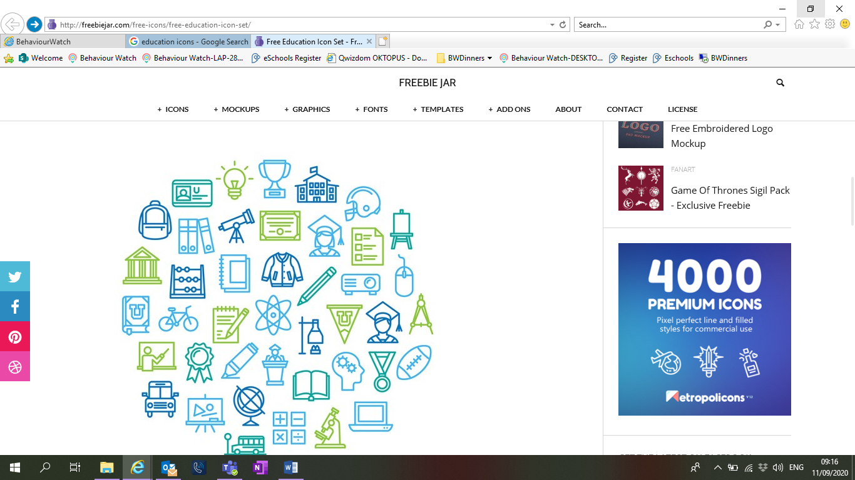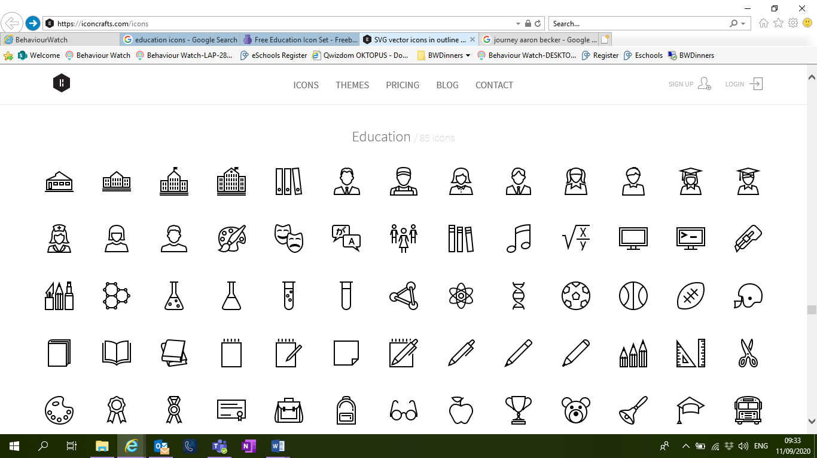

HISTORY We will be identifying eras within prehistoric Britain, mostly at the Iron Age and Stone Age. We will be learning about what Britain was like in this time.

ART We will be researching and recreating prehistoric drawings.

PE We will be doing dance and gym inside and games outside.

TERM 2: BIG QUESTION: Why do natural disasters happen?

DESTINATION: Create a class non-fiction book about volcanoes.

ENGLISH: Our text will be Fox and we will be writing a fable narrative.

MATHS: We will continue with addition and subtraction, then move on to multiplication and division.

SCIENCE:

We will be studying and comparing different types of rocks.

COMPUTING: use Word Processing in Publisher to create a Volcano explanation text with pictures.

PSHE: We will be thinking about what keeps us safe.

MUSIC:

We will continue to look at the music of Benjamin Britten.

FRENCH: We will continue learning French words for animals.



GEOGRAPHY: We will be looking at human and physical geography, specifically identifying mountain ranges.

DT: We will investigate how building survive in an earthquake zone.

PE We will be doing dance and gym inside and games outside.