Discovery MAT - Art & Design Curriculum Statement
Quotes that guide us:
‘Children are naturally creative. It is our job to give them freedom, materials and space to let their creativity blossom to its full potential.’ Jean Vant Hul

‘Every child is an artist. The problem is how to remain an artist once we grow up’. Pablo Picasso

Why is it important to teach Art & Design? (Intent)
All children are artists regardless of any barrier or need. We teach Art & Design to harness children’s creativity and allow a freedom of expression through mindfulness and experimentation. Art teaches children that there is no right or wrong and gives children the confidence to make mistakes and explore their imagination through a variety of media. Art embodies some of the highest forms of human creativity. A high-quality art & design education should engage, inspire and challenge pupils, equipping them with the knowledge and skills to experiment, invent and create their own works of art. We will enable pupils to think critically and develop a more rigorous understanding of art and how art has shaped our history, and contributes to the culture, creativity and wealth of our nation.

Key Concepts:
- Everyone is an artist and that we can explore ideas, communicate and record experiences and emotions through art.
- That Art & Design has many aspects including drawing, painting, collage, 3D, sculpture, textiles and craft using a wide range of media.
- That Art & Design means different things to different people and that we too can express an opinion, evaluate and analyse creative works using the language of art, craft and design.

Curriculum Design (Implementation)
Our Art & Design curriculum provides a clear and comprehensive document that will show progression of skills across all key stages within the strands of art. We link art with theme work, this deepens the children understanding of a topic and gives art a purpose and context. The children learn about and are inspired by a number of artists. We make good use of visits and visitors and think carefully about the timing of this to ensure links to current learning. We use the local area in order to create real art and exhibit the children’s art around our schools, share it on our websites and Facebook pages.

Our Art & Design curriculum gives children the opportunity to:
- produce creative work, exploring their ideas and recording their experiences
- become proficient in drawing, painting, sculpture and other art, craft and design techniques
- evaluate and analyse creative works using the language of art, craft and design
- know about great artists, craft makers and designers, and understand the historical and cultural development of their art forms.

Knowledge & Skills Focused
To ensure clear sequences of learning we use the Discovery MAT wide progression document to plan lessons. This gives small steps that build towards key end points that link to the National Curriculum. These break down the National Curriculum statements into smaller steps. The key skills covered link to colour, painting, drawing, printing, texture, 3D work and pattern. Key vocabulary is also identified for each year group.

What we do well as a Trust (Impact)
At Discovery, our children have an extremely positive attitude towards art, one student stated, ‘We can express ourselves more. I think for some people I think if they feel anxious it could calm them down and make them feel more relaxed. Some people use it to express their emotions and themselves.’ Children are very proud of their work and love to see it displayed around our schools. We also have a wonderful local area to inspire a wealth of art lessons within this local context e.g., the beach, local woods.

As a Trust we have regularly worked on whole school art projects/days. These have been planned and designed carefully by the MAT Art & Design Coordinator, or school Art Coordinators, and have different activities aimed towards the different primary phases. The activities are on a 2-year rolling programme, so that once the children have reached the next phase, they access the consecutive activities.

We also draw on learning and experience through contacting local artists from the wider community. We most recently engaged with local landscape artist, Josh Bygrave, who came into schools to talk to the children about his artistic journey and inspiration, followed by a taught demonstration in which the children were able to complete their own piece of work.

During our ‘Celebrating Diversity’ house days (an opportunity for children across all year groups to come together in four houses) one of the many activities was art based and creating inspired artwork from different ethnicities.

Art & Design National Curriulum & EYFS Framework
EYFS
The EYFS areas of learning that link most closely with the Art and Design Curriculum are Expressive Arts and Design and Physical Development.

Expressive Arts and Design | Physical Development
- Explore, use and refine a variety of artistic effects to express their ideas and feelings.  - Return to & build on their previous learning, refining ideas & developing their ability to represent them.  - Create collaboratively, sharing ideas, resources and skills.  - Safely use and explore a variety of materials, tools and techniques, experimenting with colour, design, texture, form and function. (ELG)  - Share their creations, explaining the process they have used. (ELG) | - Develop their small motor skills so that they can use a range of tools competently, safely & confidently.  - Use their core muscle strength to achieve a good posture when sitting at a table or sitting on the floor.  - Develop overall body-strength, balance, coordination, and agility  - Use a range of small tools, including scissors, paintbrushes and cutlery. (ELG)  - Begin to show accuracy and care when drawing. (ELG)

In EYFS, supporting children to look is an essential foundation skill. Through looking we nurture curiosity, build knowledge, and make the world our own. Looking provides us with an opportunity for active exploration. Empowered by close looking, we can build confidence in our ability to make a creative response. Exploring colour gives us a great opportunity to interact with the world. In addition, to develop our early knowledge of colour and colour mixing, we can also explore the way colour makes us feel.

Manipulating the materials of the world and transforming them into something new is an empowering process. Imagination is the stimulus for much making, and through enabling children to build and expand the worlds around them. We don’t just have to paint on paper – the world is full of textures and materials which we can use as surfaces for artwork! Children will look at how they can transform the surfaces around us by using line, colour and shape, and how can we make the objects we decorate reflect our personality? The world is full of materials, waiting to be transformed by our hands, hearts and heads. Children are given plenty of opportunity to explore materials through free exploration, ungoverned by our expectations of “outcome”, to help build experience of what it is possible to create. Throughout art exploration children are exposed to the development of their fine motor skills, whether holding tools or manipulating materials.

Key Stage 1 | Key Stage 2
Pupils should be taught:  - to use a range of materials creatively to design and make products.  - to use drawing, painting and sculpture to develop and share their ideas, experiences and imagination.  - to develop a wide range of art and design techniques in using colour, pattern, texture, line, shape, form and space.  - about the work or a range of artists, craft makers and designers, describing the differences and similarities between different practices and disciplines and making links to their own work. | Pupils should be taught to develop their techniques, including their control and their use of materials, with creativity, experimentation and an increasing awareness of different kinds of art, craft and design.  Pupils should be taught:  - to create sketch books to record their observations and use them to review and revisit ideas.  - to improve their mastery of art and design techniques, including drawing, painting and sculpture with a range of materials (for example pencil, charcoal, paint, clay).  - about great artists, architects and designers in history.

Art & Design Curriculum Overview
Year | Term 1 | Term 2 |  | Term 3 | Term 4 |  |  | Term 5 |  |  |  | Term 6
EYFS | All About Me  PAINTING | Woodland Explorers  SCULPTURE  Artist: Andy Goldsworthy | PRINTING  Christmas Cards | To Infinity and Beyond  PAINTING  Artist: Jackson Pollock | Things that Grow  SCULPTURE |  |  | Trains, Planes and Cars  PRINTING |  |  |  | On the Seven Seas  EXPRESSIVE ART
Y1 | Amazing Me  SCULPTURE  Artist: Michelle Reader | Weather Watchers | PRINTING  Christmas Cards | What’s in the Toy Box?  DRAWING | Our Local Area  COLLAGE  Artist: Henri Matisse |  |  | Women in History  PAINTING  Artist: Frieda Kahlo | National Drawing Day  NDD Artist – Mondrian |  |  | Kenya:  Too Hot to Handle!
Y2 | Our Great Britain  PAINTING  Artists: David McEown | British Bridges | PRINTING  Christmas Cards | Greenland:  Below Zero | UK Climate  PRINTING  Artist: William Morris |  |  | World Explorers | National Drawing Day  NDD Artist – Paul Klee |  |  | Commotion in the Ocean  COLLAGE  Artist: Megan Coyle
Y3 | Prehistoric Britain  DRAWING | Master of Disaster | PRINTING  Christmas Cards | Dinosaurs and Fossils  SCULPTURE  Artist: Julie Wilson | Farming and Food |  |  | Egyptians | National Drawing Day  NDD Artist – M.C. Escher |  |  | Plymouth Hoe:  Our City!  PAINTING  Artist: Brain Pollard
Y4 | Shang Dynasty | Journey Through North America  DRAWING (pastels)  Artist: Claude Monet | PRINTING  Christmas Cards | Ancient Greece  SCULPTURE  Artist: Bernard Leech | Australia  PAINTING  Artist: Clifford Possum Tjapaltjarri |  |  | Ancient Rome | National Drawing Day  NDD Artist – M.C. Escher |  |  | Inventions Which Changed the World
Y5 | Romans in Britain | Space:  Out of this World  PRINTING  Artists: Andy Warhol | PRINTING  Christmas Cards | Anglo Saxons and Vikings | Our Changing World  PAINTING  Artist: Van Gogh/Picasso |  |  | Ancient Maya | National Drawing Day  NDD Artist – M.C. Escher |  |  | Amazon Rainforest  PAINTING  Artist: John Dyer
Y6 | Dartmoor | Tudors:  Port of Plymouth  COLLAGE  Artist: Hans Holbein | PRINTING  Christmas Cards | British Empire & Industrial Revolution  PAINTING  Artist: LS Lowry | Biomes of the world |  |  | 20th Century Conflict  SCULPTURE  Artists: Alberto Giacometti | 20th Century Conflict  National Drawing Day  NDD Artist – M.C.Escher
Year | Drawing Skill |  |  |  |  |  |  |  |  | Artist
EYFS | Colour: Name colours.  Line: Practise different types of lines (straight, curvy, spiral). Use different mediums – chalk, pencil, pens.  Shape: Use 2D shapes to draw around. |  |  |  |  |  | 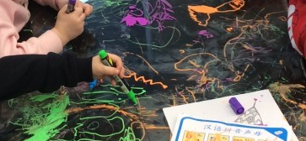  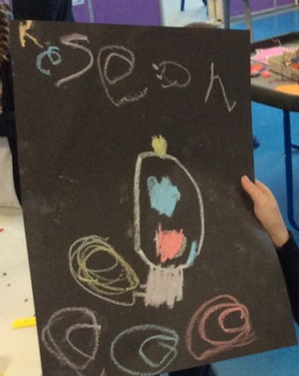
1 | Line: represent objects seen, remembered, or imagined. Practise different types of lines (straight, curvy, breakers, spiral)  Shape: Use line to draw known shapes (circle, triangle, square, rectangle). Use shapes to help build drawings such as a portrait or animal.  Space: Using space for effect (using full pages in sketchbooks)  National Drawing Day (above skills and):  Colour: Learn about primary colours. Discuss which colours are secondary colours. |  |  |  |  |  | 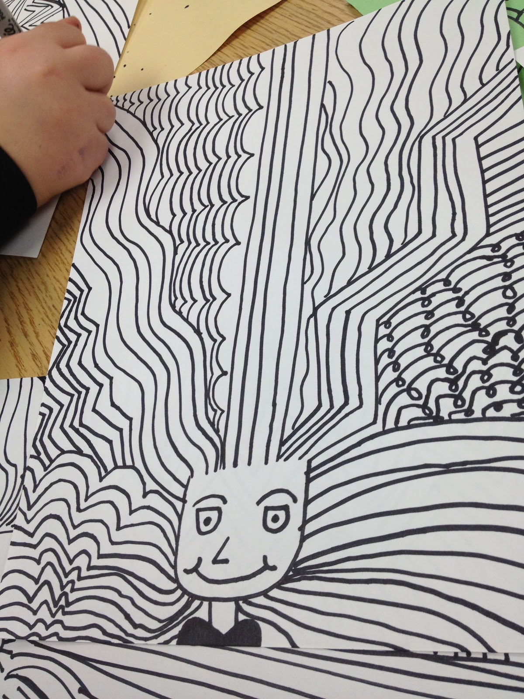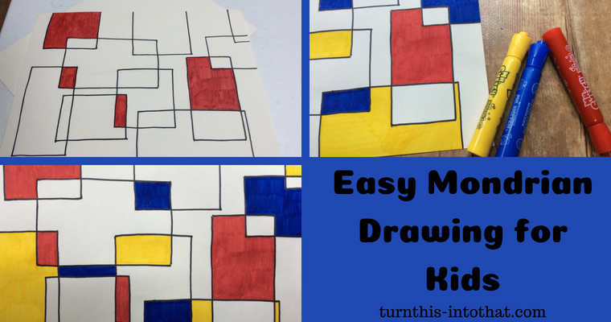 |  |  | 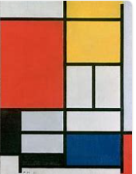  National Drawing Day: Mondrian, 1872-1944, Netherlands  MODERN
2 | National Drawing Day:  Colour: Revisits primary and secondary colours.  Pattern: Creates pattern using different lines – zentangle patterns.  Texture: Explores tone through pencil pressure.  Line: Use different lines with varying thickness. Practice drawing faint guidelines (portrait).  Shape: using proportions to create a portrait.  Form: Sketching 3D shapes. |  |  |  |  |  | 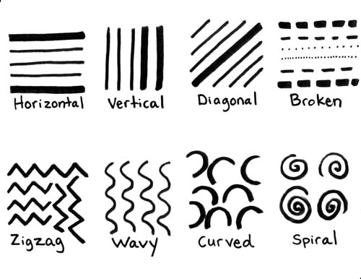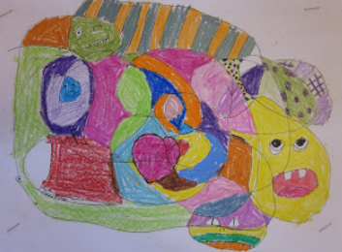 |  |  | National Drawing Day: Paul Klee,  1879-1940, Switzerland  MODERN  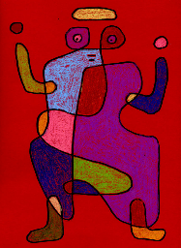
3 | Pattern/texture: Adds detail/texture to sketches through pattern.  Line: Experiment drawing with charcoal. Understanding the importance of using faint lines/guide lines.  Space: Chooses size and layout  National Drawing Day:  Colour: Recap of primary and secondary colours. Show tone through coloured pencils  Shape: Sketch portraits proportionally.  Form: Sketch 3D shapes with growing confidence. Uses contrast and lines to create 3D optical illusions.  Tone: Explores tone using different grades of pencil. |  |  |  |  |  | 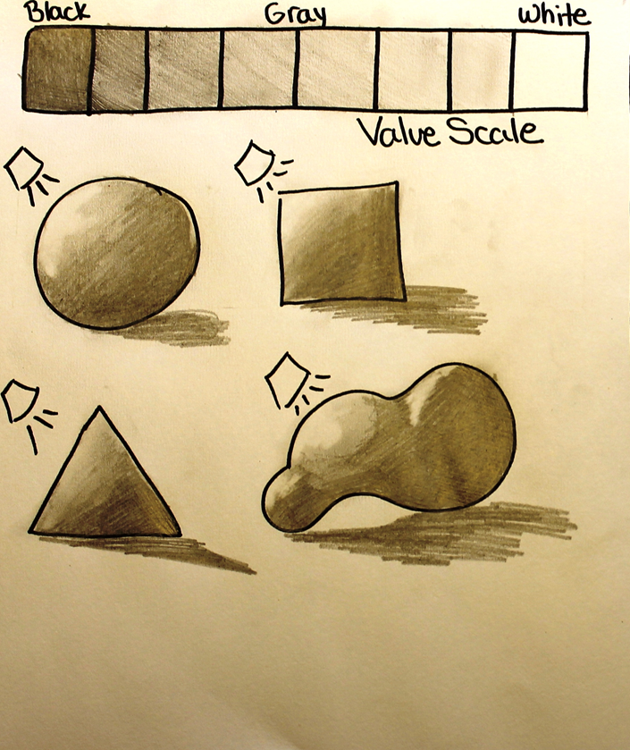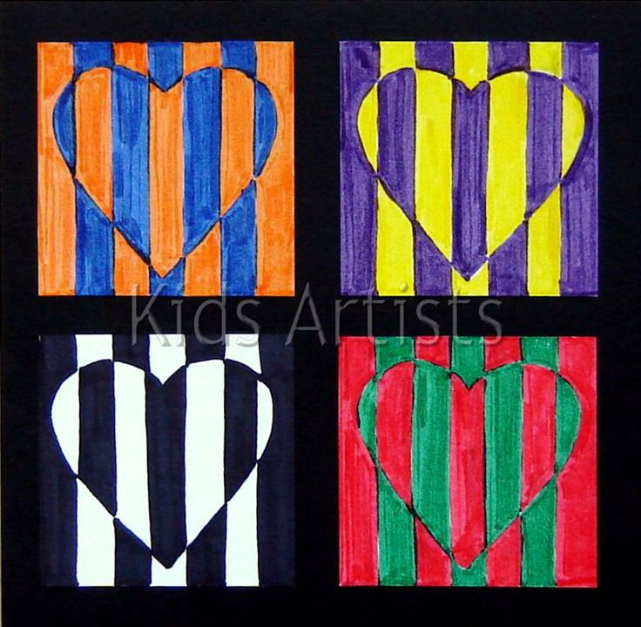 |  |  | National Drawing Day: M.C.Escher,  1898–1972,  Netherlands, Graphic / illustrator / murals  MODERN  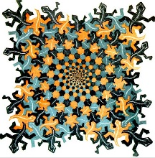
4 | Colour: Recap of colour mixing (primary, secondary and tertiary colours), with the addition of black and white for tone/tint. Experiment with pastels to blend colours.  Pattern/ Texture: Add texture to drawings by adding details such as feathers.  Line/shape: Use pastels in short strokes as per Monet.  National Drawing Day:  Form: Create an optical illusion with a vanishing point.  Space: Showing a greater awareness of space and white space when drawing.  Tone: Explore tone through shading techniques such as hatching, cross hatching, stippling. |  |  |  |  |  | 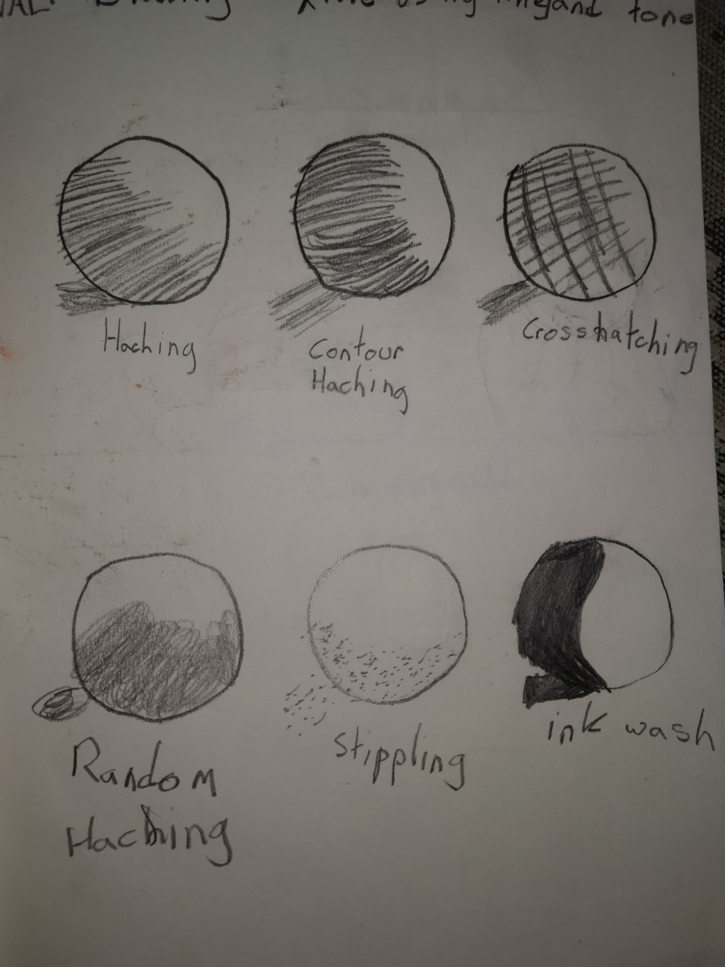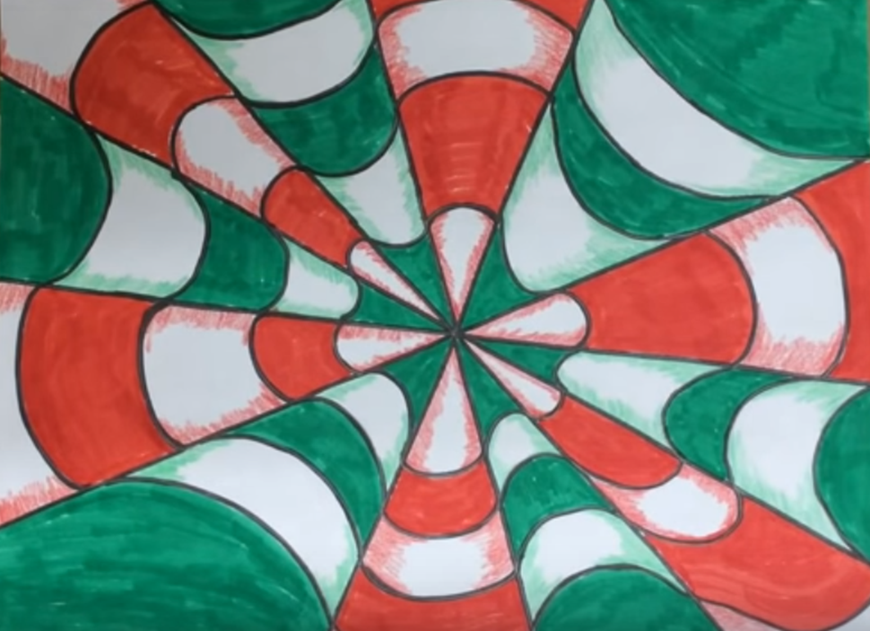 |  |  | Claude Monet, 1840-1926,  French, Painter/pastels  MODERN  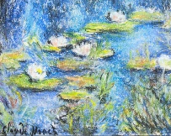
5 | National Drawing Day:  Colour: Recap of colour mixing; primary, secondary and tertiary colours. Recap tone using coloured pencils – pressure or shading techniques.  Pattern: Practise a range of texture techniques using different lines and shapes (Zentangles).  Texture: Create different textures for drawings (e.g. short fur, long fur, feathers, scales).  Line: Refine faint guidelines, so they are easily erased (sketching a realistic eye/portrait).  Shape: Use shape to give the illusion of form.  Form: Draw with perspective (one vanishing point).  Space: Distant shapes become smaller and paler. Adds greater detail to closer objects. |  |  |  |  |  | 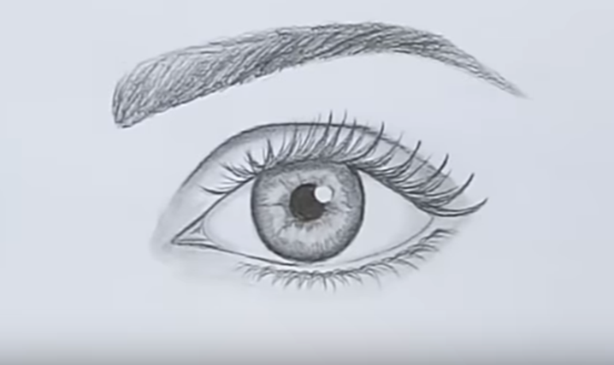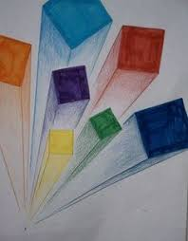 |  |  | National Drawing Day: M.C.Escher,  1898–1972, Netherlands, Graphic / illustrator / murals  MODERN
6 | National Drawing Day:  Colour: Recap of colour mixing; primary, secondary and tertiary colours. Recap the addition of black and white for tone/tint.  Pattern/Texture: Create different patterns/textures for drawings (e.g. short fur, long fur, feathers, scales).  Line: Selects appropriate media and techniques to achieve a specific outcome  Shape: Use shape to give the illusion of form.  Form: Draw to show form through 2D using tone (graded pencils, pencil pressure and shading techniques) and perspective. |  |  |  |  |  | 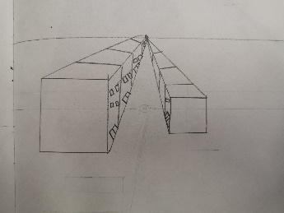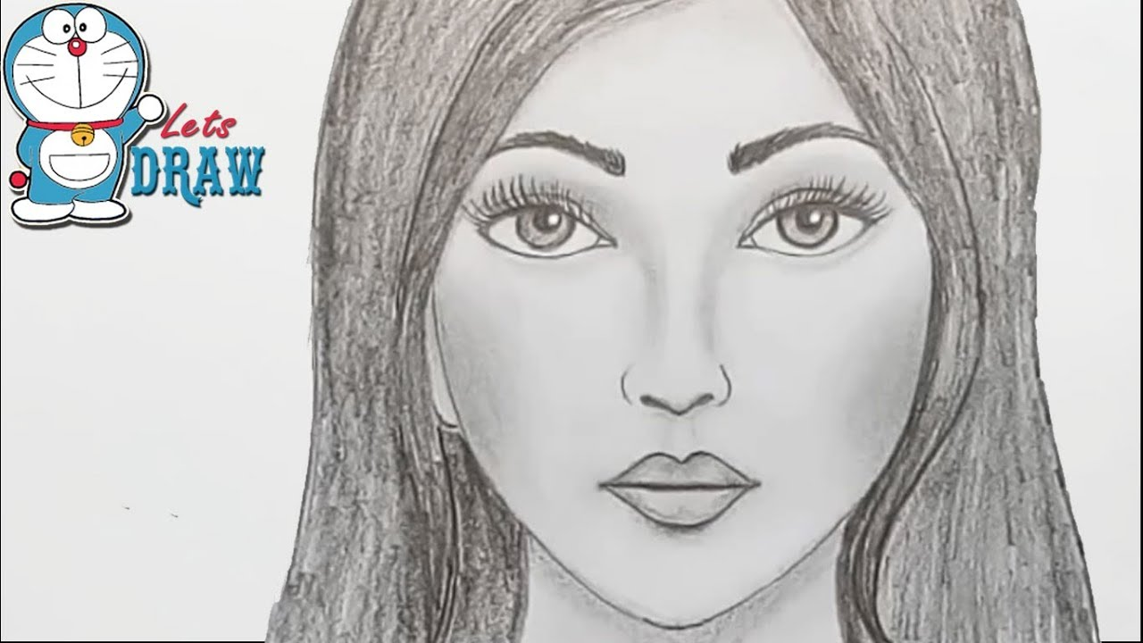 |  |  | M.C.Escher,  1898–1972, Netherlands, Graphic / illustrator / murals  MODERN  (NDD)
Year | Painting Skill |  |  |  |  |  |  |  | Artist
EYFS | Colour: Learn the names of colours.  Line: create various lines – thin and thick brushes.  Patten: use different items to create patterns – e.g. twigs car wheels |  |  |  |  | 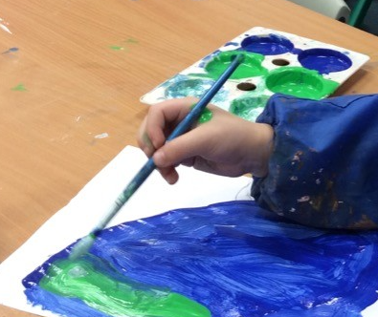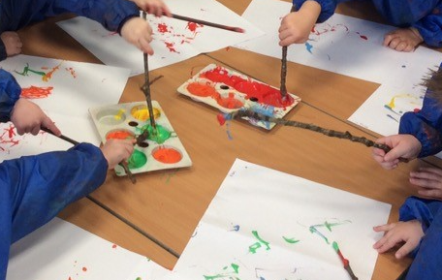 |  |  | 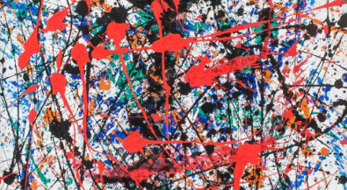  Jackson Pollock,  1912 – 1956,  American,  Painter,  MODERN
1 | Colour: Learn about primary colours. Colour mix to make secondary colours.  Line: represent objects seen.  Shape: Use line to draw known shapes (circle, triangle, square, rectangle). Use shapes to help build drawings such as a portrait.  Space: Using space for effect (using full pages in sketchbooks) |  |  |  |  | 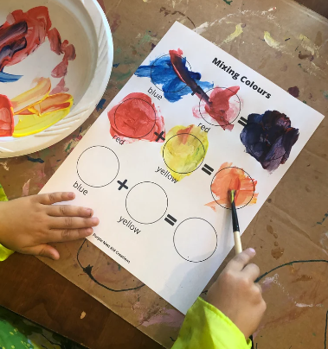 |  |  | 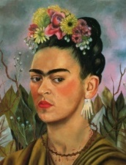  Frieda Kahlo, 1907-1954  Mexican, Painter / Portraits  MODERN
2 | Colour: Revisits primary and secondary colours. Practice colour mixing. Discuss and mix warm (red, orange, yellow) and cool (blue green, purple) colours.  Pattern: Create patterns from different brushstrokes – dab, sweep.  Line: Use different brushed to vary thickness of lines.  Shape: Use known shapes to build pictures. |  |  |  |  | 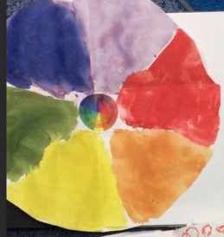 |  |  | 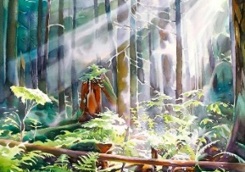  David McEown. Canadian  Watercolour  CONTEMPORARY
3 | Colour: Recap and practise colour mixing (primary & secondary), moving into tertiary colours. Recap warm and cool colours. Discuss contrasting / vibrant / dull colours. Create colour with natural materials.  Pattern: Adds detail to painting through patterns.  Texture: Explores the effect on paint of adding water, glue, sand, sawdust.  Line: Understanding the importance of using faint lines/guidelines.  Shape: Use seen shapes to create landscape.  Form: Begin to discuss and use proportion – objects in the background are smaller.  Space: Using all available white space. |  |  |  |  | 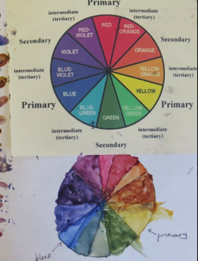 |  |  | 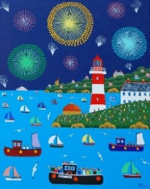  Brian Pollard:  Plymouth artist  1946-present  Painter  CONTEMPORARY  Architects: Smeaton and Eddystone
4 | Colour: Recap and practise colour mixing (primary, secondary and tertiary colours), with the addition of black and white for tone/tint. Add tone/tint using black and white. Create a paint tonal scale using one colour and adding small amounts of black.  Pattern/ Texture: Experiment adding texture to painting with different utensils for stippling – stippling brush, cotton bud, end of pencil.  Line/shape: Use dots to create art.  Space: Showing a greater awareness of space and white space when painting. |  |  |  |  | 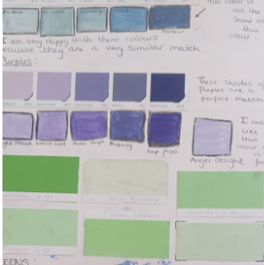 |  |  | 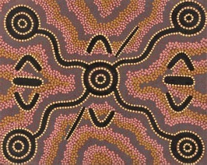  Clifford Possum Tjapaltjarri  1932 – 2002, Australian  MODERN
5 | Colour: Recap and practise colour mixing; primary, secondary and tertiary colours. Recap the addition of black and white for tone/tint.  Pattern/Texture: Create different textures and patterns for plants, by using lines and tones.  Shape: Discuss how shape is used differently by abstract artists.  Form: Show perspective through tone/objects further away are smaller, portraits in proportion.  Space: Distant shapes become smaller and paler. Adds greater detail to closer objects. |  |  |  |  | 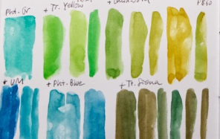 |  |  | 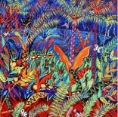  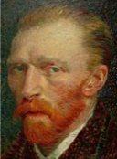  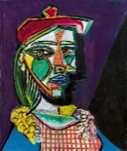  1 Van Gogh (1853-1890) TRADITIONAL  2 Pablo Picasso (1881-1973) MODERN  3 John Dyer, British, 1968 – present. C
6 | Colour: Recap of colour mixing; primary, secondary and tertiary colours. Recap the addition of black and white for tone/tint.  Pattern/Texture: Understand the texture of the paint affects the ‘mood’ of the picture (smooth/rough).  Line: Selects appropriate media and techniques to achieve a specific outcome  Shape: Use shape to give the illusion of form.  Form: Use shadows to show the illusion of form. |  |  |  |  | 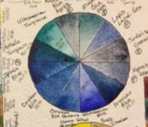 |  |  | 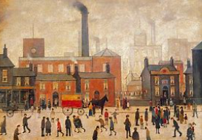  LS Lowry, 1887 – 1976, British  MODERN
Year | Sculpture Skill |  |  |  |  |  |  |  | Artist
EYFS | Form: Experiment with constructing and joining recycled materials. Make 3D objects from materials such as playdough, plasticine or clay.  Use equipment such as scissors, tape, stapler and glue to join materials. |  |  |  |  | 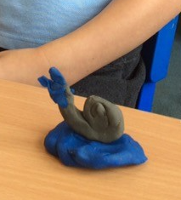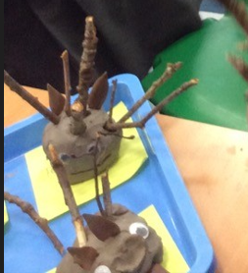 |  |  | 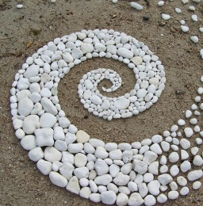  Andy Goldsworthy  1956 – present  Sculptor and land artist  English  CONTEMPORARY
1 | Form: Experiment with constructing and joining recycled materials.  Shapes/Lines: Use a variety of lines and shapes to design sculpture.  Use equipment such as scissors, tape, stapler and glue to join materials. |  |  |  |  | 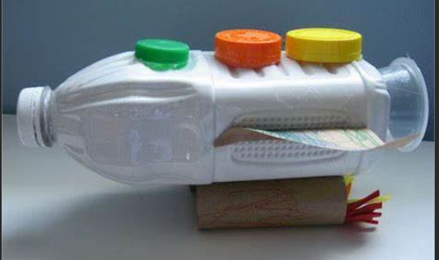 |  |  | 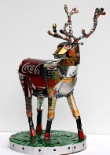  Michelle Reader  1975-present  English  Recycled materials  Sculpture  CONTEMPORARY
2
3 | Form: Construct and join recycled materials.  Shape: Choose and manipulate materials to create needed shapes.  Texture: Mod roc/papier mâché creation to create a sculpture. Paint sculpture using texture techniques such as adding salt, sand or sawdust.  Pattern: Pattern may be added to final design to create animal skin, e.g. scales. |  |  |  |  | 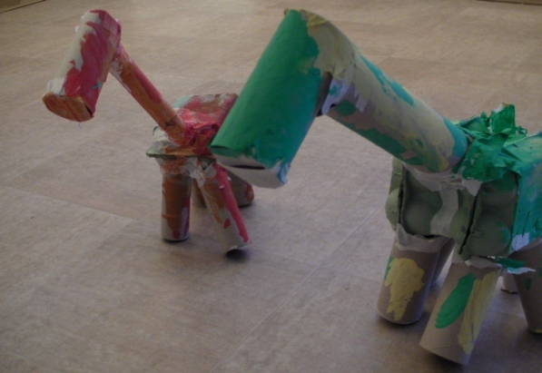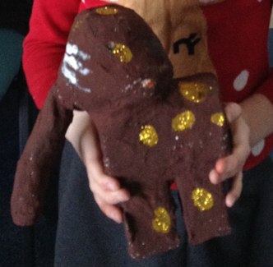 |  |  | Julie Wilson, Current, English  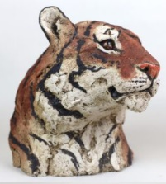  CONTEMPORARY
4 | Form: Shows an awareness of texture, form and shape by recreating an image in clay. Create a pinch pot, or coil pot.  Line: design a clay sculpture.  Pattern: design and add pattern to clay pot (e.g. Greek influence) |  |  |  |  | 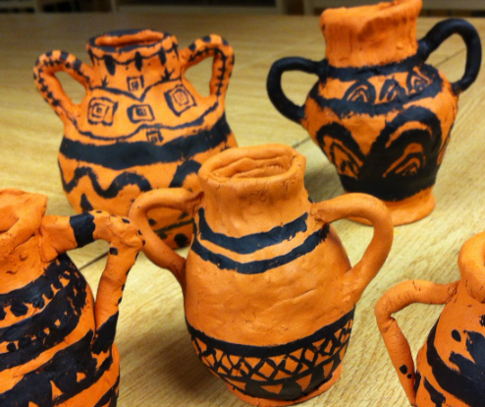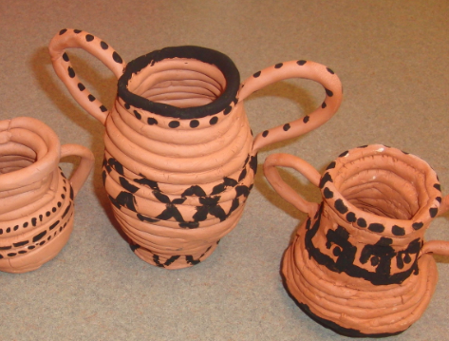 |  |  | Bernard Leech, 1887–1979,  British studio potter  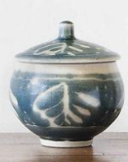  MODERN
5
6 | Form: Create wire sculptures to show movement of a human form. Use tools to help create structure and materials for stability.  Line: Design sculpture in sketchbooks, showing movement of human. |  |  |  |  | 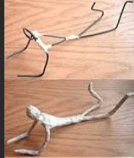 |  |  | Alberto Giacometti,  1901-1966, Swiss, Sculpture / painter  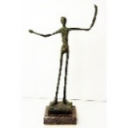  MODERN

Year | Collage/Textiles Skill |  | Artist
EYFS | Colour: collect and select coloured paper.  Texture: Add texture using natural materials such as leaves.  Shape: discuss choices using shape names. | 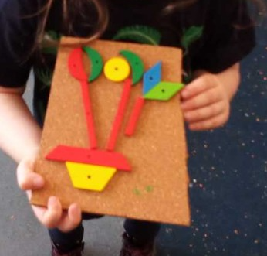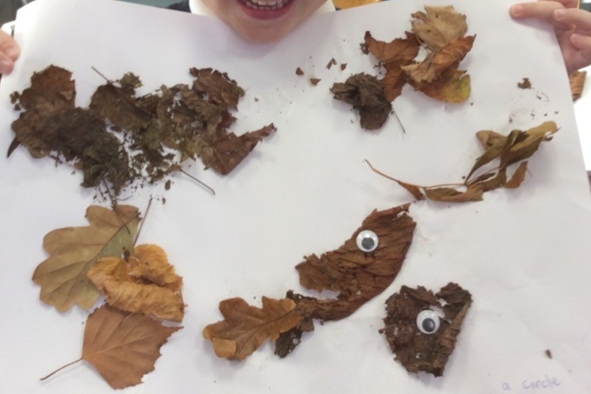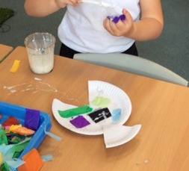
1 | Colour: collect and select coloured paper or fabric. Choose colours based on topic.  Texture: choose from torn, cut edges. Add textures by mixing materials  Shape: discuss choices using shape names  Space: experiment sorting and arranging materials | 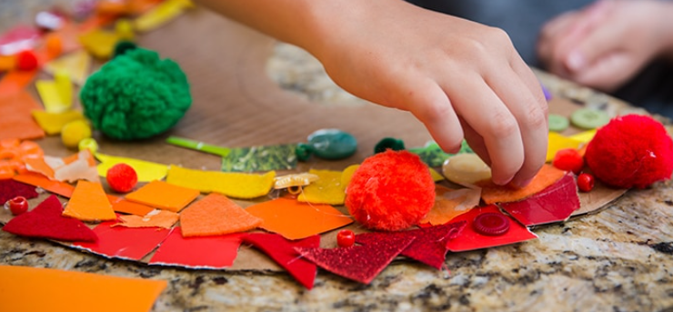 | Henri Matisse:  1869-1964, French  Collage / painting / shape  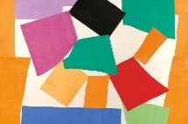  MODERN
2 | Colour: discuss warm and cool colours, contrasting colours.  Texture: choose from torn, cut edges. Add textures by mixing materials (print, magazine, fabric)  Line: Add line for definition to collaged piece.  Shape: Use shapes to create recognised collage objects (e.g. sea creature).  Space: experiment sorting and arranging materials | 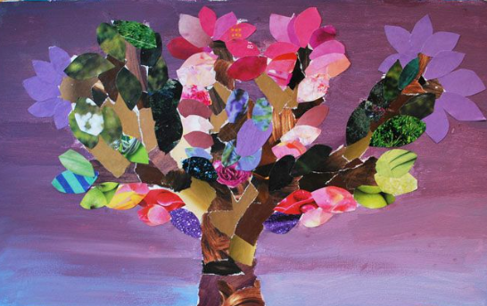 | 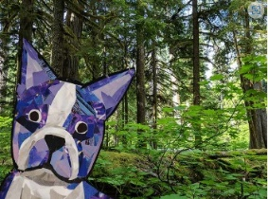  Megan Coyle  Current  American  Collage artist and illustrator  CONTEMPORARY
3
4
5
6 | Colour: select coloured fabrics related to the chosen era (i.e. Tudors)  Shape: Use shape to give the illusion of form.  Texture: Choose fabrics to add realistic details to a portrait. Overlap media to create texture.  Shape: choose and cut shapes with purpose.  Space: mix and arrange fabrics for effect. | 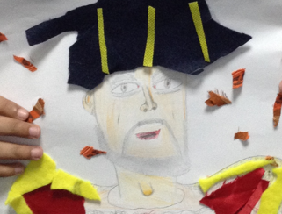 | 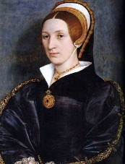  Hans Holbein The Younger, 1497 - 1543  German-Swiss painter and printmaker  TRADITIONAL

Year | Printing Skill |  | Artist
EYFS | Printing using body parts or natural materials (food, leaves etc)  Shape: Explore pattern and shape with found objects.  Pattern: Explore patterns that can be created. | 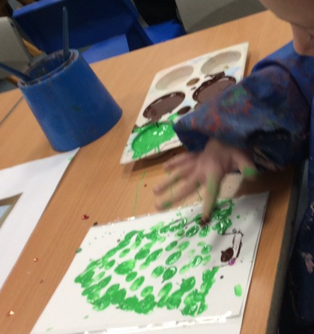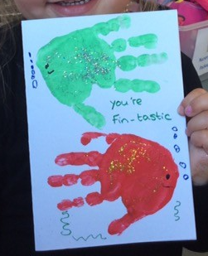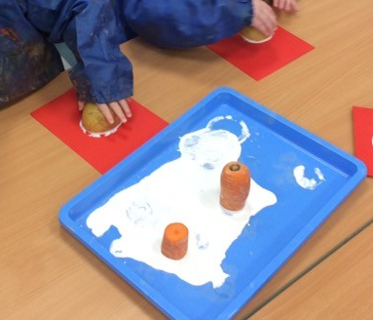
1
2 | Block print  Shape: Explore pattern and shape with found objects.  Pattern: Design and make a printing block with found objects onto card (e.g. string, seeds, match sticks, wool etc). Roll with ink and print into sketchbooks. | 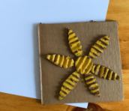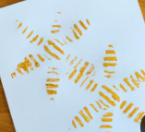 | 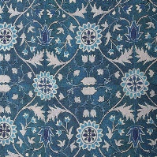  William Morris  1834-1896  British  wallpaper designer  TRADITIONAL
3
4
5 | Polystyrene tile print (relief printing)  Line/pattern: Use a variety of lines to create pattern.  Space: Design printing tile, understanding the relief process (indented places will not print).  Colour: Choose colours to show a contrast between background and print. | 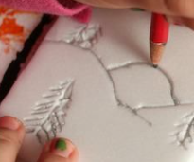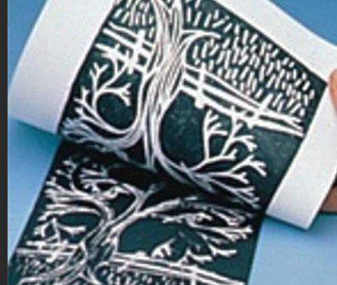 | 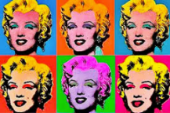  Andy Warhol:  1928-1987  Pop art / Print  American  MODERN
6

NB: Printing is generally covered in Autumn Term 2 through the production of printed Christmas Cards by all year groups.

Lesson Sequence:
Sketchbooks are used from Y1 – Y6. Ensure that this progression of lessons is evident within sketchbooks.
- Explore | Taking in ideas (be a magpie). Collect visual information to use as a source material for their own work.  Facts about your focus artist and their work. Cuttings and drawings of artist's work. Annotate- What do I like and why?  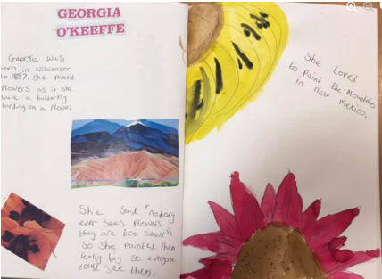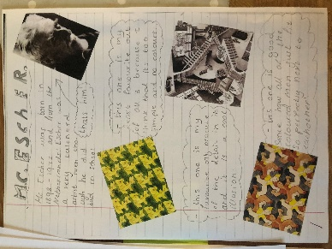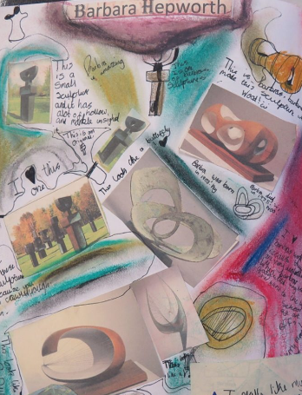
- Investigate (testing out) | DRAWING - Practice drawing techniques such as drawing different lines and shapes, shading, perspective etc. Experiment with different materials- pencil, charcoal, pastels etc. Annotate- Record details about the item being drawn for future reference.  PAINTING - Practice colour mixing (primary/ secondary/ tints/ shades). Discuss warm and cold colours. Use a colour wheel to experiment. Explore different types of paint- powder, watercolour, block paints.  COLLAGE - Cut and stick different materials Annotate- which will work best and why?  SCULPTURE – draw a design before making.  PRINTING - Test out printing techniques and different colours straight into sketchbook before creating final piece.  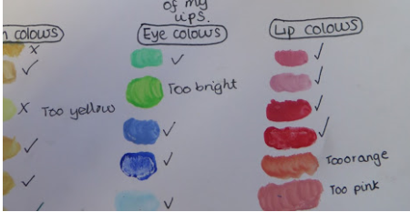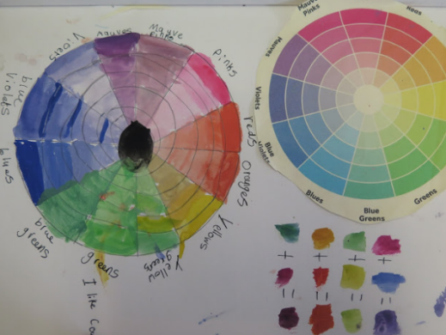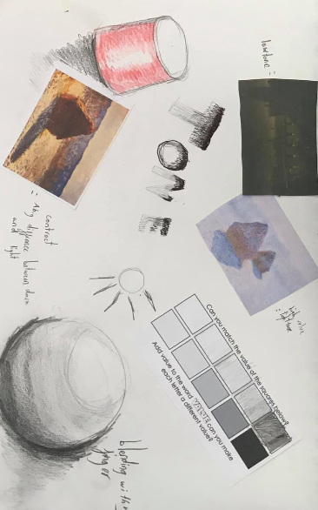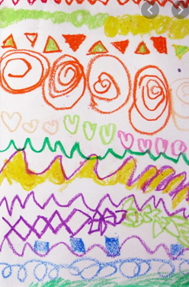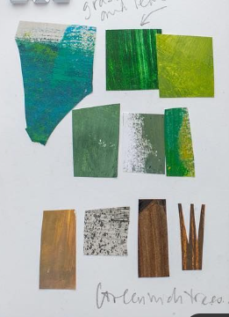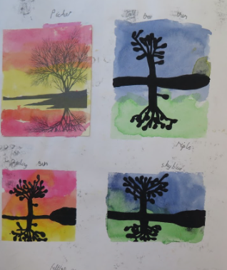
- Design | Use inspiration from artist study to create own artwork (inspiration could be materials, brush strokes, colours etc)
- Make (and lesson 5) | Sometimes, a final piece of work may be done outside the sketchbooks. If this is the case, a photograph can be put in the sketchbook. It could be put on a new page and annotated, or it could be stuck (flappy style) on the pages already filled.
- Evaluate: | Use What, Think, Link examples.  Peer assessment- give children opportunities to discuss their work with a partner. This could be a post-it note saying what they like about their partners work (thus not to ruin any of their artwork).  Leave books open at the end of the lesson, allowing children to view each other’s work and give feedback.

Year Group | Evaluating your own and others work (including famous artists)
EYFS | Discuss and describe the work of famous artists and designers  Explain how a piece of art makes them feel. | What  A brief description about what you have made and how you have made it. | Think  Explaining why you have selected used the materials you have. | Link  Link the piece to your theme or artist and reflect on the successes; what will you take forward?
 |  | - I have made a…  - I used…  - We looked at the artist… | - I/they made my art because…  - I/they used… because…  - I/they wanted to… | - The part I like is…  - My work looks like…  - Next time I want to…  - My work makes me feel…
KS1 | Discuss and describe the work of famous artists and designers Express opinions (thoughts and feelings) on the work of famous artists.  Explain how a piece of art makes them feel. | What  A brief description about what you have made and how you have made it. | Think  Explaining why you have selected used the materials you have. | Link  Link the piece to your theme or artist and reflect on the successes; what will you take forward?
 |  | - I/they have made a…  - I/they used…  - We looked at the artist…  - I used a… to help my ideas.  - My/their work is…  - The materials I/they used are... | - I/they used… colour(s) because…  - I/they made art because…  - I/they used… because…  - I/they wanted to… | - The part I like is…  - I think… worked well.  - My work looks like…  - I think … was not as successful because…  - I would do… to make it better.  - Next time I want to…  - My work makes me feel…
LKS2 | Reflect upon work from famous artists, expressing opinions, referring to techniques and effect.  Compare work to previously studied artists (styles and approaches). | What  A brief description about what you have made and how you have made it. | Think  Explaining why you have selected used the materials you have. | Link  Link the piece to your theme or artist and reflect on the successes; what will you take forward?
 |  | - I /they created a…  - I wanted to use… because…  - I/he/she was inspired by…  - I liked working with… because…  - I/they chose to create an image of… because… | - The materials I/they have selected are effective due to…  - I/they chose the design because…  - My/their choice of media allowed me to…  - My design will allow me to…  - The technique I/they have used is… | - I think using… worked well because…  - I feel… captures the theme well because…  - I need to improve my…  - I think … was not as successful because…  - Next time I would like to…  - My design was powerful because…  - My work makes me feel…
UKS2 | Reflect upon work from famous artists, expressing opinions, referring to techniques and effect.  Compare work to previously studied artists (styles and approaches). | What  A brief description about what you have made and how you have made it. | Think  Explaining why you have selected used the materials you have. | Link  Link the piece to your theme or artist and reflect on the successes; what will you take forward?
 |  | - I/they created a…  - I/they wanted to use… because…  - I/he/she was inspired by…  - I/they have shown… in the style of…  - The artist has influenced my designs because…  - In this piece, the materials I/they have used are…  - I/they found working with…  - I/they chose to create an image of … because… | - The materials I/they have selected are effective due to…  - The technique I/they have used is…  - Through focusing on my use of… I…  - I/they was able to capture…  - My/their choice of media allowed me/them to portray...  - I/they chose to emphasise… in this piece of art because…  - I/they wanted to incorporate… as it would…  - Using… allows me to… | - Through working this way, I have learned to…  - To develop this piece further I would need to…  - I think using… worked really well because…  - I am particularly pleased with… because…  - … was least successful because…  - I aim to now…  - I need to refine… because…  - In order to improve, I need to develop my skill in/ use of…  - The impact of my art it...  - My art communicates…

