**Weston Mill Community Primary Academy   
Autumn Term Learning   
Year 5 ~ 2024-2025**

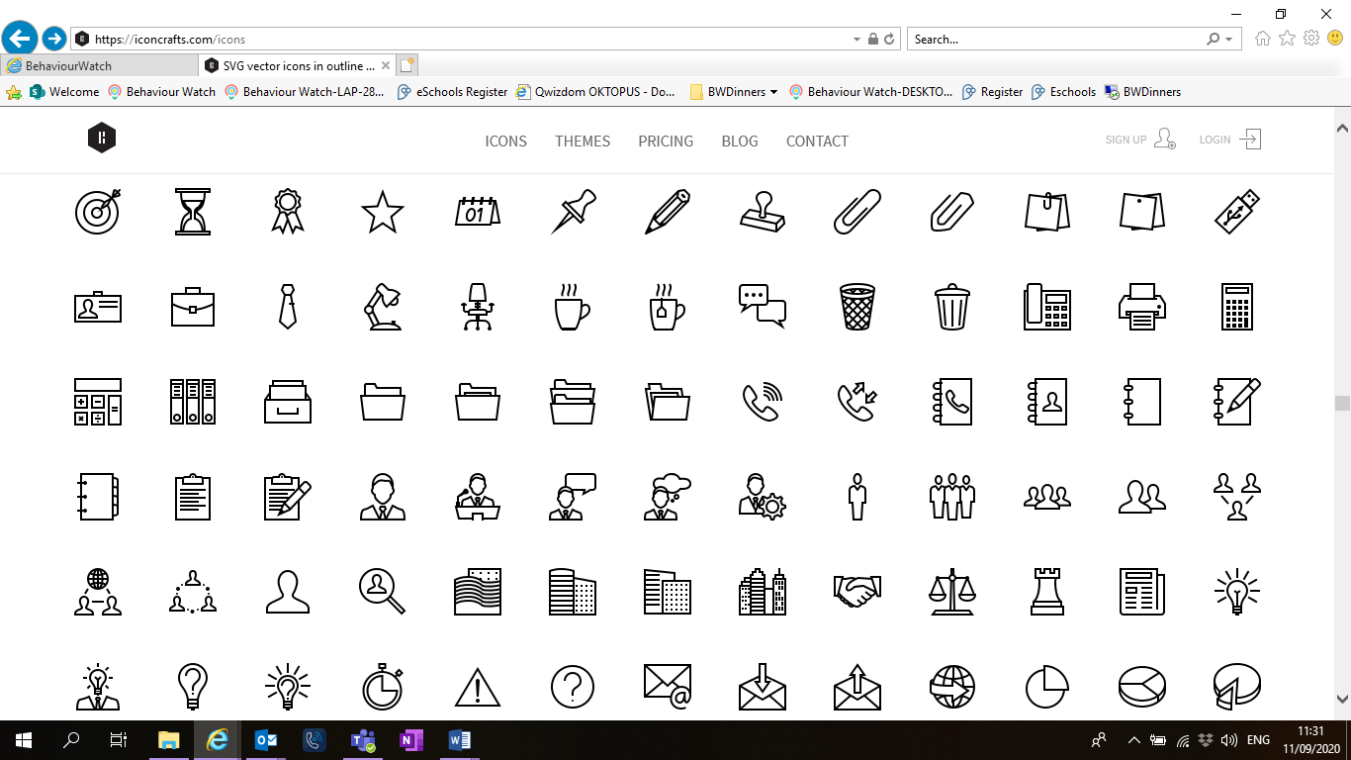

**Autumn Term**On the reverse, please find an outline of your child’s learning for Autumn Term 1 and 2.

We will be focusing on settling back into school after a great summer break. We are so pleased to see the children getting on well in their new classes and the progress they have been making so far.

How you can help:  
Reading, times tables and spellings are the main areas you can make a huge difference with at home, and these are what we expect the children to complete as homework each week. Reading books are changed when the children are ready to change their books in school and they have a Reading Diary that they can bring backwards and forwards from school to track their reading at home. Children are still using the Renaissance Reading program. Children should try to read with an adult every day; a good guide is 30 mins per day. It is even more helpful if you can ask them questions about what they have been reading, or to predict what they think will happen next.

Each week, your child will be given a list of spellings for their age group. They are tested once a week, on a Friday. You can really support your child by helping them to learn their spellings at home. A few minutes each evening or as you are walking to or from school will make all the difference.

Children in Y5 will be expected to learn all the times tables up to 12x12 by the end of the year. Each week, the children will have a short times table test and when they have completed three of these with only a few errors, they will move onto their next times table. When they have learnt up to the 12x table, they will have a grid format which helps them remember all their tables. Children have access to a website called Times table Rockstars which they will have their password for, and it helps them to practice their tables in an engaging way. You can also help by listening to the children recite their tables or asking questions for the children to answer.

Reminders / Upcoming Trips and Visits  
*Please join our Facebook page for regular updates about school events and your child’s learning.

*

If you have any questions or would like more information about how to support your child’s learning, please speak to your child’s class teacher at the start/end of the day. For any other questions, please call or email the school office on **01752 365250** or [westonmill.desk@discoverymat.co.uk](mailto:westonmill.desk@discoverymat.co.uk).

PE   
The children will continue to participate in PE sessions each week. Our topic this term follows the ‘Cambridge PE’ curriculum, focusing on core skills. **On our PE day, Year 5, children will be required to come into school in their PE kit.** The children will be going inside and outside and will need suitable outside kit including trainers or plimsolls. The school PE kit is a white t-shirt, black shorts/jogging bottoms, their school jumper or cardigan, socks and trainers or plimsolls. Hoodies **must not** be worn. Our usual PE days will be **Monday and Thursday**.

TERM 1: Romans in Britain/Anglo Saxons.  
  
BIG QUESTION: How did the Romans change Britain?

DESTINATION: Create a Saxon tunic.

**ENGLISH** Year 5 will begin by looking at exploration narrative about the moon landings which links to our science theme: Space, next term. We will then be writing a mission log inspired by the astronaut’s experiences.

**MATHS**: This term children will be practicing Roman Numerals and working on Place Value, Addition and Subtraction. We will be looking at numbers up to 1,000,000 and link this knowledge to our understanding of adding and subtracting numbers with more than four digits.

**SCIENCE** In Science this term, the children will be investigating the changes in human development, and comparing gestation periods of other animals as part of our Animals including humans unit.

**COMPUTING** In computing this term, we will be looking at self-image and identity as well as Relationships online.

**PSHE** We will be learning about what makes up a person’s identity.

**MUSIC** this term we are learning the song “Just like a Roman!” linked to our theme.

**FRENCH** this term we will look at classroom instructions, sports and opinions.

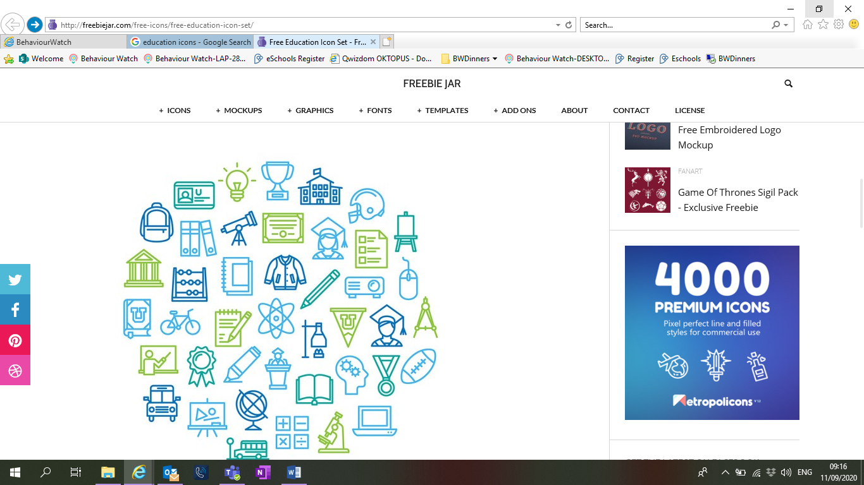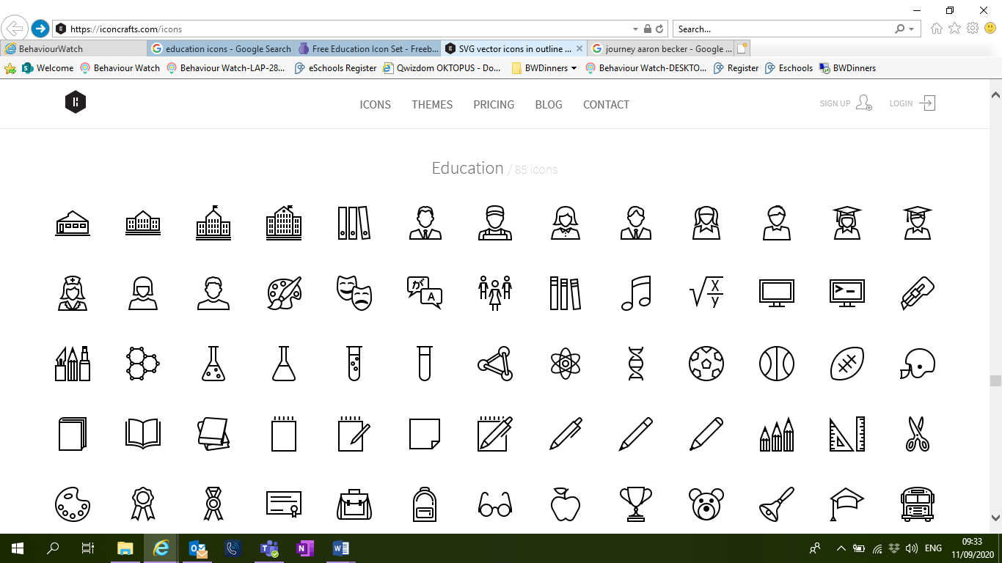

**HISTORY** To explore the impact of Roman invasions on people living within Britain and discover how Anglo-Saxon life developed after the fall of the Roman empire.

**DT** Children will be looking at the material and design for an Anglo-Saxon tunic and making their own.

**PE** This term we are learning the skills for Netball and Gymnastics.

TERM 2: SPACE – Out of this world  
  
BIG QUESTION: What have humans discovered about space?

DESTINATION Create a space website.

**ENGLISH**: This term the children will exploring setting and will write their own narrative from the perspective of the main character from an illustration. We will then be writing a letter from the father to his son, based around the text “Farther” that we are using.

**MATHS:** This term we will be practicing multiplication and division, including multiples, common factors, square numbers and cubed numbers. Then we will move onto fractions and explore equivalent fractions and how to add and subtract fractions.

**SCIENCE**: This term children will be investigating Earth and Space. We will be exploring what causes night and day

**COMPUTING**: In computing this term children will create a website linking to our theme about space and looking at online reputation.

**PSHE: this term we look at what decisions people can make with money.**

**MUSIC:** this term chdn will compose and perform an individual 30 second piece of music about a planet. Inspired by Holst – the planets, using musical notation**.**

**FRENCH**: investigating the masculine & feminine forms, weather, hobbies and Christmas.



**GEOGRAPHY**: This term children are investigating the position and significance of time zones (including day and night).

**ART:** In art the children will be continuing their space theme using polystyrene to create relief printing.

**PE**: After half term we will be continuing our learning of Netball and Gymnastics.