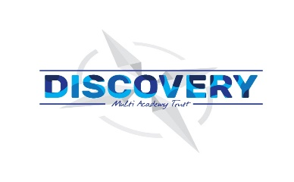

**Weston Mill Community Primary Academy   
Spring Term Learning   
Year 5 ~ 2024-2025**

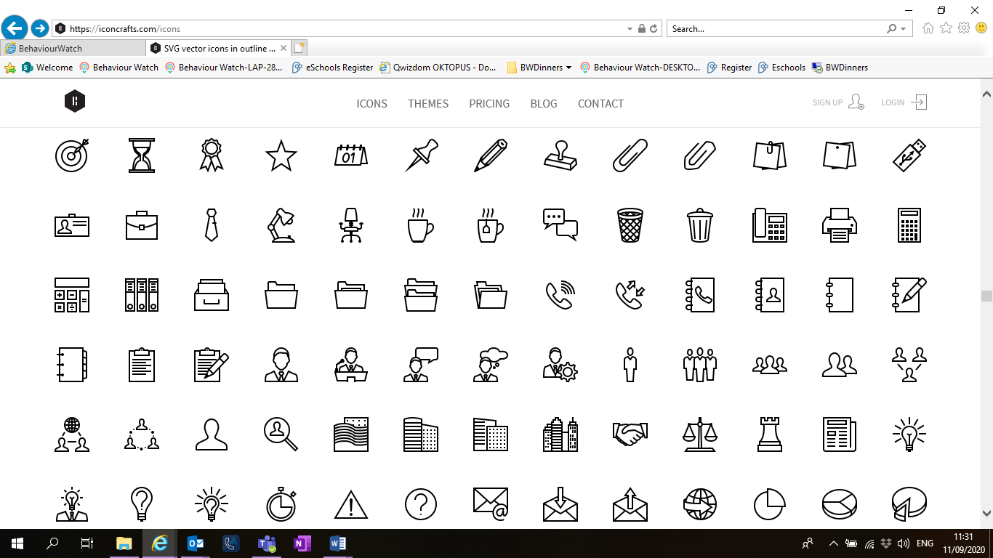

**Spring Term**On the reverse, please find an outline of your child’s learning for Spring Term 3 and 4.

We will be focusing on settling back into school after a great Winter break. We are so pleased to see the children getting on well in their new classes and the progress they have been making so far.

How you can help:  
Reading, times tables and spellings are the main areas you can make a huge difference with at home, and these are what we expect the children to complete as homework each week. Reading books are changed when the children are ready to change their books in school and they have a Reading Diary that they can bring backwards and forwards from school to track their reading at home. Children are still using the Renaissance Reading program. Children should try to read with an adult every day; a good guide is 30 mins per day. It is even more helpful if you can ask them questions about what they have been reading, or to predict what they think will happen next.

Each week, your child will be given a list of spellings for their age group. They are tested once a week, on a Friday. You can really support your child by helping them to learn their spellings at home. A few minutes each evening or as you are walking to or from school will make all the difference.

Children in Y5 will be expected to learn all the times tables up to 12x12 by the end of the year. Each week, the children will have a short times table test and when they have completed three of these with only a few errors, they will move onto their next times table. When they have learnt up to the 12x table, they will have a grid format which helps them remember all their tables. Children have access to a website called Times table Rockstars which they will have their password for, and it helps them to practice their tables in an engaging way. You can also help by listening to the children recite their tables or asking questions for the children to answer.

Reminders / Upcoming Trips and Visits  
*Please join our Facebook page for regular updates about school events and your child’s learning.

*

If you have any questions or would like more information about how to support your child’s learning, please speak to your child’s class teacher at the start/end of the day. For any other questions, please call or email the school office on **01752 365250** or [westonmill.desk@discoverymat.co.uk](mailto:westonmill.desk@discoverymat.co.uk).

PE   
During term 3 we will be attending swimming lessons at Plymouths life centre as part of the National Curriculum. This will happen every day for the first three weeks. The children will continue to participate in PE sessions each week from week 4 of Term 3 onwards. Our topic this term follows the ‘Cambridge PE’ curriculum, focusing on core skills. **On our PE day, Year 5, children will be required to come into school in their PE kit.** The children will be going inside and outside and will need suitable outside kit including trainers or plimsolls. The school PE kit is a white t-shirt, black shorts/jogging bottoms, their school jumper or cardigan, socks and trainers or plimsolls. Hoodies **must not** be worn. Our usual PE days will be **Monday and Thursday**.

TERM 3 : Vikings  
  
BIG QUESTION: Why did invaders settle in Britain.

DESTINATION: Perform a Viking Song.

**ENGLISH** Year 5 will begin by looking at cliffhanger narrative inspired by the hound of the Baskervilles. The focus will be on adverbials, verb prefixes, relative clauses and commas for parenthesis.

**MATHS**: This term children will be continuing to practice Multiplication and Division, Fractions and begin Decimals and Percentages.

**SCIENCE** In Science this term, the children will be investigating the properties of materials. This includes conduction of electricity and insulation.

**COMPUTING** In computing this term, we will be looking at National Online Safety to learn more about cyber bullying and managing online information.

**PSHE** We will be learning about what makes up a person’s identity and RSE

**PE** This term we are Swimming, learning the skills for invasion games and practicing balance and agility through Dance.

**FRENCH** this term we will revisit vocabulary to present ourselves.

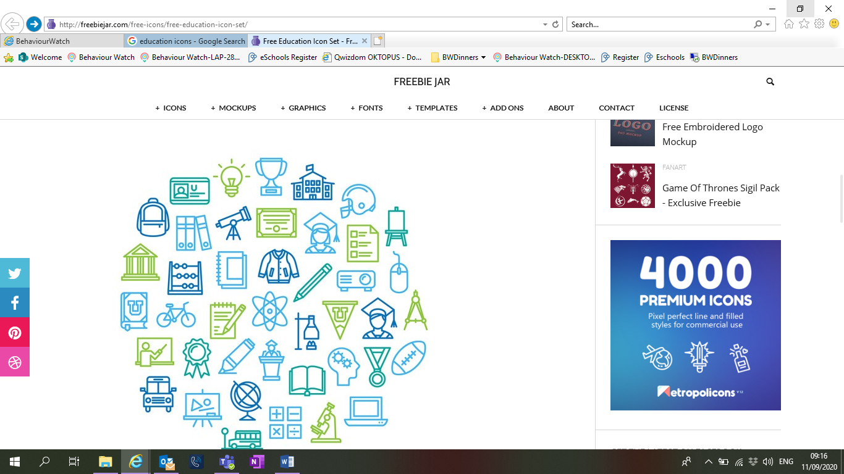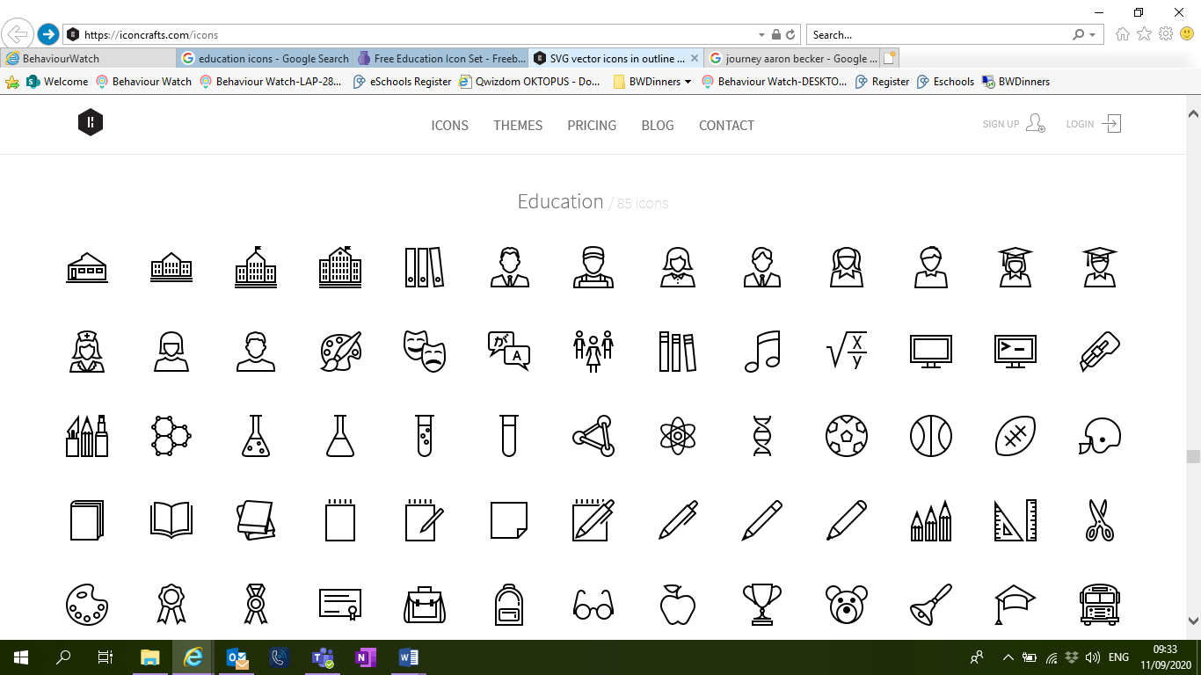

**HISTORY** We will be exploring the invasion of the Vikings; Investigating how, when and why the Vikings invaded and how life in Britain changed because of it.

**Geography** This term we will be plotting Viking settlements and Viking homelands on a map and locatingand labelling countries from United Kingdom and Europe on a map.

**MUSIC** this term we will be learning a Viking song to sing.

TERM 4: Our Changing World  
  
BIG QUESTION: How can I change the world?

DESTINATION To create an environmental radio broadcast.

**ENGLISH**: In English this term the children will exploring Character Narrative and a Bargain letter. The focus will be on verb prefixes, adverbs, modal verbs and adverbials.

**MATHS:** This term we will be continuing to practice Decimals and Percentages and looking at measurement and statistics.

**SCIENCE**: This term children will be investigating Animals, including humans. They will describe the changes as humans experience puberty and develop to old age, drawing a timeline to indicate stages in the growth development. humans.

**COMPUTING**: In computing this term, children will plan and create an environmentally-themed radio interview – (record on Chromebook).

**PSHE:** this term we look at How can friends communicate safely? And the second part of RSE.

**FRENCH**: This term children will be learning how to talk about family.



**GEOGRAPHY**: This term children are investigating the Human & Physical Geography To locate lines of longitude and latitude on maps and atlases.

• Use 4 figure grid referencing, building on our key and symbol knowledge.

• To name and locate major rivers and mountains in the world.

• To explore different temperate zones and how these have changed over time.

• To explore sustainable development and the use of renewable energy.

**ART:** This term the children will be looking at the work of Van Gough and Picasso. To recap and practise colour mixing; primary, secondary and tertiary colours.

**PE**: After half term we will be continuing our learning of Netball and Gymnastics.

