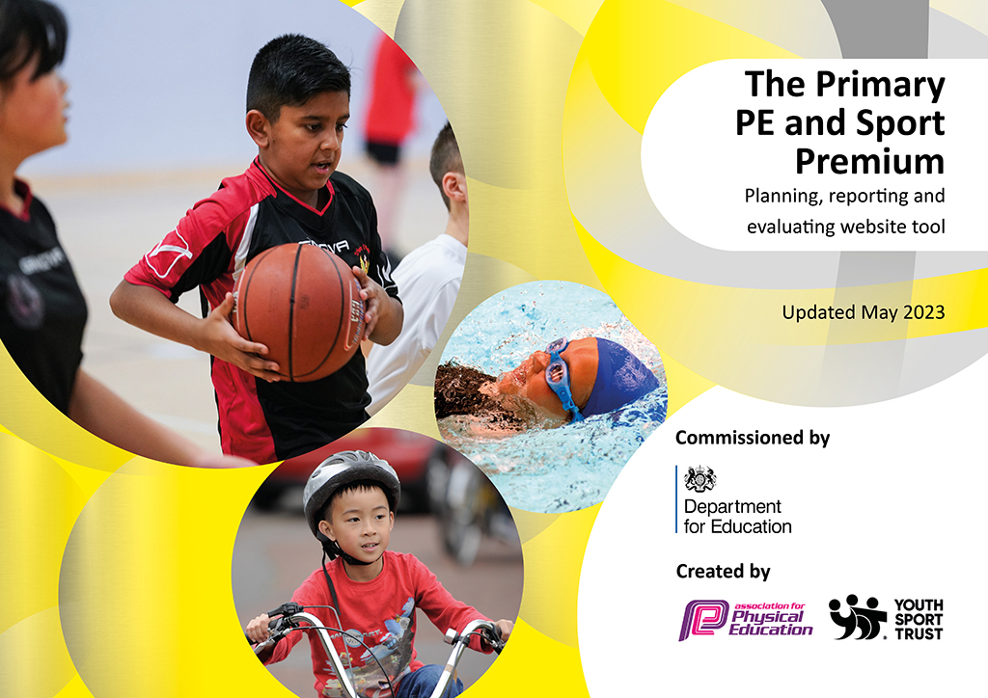
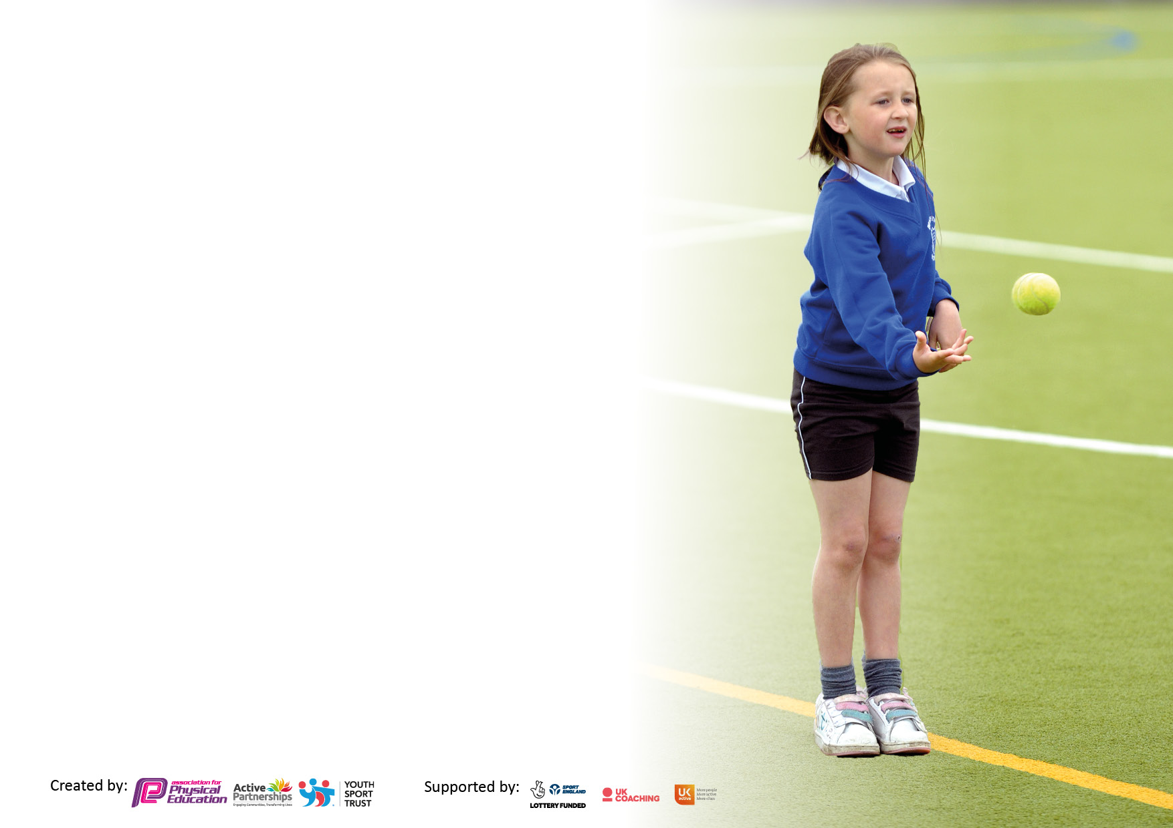

It is important that your grant is used effectively and based on school need. The Education Inspection Framework makes clear there will be a focus on ‘whether leaders and those responsible for governors all understand their respective roles and perform these in a way that enhances the effectiveness of the school’.

Under the Quality of Education Ofsted inspectors consider:
Intent - Curriculum design, coverage and appropriateness
Implementation - Curriculum delivery, Teaching (pedagogy) and Assessment
Impact - Attainment and progress

To assist schools with common transferable language this template has been developed to utilise the same three headings which should make your plans easily transferable between working documents.

Schools must use the funding to make additional and sustainable improvements to the quality of Physical Education, School Sport and Physical Activity (PESSPA) they offer. This means that you should use the Primary PE and sport premium to:

- Develop or add to the PESSPA activities that your school already offer
- Build capacity and capability within the school to ensure that improvements made now will benefit pupils joining the school in future years
- The Primary PE and sport premium should not be used to fund capital spend projects; the school’s budget should fund these.

Please visit gov.uk for the revised DfE guidance including the5keyindicatorsacrosswhichschoolsshoulddemonstrate an improvement. This document will helpyoutoreviewyourprovisionandtoreportyourspend.DfEencouragesschools to use this template as an effective way of meeting the reporting requirements of the Primary PE and Sport Premium.

We recommend you start by reflecting on the impact of current provision and reviewing the previous spend.

Schools are required to publish details of how they spend this funding, including any under-spend from 2021/2022, as well as on the impact it has on pupils’ PE and sport participation and attainment. The funding should be spent by 31st July but the DfE has stated that there will be no clawback of any unspent money so this can be carried forward into 2023/24.

We recommend regularly updating the table and publishing it on your website throughout the year. This evidences your ongoing self-evaluation of how you are using the funding to secure maximum, sustainable impact. Final copy must be posted on your website by the end of the academic year and no later than the 31st July 2023. To see an example of how to complete the table please click HERE.

Details with regard to funding
Please complete the table below.

Total amount carried over from 2021/22 | £0
Total amount allocated for 2021/22 | £18,560 18333.55
How much (if any) do you intend to carry over from this total fund into 2022/23? | £160.81
Total amount allocated for 2022/23 | £ 18,320
Total amount of funding for 2022/23. Ideally should be spent and reported on by 31st July 2023. | £ 18,320
Swimming Data
Please report on your Swimming Data below.

Meeting national curriculum requirements for swimming and water safety.  N.B. Complete this section to your best ability. For example you might have practised safe self-rescue techniques on dry land which you can then transfer to the pool when school swimming restarts.  Due to exceptional circumstances priority should be given to ensuring that pupils can perform safe self rescue even if they do not fully meet the first two requirements of the NC programme of study | Completed in school swimming lessons.
What percentage of your current Year 6 cohort swim competently, confidently and proficiently over a distance of at least 25 metres?  N.B. Even though your pupils may swim in another year please report on their attainment on leaving primary school at the end of the summer term 2023.  Please see note above | 64%
What percentage of your current Year 6 cohort use a range of strokes effectively [for example, front crawl, backstroke and breaststroke]?  Please see note above | 68%
What percentage of your current Year 6 cohort perform safe self-rescue in different water-based situations? | 100%
Schools can choose to use the Primary PE and sport premium to provide additional provision for swimming but this must be for activity over and above the national curriculum requirements. Have you used it in this way? | No

Action Plan and Budget Tracking
Capture your intended annual spend against the 5 key indicators. Clarify the success criteria and evidence of impact that you intend to measure to evaluate for pupils today and for the future.

Academic Year: 2022/23 | Total fund allocated: | Date Updated:
Key indicator 1: The engagement of all pupils in regular physical activity – Chief Medical Officers guidelines recommend that primary school pupils undertake at least 30 minutes of physical activity a day in school |  |  |  | Percentage of total allocation:
 |  |  |  | 18%
Intent | Implementation |  | Impact
Your school focus should be clear what you want the pupils to know and be able to do and about  what they need to learn and to  consolidate through practice: | Make sure your actions to achieve are linked to your intentions: | Funding allocated: | Evidence of impact: what do pupils now know and what can they now do? What has changed?: | Sustainability and suggested next steps:
To provide opportunities to develop children's skills in enrichment sporting activities, whilst developing skills and knowledge. | Provide swimming lessons for children in Year 6. | £2,876.25 | Children have developed essential skills in swimming and water safety, which is captured through assessment data from swimming teachers and school assessment tool. | Look at providing opportunities to swim earlier in the curriculum and provide top-up swimming for children who require further opportunities to practice.
To provide opportunities to develop children's skills in enrichment sporting activities, whilst developing skills and knowledge. | Sailing sessions for children in Year 3 | £500 | Children have the opportunity to develop skills, and engage in physical activity beyond the classroom. | Explore other alternatives to introduce children to a range of different sport or physical activities to promote interest and engagement with physical activity.

Key indicator 2: The profile of PESSPA being raised across the school as a tool for whole school improvement |  |  |  | Percentage of total allocation:
 |  |  |  | 12%
Intent | Implementation |  | Impact
Your school focus should be clear what you want the pupils to know and be able to do and about  what they need to learn and to  consolidate through practice: | Make sure your actions to achieve are linked to your intentions: | Funding allocated: | Evidence of impact: what do pupils now know and what can they now do? What has changed?: | Sustainability and suggested next steps:
To develop PE provision through CPD by PE specialist teachers. | Provide CPD opportunities to develop practice within the delivery of Real PE. | £2,250 | Development of staff subject knowledge to develop PE provision across the school. Engagement and involvements of children in a range of sports. | Development of other sport’s within the curriculum.

Key indicator 3: Increased confidence, knowledge and skills of all staff in teaching PE and sport |  |  |  | Percentage of total allocation:
 |  |  |  | 37%
Intent | Implementation |  | Impact
Your school focus should be clear | Make sure your actions to | Funding | Evidence of impact: what do | Sustainability and suggested
what you want the pupils to know | achieve are linked to your | allocated: | pupils now know and what | next steps:
and be able to do and about | intentions: |  | can they now do? What has
what they need to learn and to |  |  | changed?:
consolidate through practice:
To develop pedagogy of teachers in delivery of PE sessions to have a greater impact on teacher and learning. | Provide CPD opportunities to develop practice within the delivery of Real PE.  Continue to subscribe to Real PE.  Support provided for staff CPD through additional staff | £2,702 | PE coordinator to support staff with the delivery of Real PE and ensure progression is clear.  Gather feedback from staff following CPD sessions to evaluate confidence and areas of development within the teaching of PE. | Review the opportunities within Real PE in the delivery of PE to ensure that it meets the needs of the children and there is appropriate level of challenge.
To develop pedagogy of teachers in delivery of PE sessions to have a greater impact on teacher and learning. | Use PSSP coaches to develop PE CPD for teachers to support areas of development. | £2,250 | Gather feedback from staff following CPD sessions to evaluate confidence and areas of development within the teaching of PE. | Review the use of PSSP coaches to ensure targeted support continues, where needed, and the expertise is ustilised to continue to improve outcomes for all children.
To develop the expertise of the PE coordinator in support staff to have a greater impact on teaching and learning. | Attend PE Deep Dive training. | £175 | Review provision of PE across the school to ensure it is progressive and works to develop skills. | Address any areas of development or opportunities for future training and plan for this throughout the academic year.
To provide staff development opportunities on raising the profile of physical activities and developing a healthy lifestyle. | PLP coaches to lead CPD sessions with targeted year group on healthy eating and engagement in physical activities. | £1,560 | Staff increased confidence in delivering both practical and theory based PE lessons. Children have a greater awareness of what it means to be healthy and make conscious choices to be healthy. | Look at the development of this through PE teaching across the school.

Key indicator 4: Broader experience of a range of sports and activities offered to all pupils |  |  |  | Percentage of total allocation:
 |  |  |  | 25%
Intent | Implementation |  | Impact
Your school focus should be clear | Make sure your actions to | Funding | Evidence of impact: what do | Sustainability and suggested
what you want the pupils to know | achieve are linked to your | allocated: | pupils now know and what | next steps:
and be able to do and about | intentions: |  | can they now do? What has
what they need to learn and to |  |  | changed?:
consolidate through practice:
To improve pupil’s play skills  To increase enjoyment  To improve behaviour during playtime. | Support provided by additional support staff.  Additional play equipment provided to increase opportunities for children to develop skills. | £370.60 | HoS coordinator to monitor and gather feedback from students. | Providing opportunities to different activities during lunchtime and during the day.
To implement a Lunchtime Football Club (Plymouth Argyle) to engage all pupils in team sports. | To provide timetable and equipment needed to ensure that all children have the opportunity to participate in team sport – football. | £4,202 | Development of team activity. Increased engagement in playtime activities and reduction in behaviour incidents at playtime. | Look at developing the provision to promote different sports.

Key indicator 5: Increased participation in competitive sport |  |  |  | Percentage of total allocation:
 |  |  |  | 30%
Intent | Implementation |  | Impact
Your school focus should be clear | Make sure your actions to | Funding | Evidence of impact: what do | Sustainability and suggested
what you want the pupils to know | achieve are linked to your | allocated: | pupils now know and what | next steps:
and be able to do and about | intentions: |  | can they now do? What has
what they need to learn and to |  |  | changed?:
consolidate through practice:
To improve pupil’s play skills  To increase enjoyment  To improve behaviour during playtime. | Support provided by additional support staff.  Additional play equipment provided to increase opportunities for children to develop skills. | £384.15 | HoS coordinator to monitor and gather feedback from students. | Providing opportunities to different activities during lunchtime and during the day.
Increase the number of students that take part in intra school competition | Cover transport / staffing costs. | £750 | PSSP termly report. Match reports shared with parents and online platforms. | Continue the affiliation with PSSP to ensure support to PE coordinator and broad range of events access.
To engage the children in participating in competitive sport over a longer time period. | To promote running within the school, through weekly running club, leading to the Schools Challenge as part of the Plymouth Half Marathon. | £300 | Children sense of achievement in completing the half marathon. | Expanding the provision to enable more children to participate and represent their school.

Signed off by
Head Teacher: | Kathryn Catherwood
Date: | 27/07/2022
Subject Leader: | Kostas Kombostiotis
Date: | 27/07/22
Governor: | Jill Callicott
Date: | 27/07/22

