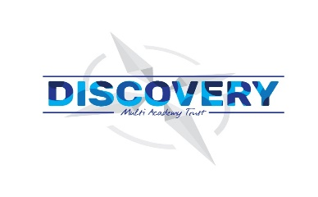

**Weston Mill Community Primary Academy   
Autumn Term Learning   
Year 2 ~ 2024-2025**

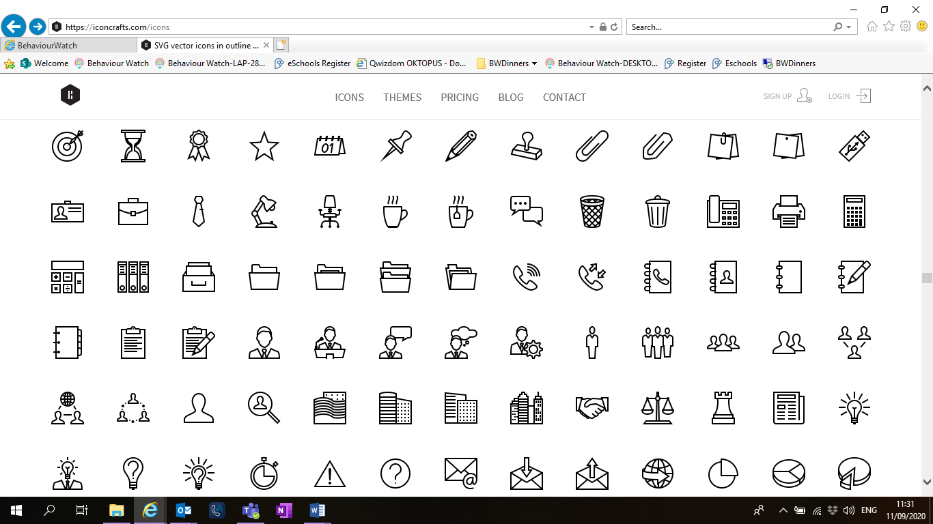

Reminders / Upcoming Trips and Visits  
*Please join our Facebook page for regular updates about school events and your child’s learning.

**Autumn Term**On the reverse, please find an outline of your child’s learning for Autumn Term 1 and 2.

We will be focusing on settling back into school after a great summer break. We are so pleased to see the children getting on well in their new classes and the progress they have been making so far.

How you can help:  
Reading, times tables and spellings are the main areas you can make a huge difference with at home, and these are what we expect the children to complete as homework each week. Reading books are changed when the children are ready to change their books in school and they have a Reading Diary that they can bring backwards and forwards from school to track their reading at home. Children are still using the Renaissance Reading program. Children should try to read with an adult every day; a good guide is 30 mins per day. It is even more helpful if you can ask them questions about what they have been reading, or to predict what they think will happen next.

Each week, your child will be given a list of spellings for their age group. They are tested once a week, on a Friday. You can really support your child by helping them to learn their spellings at home. A few minutes each evening or as you are walking to or from school will make all the difference.

Children in Y2 will be expected to learn the x10, x2 and x5 times tables by the end of the year. Each week, the children will have a short times table test and when they have completed three of these with only a few errors, they will move onto their next times table. When they have learnt these 3, they can move on to the next time table. Children have access to a website called Times table Rockstars which they will have their password for, and it helps them to practice their tables in an engaging way. You can also help by listening to the children recite their tables or asking questions for the children to answer.

If you have any questions or would like more information about how to support your child’s learning, please speak to your child’s class teacher at the start/end of the day. For any other questions, please call or email the school office on **01752 365250** or [westonmill.desk@discoverymat.co.uk](mailto:westonmill.desk@discoverymat.co.uk).

PE   
The children will continue to participate in PE sessions each week. Our topic this term follows the ‘Cambridge PE’ curriculum, focusing on core skills. **On our PE day, Year 2, children will be required to come into school in their PE kit.** The children will be going inside and outside and will need suitable outside kit including trainers or plimsolls. School PE kit is a white t-shirt, black shorts/jogging bottoms, their school jumper or cardigan, socks and trainers or plimsolls. Hoodies **must not** be worn. Our usual PE days will be **Tuesday and Wednesday**.

TERM 1: Our Great Britain  
  
BIG QUESTION: Why is Britain Great?

DESTINATION: To create a leaflet to share with another year group.

ENGLISH: In Writing this term we will be studying a book called “A River” with our outcomes being a circular narrative and a letter. In Reading, we will be looking at a book by Dick King-Smith, called The Hodgeheg.

MATHS: This term the children will be working on place value and progressing onto addition and subtraction. We will be looking at numbers up to 100 and exploring how 2-digits numbers are made of Tens and Ones.

SCIENCE: In Science this term, the children will be investigating all about living things and their habitats.

COMPUTING: In computing this term, we will be learning how to log on to chrome books and practicing typing skills.

PSHE: We will be learning about how to be good friends.

MUSIC: In music this term we will be looking at the British National Anthem. We will learn and sing the British National Anthem and national songs e.g. Rule Britannia.

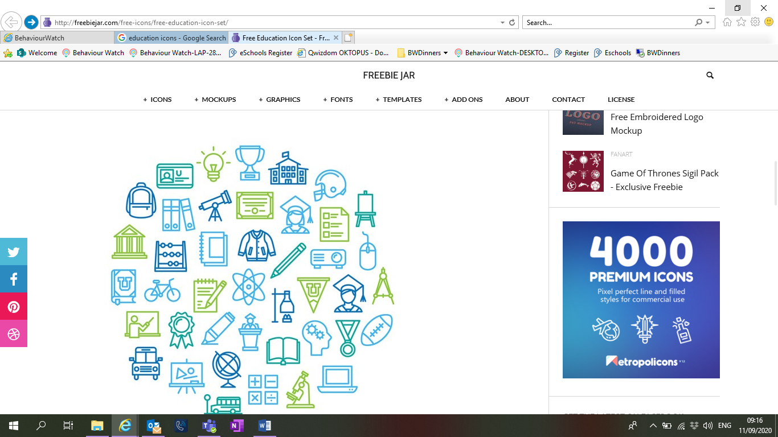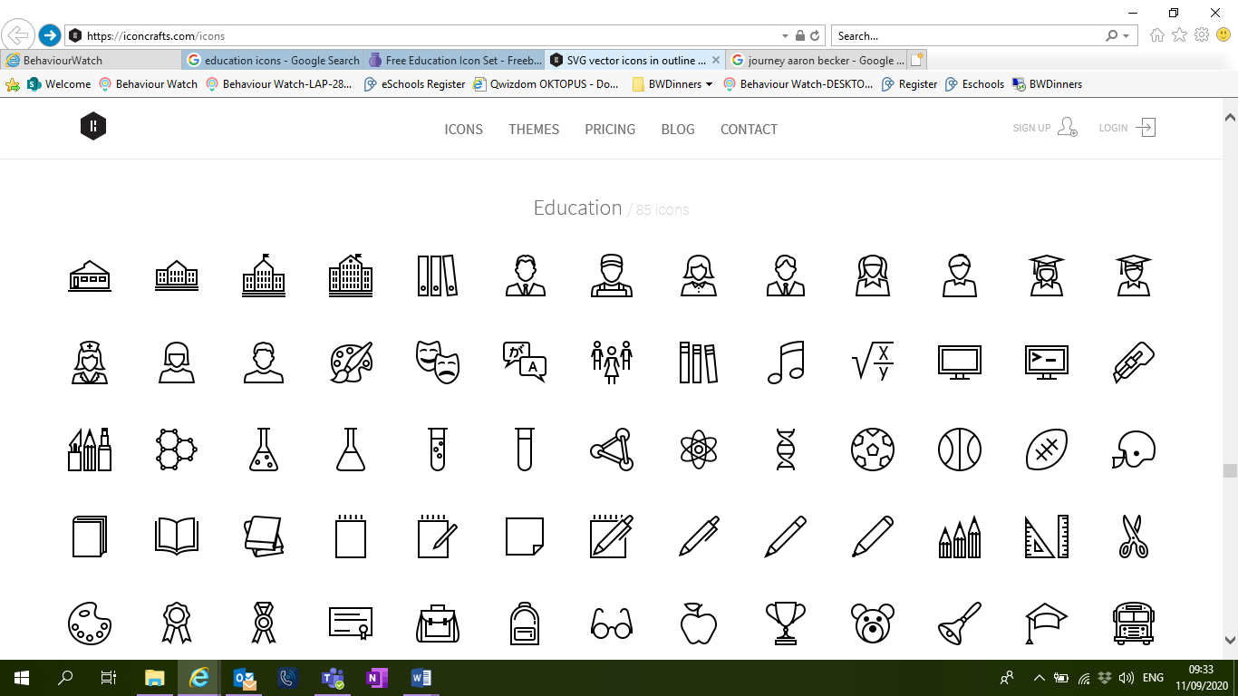

HISTORY: To understand where kings and queens fit into chronological order. To investigate key events in a monarch’s life and what impact that that had on society. To compare the lives of 2 monarchs (e.g. Elizabeth and Victoria). To discover how democracy in the UK has developed over time. – Houses of parliament and the gunpowder plot.

DT: We won’t be doing any DT this term.

PE: In PE this term we will covering Gymnastics in our indoor session and Fundamental Skills in our outdoor session.

TERM 2: British Bridges  
  
BIG QUESTION: What makes a bridge strong?

DESTINATION: To build bridges with parents and test their strength.

ENGLISH: In Writing this term we will be studying a book called “The Night Gardener”. Children will write a setting narrative and a diary. In Reading, we will be looking at a book by Barbara Henderson, called Rivet Boy.

MATHS: In Term 2 we will continue to look at addition and subtraction before we move to look at shape. Children will be learning to add and subtract across a 10. Then they will be learning about 2D and 3D shapes and their properties.

SCIENCE: **Use of everyday materials**

We will explore material properties and identify key uses for that material. To identify the best material to construct a bridge and explain their choice.

COMPUTING: Children will learn how to use an appropriate programme to create a picture of a bridge (Paint).

PSHE: We will be learning about bullying and how to recognise hurtful behaviour, including online.

MUSIC: Ship on the Ocean - Mike Reinstein & Reina James-Reinstein In Music we will be singing songs collaboratively. We also explore melody, pulse and rhythm.



DT: We will design, make, test a bridge for a purpose. We will build structures, exploring how they can be made stronger, stiffer, more stable. And finally, we will evaluate a product against a design brief.

PE: In PE this term we will covering Gymnastics in our indoor session and Fundamental Skills in our outdoor session.