Discover what’s on for families at Best Start Family Hubs!
What is a Best Start Family Hub?
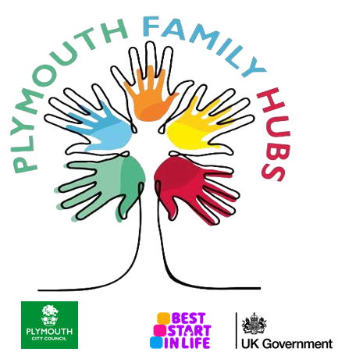
Family Hubs support families from pregnancy, through childhood, and up to age 19 (or 25 for those with special educational needs and disabilities). Whether it's free classes, events and activities, help with your children before they start school or finance and housing advice - the hubs will provide wrap around support either providing the service directly or connecting you to the right local support.

Our Plymouth Family Hub website is the best place to keep up to date with our face‑to‑face and virtual offer. Visit Family Hubs | PLYMOUTH.GOV.UK to find the latest information. You can also view our current timetable and contact details below.

Are you aware that Best Start Family Hubs are here to support you in your local area...
We have 11 Family Hubs across the city:
- DELL Family Hub (Efford)
- Four Woods Family Hub (West Park)
- Green Ark Family Hub (Devonport)
- Manor Street Family Hub (Stonehouse)
- Morice Town Family Hub (Devonport)
- Nomony Family Hub (Cattedown)
- North Prospect Family Hub (North Prospect)
- Rees Family and Wellbeing Hub (Plympton)
- Southway Family and Wellbeing Hub (Southway)
- The Barn Family Hub (Barne Barton)
- Whitleigh Family and Wellbeing Hub (Whitleigh)

Find a Family Hub | PLYMOUTH.GOV.UK

We also have a number of satellite sites in community-based locations, working alongside Family Hubs to give families more flexible and accessible ways to connect with us. Many satellite sites offer activities linked to their nearest main hub, such as parenting courses, coffee mornings and play groups. You can find these alternative venues at the end of the ‘Find a Family Hub’ list.

How a Best Start Family Hub can support you and your family

Your local Family Hub has:
- Practical help from professionals and peer supporters
- Guidance on creating a positive home learning environment
- Breast feeding and infant feeding support
- Equipment on loan for example, breast pumps

- Face to face support, to talk through your family’s needs and agree a plan that works for you
- Activities and groups for the family, and links with organisations across the city that offer fun, inclusive opportunities for all ages and needs, including SEND
- Access to extra help if things get difficult
- Connections to community services enabling wider support

What to expect
- Friendly, welcoming staff who are available to talk about anything you may be worried about. Family Hubs offer a “one-stop shop” of services, and there are no wrong questions.
- A range of support formats to suit you: drop‑ins, support groups, bookable courses, and outreach, with the option to attend alone or bring your children. Please refer to our timetable or contact us to find out more about specific services such as crèches. Activities take place across our Family Hubs and satellite sites, including libraries and other community venues.
- Support for parents, carers, grandparents and wider family members, recognising that every family is unique.

Family Hubs are here to support families early, so small worries do not grow into bigger ones. “The right support at the right time in the right place” means helping you and your family find what works best for you, when you need it.
At family hubs, this means:
- The right thing to do: reaching out for help, advice or reassurance whenever you need it.
- The right time: accessing support early, whether during pregnancy, starting school or as soon as things start to feel difficult.
- The right support: receiving help from the people who know you best, with additional professional support available if it’s needed.

Online resources
Family Hubs offer online support alongside our in-person services. Visit our website for the latest information about Plymouth Family Hubs.gov.uk

Explore our padlets, these are up to date virtual bulletin boards for various topics surrounding local support:
Best Start Family Hubs Timetable : A city-wide timetable, kept up to date on our available support groups, activities, events.

Family Hub SEND Support in Plymouth : Information for families where you might be worried about your child's development, or where your child has a diagnosis with SEND (special educational needs and disabilities)
Plymouth Family Hubs Home Learning (PEEP) : For parents/carers with children from birth to five. An online space for our PEEP play groups where ideas and activities are shared to support your child’s development and learning.

Plymouth Best Start Family Hub Infant Feeding : Infant feeding resources including our supportive videos, helpful links, latch-on group and breast pump hire details.

Plymouth Best Start Family Hubs Antenatal Services and Information : For expectant families, see more on what support we can provide and navigation around Plymouth’s antenatal services.

Best Start Family Hub Parenting Programmes : We offer many parenting courses that are evidenced based and support families to become confident on child development and emotional needs.


Togetherness is an NHS online platform offering evidence‑based emotional‑health learning for parents, families and young people. Developed by psychologists and other professionals, it helps you understand your child’s development and emotions, supporting healthier relationships and emotional wellbeing.
These pathways begin in the antenatal stage up to teenagers, with a teenage learning pathway for them to better understand their changing brain and support emotional health.
To explore the courses available to you, use this link: Pathways library - Togetherness
Free access using code ‘TAMAR’

Other useful websites:

These national websites offer online parenting toolkits for families with children and young people. They include trusted advice linked to pregnancy, early years, parenting and family support, and are run by organisations involved in delivering Family Hubs services locally:
- Best Start in Life : Government information and guidance for families from pregnancy through the early years.
- Parent Talk : Practical advice and support for parents and carers from Action for Children.
- Family Space : Online information and support for families from Barnardo’s.

Kooth.com : Young people can access online support including one-to-one counselling, peer discussion boards, self-help content, journals and goal trackers.

Bitesize Parenting : An engaging platform for parents and carers, exploring a range of topics on school life, wellbeing, transitions, SEND through podcasts including the Parenting Teens pod, articles and short video clips.

Tiny Happy People: For families with children aged 0-5, this CBeebies page offers lots of fun advice and activities to support child development and learning.

How to contact Best Start Family Hubs for further information

- Contact a Family Hub directly. Contact details listed under each hub here

- Email: familyhubs@plymouth.gov.uk

- Contact us on Facebook

- Speak to your family support worker within the school

