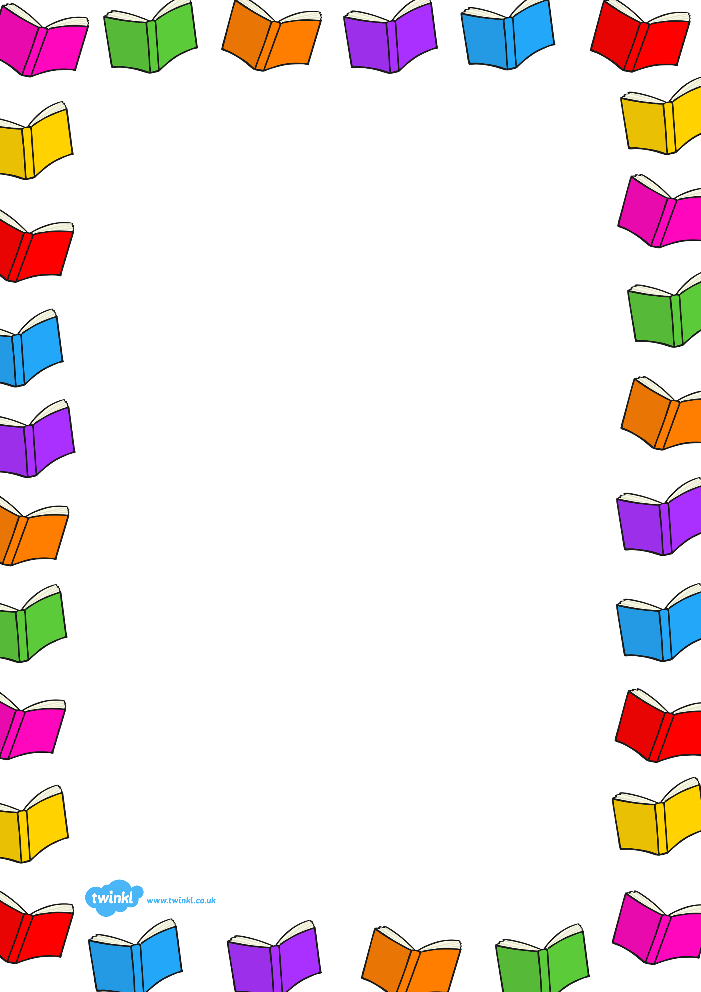
In order to borrow a book you must bring your planner/reading log to school every day as it will have a bar code unique to you.
Once you have chosen a book in the library you must scan that book’s barcode then scan the bar code on your planner. The computer screen will display ‘issued’ if done correctly.
Once you have borrowed a book that must come into school every day as you may need to read it during class time.
To return a book simply scan the barcode on the book, the computer screen will display ‘returned’ and place the book in the trolley. This is important or the library system will think you still have the book.
Each child can borrow one book at a time and borrow it for up to two weeks.
After this time the book must be renewed or returned, or you will get a reminder letter.
Reminder 1 is issued on the first day the book is overdue.
Reminder 2 is issued when the book is a week overdue.
Reminder 3 is issued when the book is two weeks overdue.
Reminder 4 is issued when the book is three weeks overdue.
This is what the reminder letters will look like:
Overdue Reminder 1
Reminder for Name of Child of Name of Class and Year.

Dear Name of Child,
The item below is now overdue.
Please return to the library as soon as possible.
If you require longer to read the item you could renew it.
Thank you,
Library Manager.
Overdue Reminder 2
Reminder for Name of Child of Name of Class and Year.

Dear Name of Child,
The item below is still overdue.
Please return it to the library immediately.
Thank you,
Library Manager.

Overdue Reminder 3
Reminder for Name of Child of Name of Class and Year.

Dear Name of Child,
Despite several reminders, the item below has not been returned.
Please contact the library immediately or your parent/carer will be asked to (voluntarily) replace the item borrowed.
Thank you,
Library Manager.

Overdue Reminder 4
Reminder for Name of Child of Name of Class and Year.

Dear Parent/Carer,
Despite several reminders, the item below has not been returned to the library.
A voluntary replacement of the item would be greatly appreciated by all the other library users.
Thank you,
Library Manager.

