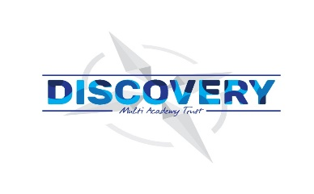

**Weston Mill Community Primary Academy   
Autumn Term Learning   
Year 6 ~ 2024-2025**

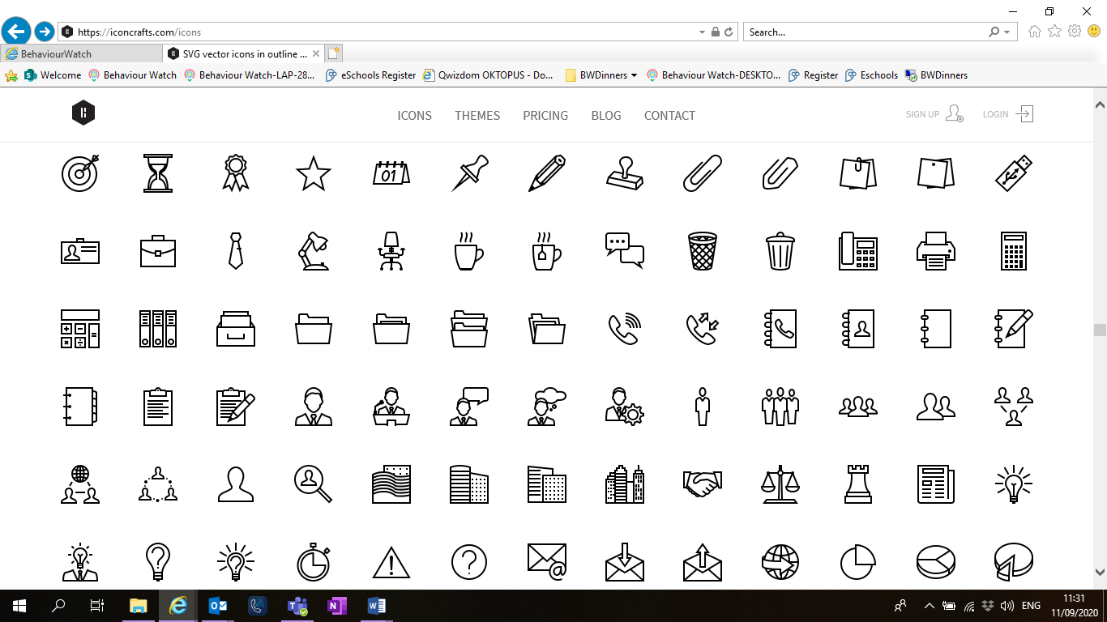

**Autumn Term**On the reverse, please find an outline of your child’s learning for Autumn Term 1 and 2.

We will be focusing on settling back into school after a great summer break. We are so pleased to see the children getting on well in their new classes and the progress they have been making so far.

How you can help:  
Reading, times tables and spellings are the main areas you can make a huge difference with at home, and these are what we expect the children to complete as homework each week. Reading books are changed when children have completed a reading quiz. This will also be how we are tracking their reading progress. Children are still using the Renaissance Reading program. Children should try to read with an adult every day; a good guide is 30 mins per day. It is even more helpful if you can ask them questions about what they have been reading, or to predict what they think will happen next.

Each week, your child will be given a list of spellings for their age group. They are tested once a week, on a Friday. You can really support your child by helping them to learn their spellings at home. A few minutes each evening or as you are walking to or from school will make all the difference.

Children in Y6 will have further homework to help support them for both Y6 SATs and also the preparation for secondary school. Furthermore, each week, the children will have a short times table test and when they have completed three of these with only a few errors, they will move onto their next times table. When they have learnt up to the 12x table, they will have a grid format which helps them remember all their tables. Children have access to a website called Times table Rockstars which they will have their password for, and it helps them to practice their tables in an engaging way. You can also help by listening to the children recite their tables or asking questions for the children to answer.

Reminders / Upcoming Trips and Visits  
*Please join our Facebook page for regular updates about school events and your child’s learning.

*There will be a Y6 SATs Parent Information later in the year.

If you have any questions or would like more information about how to support your child’s learning, please speak to your child’s class teacher at the start/end of the day. For any other questions, please call or email the school office on **01752 365250** or [westonmill.desk@discoverymat.co.uk](mailto:westonmill.desk@discoverymat.co.uk).

PE   
The children will continue to participate in PE sessions each week. Our topic this term follows the ‘Cambridge PE’ curriculum, focusing on core skills. **On our PE days, Year 6, children will be required to come into school in their PE kit.** The children will be going inside and outside and will need suitable outside kit including trainers or plimsolls. School PE kit is a white t-shirt, black shorts/jogging bottoms, their school jumper or cardigan, socks and trainers or plimsolls. Hoodies **must not** be worn. Our usual PE days will be **Monday and Thursday.**

TERM 1: Dartmoor  
BIG QUESTION: What is the importance of Dartmoor to the local residents?  
DESTINATION: Field study of Dartmoor.

ENGLISH Year 6 will be focusing on the vehicle text: Rose Blanche. They will be writing a diary entry and a bravery award speech. We will also be continuing our reading fluency, beginning with War Horse.

MATHS: This term the children will be working on Place Value up to 1,000,000. Children will initial explore these numbers before reading and writing them, rounding and comparing them.

SCIENCE In Science this term, the children will be investigating living things and their habitats.

COMPUTING In computing this term, children will be continuing looking at internet safety.

PSHE Children will be learning how to keep healthy as we grow.

MUSIC Children will be finding out about the history of folk music. We will begin bu listening to the music and composing our own pieces.

FRENCH Children will be continuing to learn French this term, focusing on the basic conversational skills.

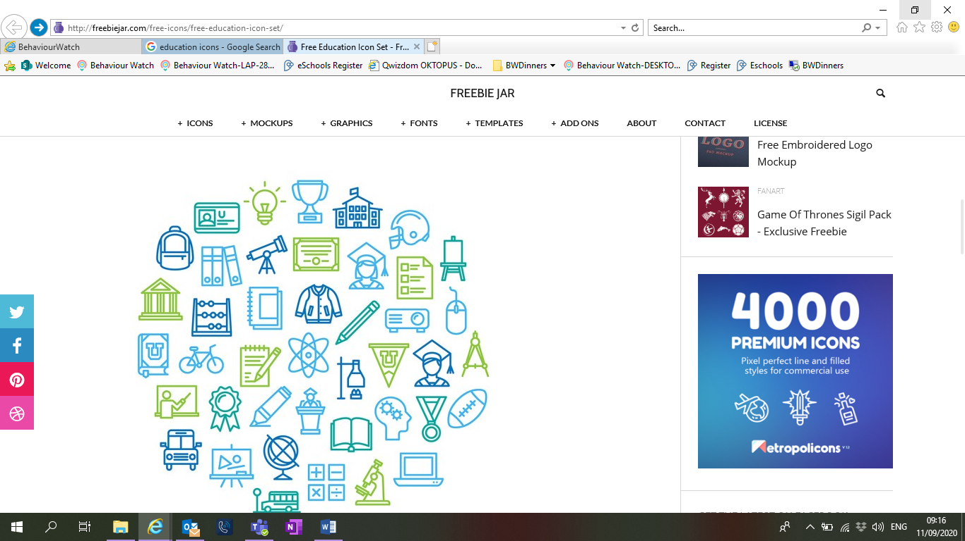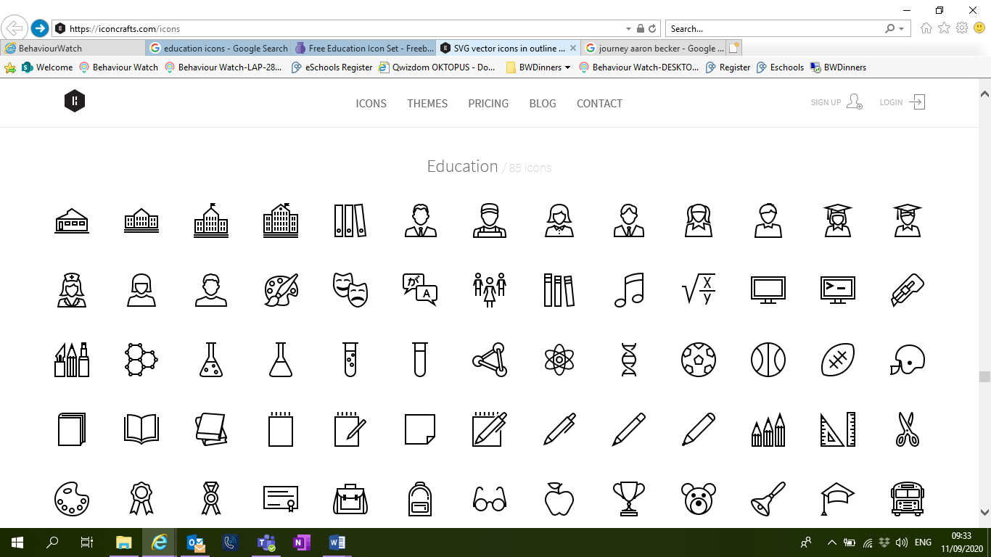

GEOGRAPHY This term, children will be using the 8 compass points and ordnance survey maps to support fieldwork.

DT Year 6 will be researching, designing, making and evaluating Dartmoor bridge structures.

PE Year 6 will build upon out fundamental skills, in team games.

TERM 2: Tudors: Port of Plymouth  
BIG QUESTION: Why did the Mayflower leave Plymouth?

DESTINATION: To create a verbal/visual performance of the Mayflower journey.

ENGLISH: In reading, children will be practising their fluency with stories such as The Secret Diary of Thomas Snoop.

MATHS: This term, the children will be working on a selection of methods using fractions, including multiplying and comparing mixed number fractions.

SCIENCE: Year 6 will be learning about Electricity this term and will be conducting a voltage experiment!

COMPUTING: Children will create a presentation using Google slides.

PSHE: Children will continue learning how to keep healthy. RSE Puberty, Relationships, Reproduction.

MUSIC: Children will be appreciating and listening Tudor music and creating and singing a Tudor song.

ART Children will be creating portraits using pastel/collage techniques.



HISTORY: Children will be ordering significant events of the Plymouth Tudors on a timeline leading up to Mayflower leaving Plymouth and comparing events that happened across this time period.

DT: During this term, children will research, design, make and evaluate a Tudor purse as they explore textiles.

PE: Invasion games and Gymnastics.