**Spring Term**On the reverse, please find an outline of your child’s learning for Spring Term 3 and 4.

We will be focusing on further developing the children’s oracy skills encouraging them to ask questions and investigate to find answers. It has been so wonderful to see the children come back all excited and ready to learn.

**How you can help: Please see below and attached home learning activity sheets for further ideas.**

**Personal Social and Emotional Development** – Encourage talk about thoughts and feelings.

**Literacy** – Every Friday we will send a library book home for you to read and discuss with your child. Also at an appropriate time for your child, there will also bring home a Read Write Inc book, this could be a sound blending book, a ditty photocopy or a coloured book that the children will be able to read to you.

**Communication and Language** – Sing songs, read a variety of books, and make time to talk.

**Math** – Count objects at home and in the community. Look for patterns and shapes in the world. Play mathematical games involving dice, counting, number matching and identification.

**Understanding the World** – Talk about the changes your child is noticing in the world around them (e.g. look for signs of Winter/Spring). Talk about family and special family events they have experienced (e.g. birthdays, holidays, get-togethers). Talk about the past and the present and old and new. Encourage them to ask questions and explore how things work around them.

**Physical Development** – Spend time exploring movement (e.g. running, stepping, climbing, balancing). Encourage independence, for example dressing and undressing and using cutlery at mealtimes.

**Expressive Arts and Design** – Look for colours in the environment. Sing, dance and retell stories.

You can also encourage your child to use counting objects at home and look for numbers and shapes in the world around them (e.g. on the walk to school). Children are very interested in the world around them ask them what they can see and what might be different throughout the time of day and seasons. Mathematical games involving dice, counting, number matching and identification (e.g. bingo, dominoes, snakes and ladders) can also be fun!

**Weston Mill Community Primary Academy   
Spring Term Learning   
Reception ~ 2024-2025**

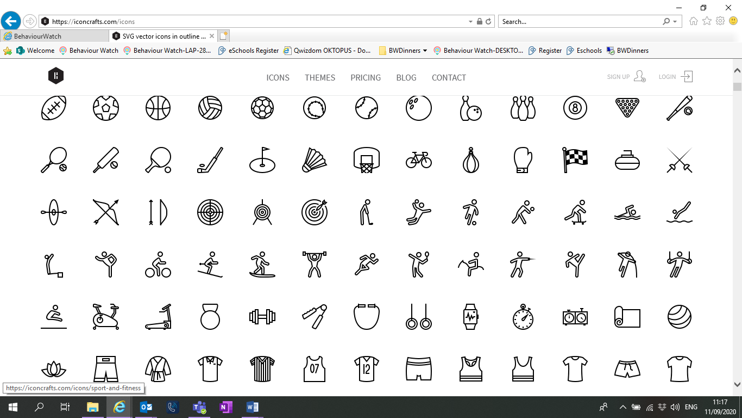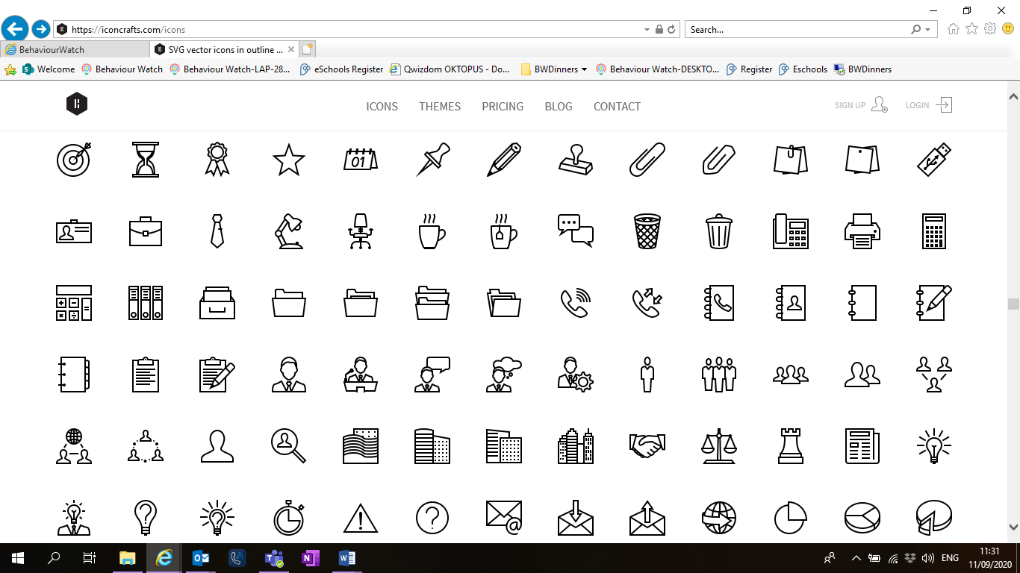

Reminders / Upcoming Trips and Visits  
*Please join our Facebook page for regular updates about school events and your child’s learning.

* We will be having a ‘wow’ dress up day exploring Space and what it’s like to be an astronaut. The children can come to school dressed as an astronaut, alien or something you would find in space! Our Wow day is Thursday 13th February.
* In term 4 we will be going on a trip to the local Garden Centre and creating own our garden, learning how to care for plants to help them grow. Details to follow. 

If you have any questions or would like more information about how to support your child’s learning, please speak to your child’s class teacher at the start/end of the day. For any other questions, please call or email the school office on **01752 365250** or [westonmill.desk@discoverymat.co.uk](mailto:westonmill.desk@discoverymat.co.uk).

PE   
The children will participate in PE sessions each week. **On our PE day, Wednesday, children will be required to wear their PE kit in school for the whole day.** The children will be inside and will need suitable outside kit, including trainers or plimsolls. School PE kit is a white t-shirt, black or blue shorts and trainers or plimsolls. As well as our PE session the children will take part in other indoor and outdoor activities during the week, which will be completed in school uniform. With the changeable weather please ensure your child has a named waterproof coat in school daily. As part of our learning we will be getting outside in nature and exploring the local area. Please could your child have a labelled pair of wellies that could be stored in school, for use during Welly Walk Time and outdoor learning activities. **Please ensure all uniform, PE kit and wellies are named.**

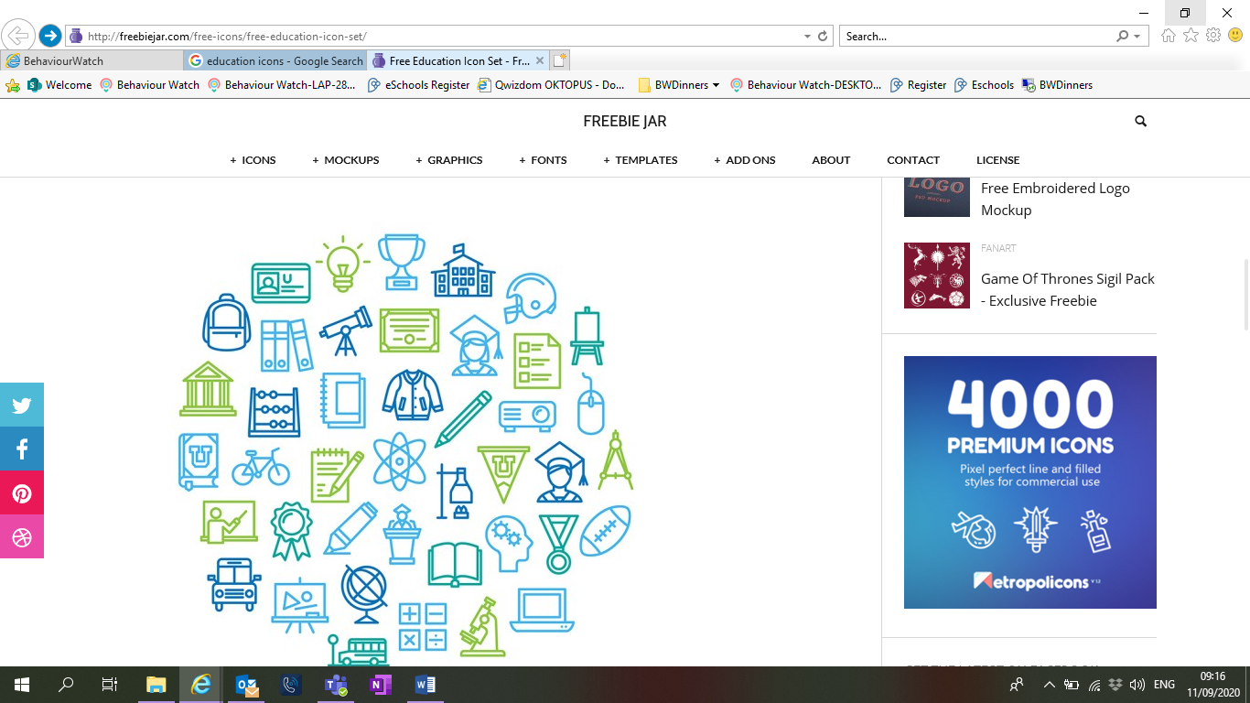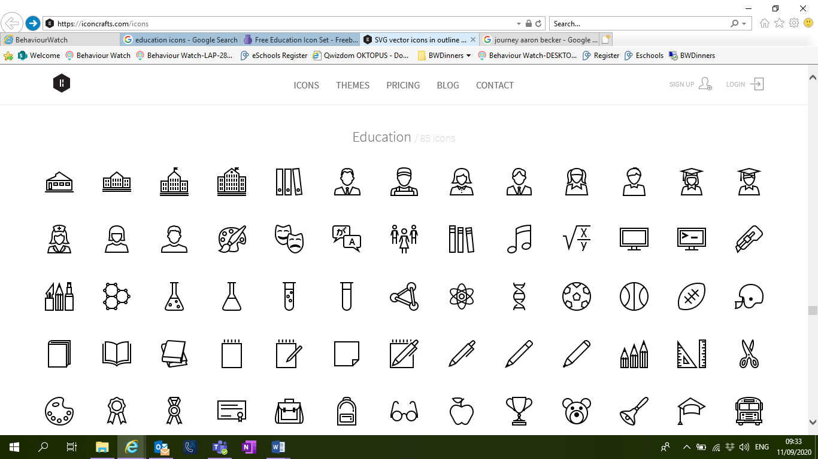

PHYSICAL DEVELOPMENT –

* Putting on our jumpers/cardigans and coats independently and practicing doing our zips and buttons,
* PE Dance – special awareness, levels, turns.
* PE Fundamentals – games.

PERSONAL, SOCIAL AND EMOTIONAL DEVELOPMENT –

* Continue to learn how to share, building constructive and respectful relationships.
* Noticing and celebrating differences between each other.

EXPRESSIVE ARTS AND DESIGN –

* Return to and build on previous learning, refining their ideas (technique, colour, design and texture).
* Develop storylines in their play.
* Use props to support role play.
* Artist Study – Jackson Pollock

TERM 4: Things that Grow

Books:

‘Jack and the Beanstalk’

‘The Enormous Turnip’ – Katie Daynes

‘Eddie’s Garden’ – Sarah Garland

UNDERSTANDING THE WORLD –

* Know where vegetables grow around the world.
* Draw and label pictures of flowers/plants.
* Engage in an investigation/enquiry.
* In RE we will why is Easter special to Christians?

UNDERSTANDING THE WORLD –

* Name some of the things in space.
* Fizzing planet experiment.
* Use our senses to explore the natural world.
* Noticing seasonal changes, such as the weather.
* In RE we will explore, which places are special and why?

PERSONAL, SOCIAL AND EMOTIONAL DEVELOPMENT –

* To understand how to care for living things.
* To understand why making healthy food choices is important.

EXPRESSIVE ARTS AND DESIGN –

* Engage in process driven art activities; paint, collage, drawing, chalk/ pastels, junk modelling.
* Artist study – Henri Matisse.

TERM 3: To Infinity and Beyond

Books

‘Aliens Love Underpants’ – Claire Freedman

‘How to Catch a Star’ – Oliver Jeffers.

‘Welcome to Alien School’ – Caryl Hart

PHYSICAL DEVELOPMENT –

* PE Dance – special awareness, levels, turns.
* PE Fundamentals – games.

COMMUNICATION AND LANGUAGE –

* Retelling stories and narratives.
* Engage in non-fiction texts about plants and the life cycle of a butterfly.
* Use new vocabulary during discussion around non- fiction.

LITERACY –

* Daily ‘Read, Write, Inc’ sessions where we will continue to learn the Set 1 sounds or progress to Set 2 sounds. During these sessions we will practice reading red words, green words, alien words and ‘holding a sentence’.
* Using finger spaces, capital letters and full stops.
* Engaging in non-fiction texts.

MATH –

* Length, height, and time.
* Consolidate number skills and develop a deep understanding of composition.
* Counting to 20 and beyond.

COMMUNICATION AND LANGUAGE –

* Retell a story, once they have developed a deep familiarity with the text, some as exact repetition and some in their own words.
* Engage in story times by listening and responding appropriately to questions.
* Ask questions to find out more and check understanding.
* Engage in non-fiction texts about space.

LITERACY –

* Daily ‘Read, Write, Inc’ sessions where we will continue to learn the Set 1 sounds or progress to Set 2 sounds. During these sessions we will practice reading red words, green words, alien words and ‘holding a sentence’.
* Writing words and captions.
* Listening to and talking about books.
* Using new vocabulary in different contexts.

MATHS –

* Subitise
* Explore composition of numbers to 5 and beyond.
* Mass and capacity.