Discovery MAT – Design & Technology Curriculum Statement
Quote that guide us:
‘Good buildings come from good people, and all problems are solved by good design.’ Stephen Gardiner (British Architect)

‘High-quality design and technology education makes an essential contribution to the creativity, culture, wealth, and well-being of the nation.’ National Curriculum.

Why is it important to teach Design & Technology? (Intent)
Design and Technology is an inspiring, rigorous and practical subject. D&T should provide all children with a real-life and relevant context for learning. We encourage children to use their inquiry, observation, creativity, problem-solving, flexibility, and collaboration skills to design and make products that solve real and relevant problems within a variety of contexts, considering their own and others’ needs, wants, and values. Through the D&T curriculum, children should be inspired by engineers, designers, chefs, and architects to enable them to create a range of structures, mechanisms, textiles, electrical systems, and food products with a real-life purpose.

Key Concepts:
- Using creativity and imagination, pupils design and make products that solve real and relevant problems within a variety of contexts, considering their own and others’ needs, wants and values.
- They acquire a broad range of subject knowledge and draw on disciplines such as mathematics, science, engineering, computing, and art.
- Pupils learn how to take risks, becoming resourceful, innovative, enterprising, and capable citizens.
- Through the evaluation of past and present design and technology, they develop a critical understanding of its impact on daily life and the wider world.
Curriculum Design (Implementation)
Our D&T curriculum provides a clear and comprehensive document that will show progression of skills and vocabulary across all key stages within the strands of D&T. All teaching of D&T follows the design, make, and evaluate cycle. Each stage is rooted in technical knowledge. The design process is rooted in real-life, relevant context and linked with our topic to ensure meaning and purpose to the learning. While making, children are provided with choice of a range of tools to choose freely from. To evaluate, children evaluate their finished products against a design criterion. Each of these stages are given equal weight.

In KS1 this looks like:

Design
- design purposeful, functional, appealing products for themselves and other users based on design criteria
- generate, develop, model and communicate their ideas through talking, drawing, templates, mock-ups and, where appropriate, information and communication technology
Make
- select from and use a range of tools and equipment to perform practical tasks (for example, cutting, shaping, joining and finishing).
- select from and use a wide range of materials and components, including construction materials, textiles and ingredients, according to their characteristics

Evaluate
- explore and evaluate a range of existing products
- evaluate their ideas and products against design criteria

In KS2 this looks like:

Design
- use research and develop design criteria to inform the design of innovative, functional, appealing products that are fit for purpose, aimed at particular individuals or groups
- generate, develop, model and communicate their ideas through discussion, annotated sketches, cross-sectional and exploded diagrams, prototypes, pattern pieces and computer-aided design
Make
- select from and use a wider range of tools and equipment to perform practical tasks (for example, cutting, shaping, joining and finishing), accurately
- select from and use a wider range of materials and components, including construction materials, textiles and ingredients, according to their functional properties and aesthetic qualities
Evaluate
- investigate and analyse a range of existing products
- evaluate their ideas and products against their own design criteria and consider the views of others to improve their work
- understand how key events and individuals in design and technology have helped shape the world

Knowledge Focused
To ensure clear sequences of learning, key skills and key knowledge for D&T have been mapped across the Discovery MAT wide progression document, which is used to plan sequences of lessons. These give small steps that build towards key end points that link to the National Curriculum. These break down the National Curriculum statements into smaller steps. Key vocabulary is identified for each year group.

What we do well as a Trust (Impact)
As a MAT, we aim to create an inquisitive learning environment within our classrooms and reinforce the understanding that they are a supportive place to plan, implement and adapt ideas and learn. The study of D&T across the MAT allows our pupils to safely experience the wide range of skills and knowledge encompassed by this practical subject. All the D&T sequences have been planned and designed carefully to ensure they correlate with themes of learning and often have many cross-curricular links, particularly with History, Geography and Science. As well as each sequence of lessons being purposeful, we ensure they are relevant and modern in many ways.

 | Design & Technology Curriulum & EYFS Framework
 | EYFS |  |  | KS1 |  |  | KS2
 |  |  |  | Through a variety of creative and practical activities, pupils should be taught the knowledge, understanding and skills needed to engage in an iterative process of designing and making. They should work in a range of relevant contexts [for example, the home and school, gardens and playground]
 | Nursery:  - Use one-handed tools and equipment, for example, making snips in paper with scissors. (PD)  - Select shapes appropriately: flat surfaces for building, a triangular prism for a roof etc. (M)  - Combine shapes to make new ones – an arch, a bigger triangle etc. (M)  - Use all their senses in hands-on exploration of natural materials. (UW)  - Make imaginative and complex ‘small worlds’ with blocks and construction kits, such as a city with different buildings and a park. (EAD)  - Explore different materials freely, to develop their ideas about how to use them and what to make. (EAD)  - Develop their own ideas and then decide which materials to use to express them. (EAD)  - Join different materials and explore different textures. (EAD)  - Make healthy choices about food, drink, activity and toothbrushing. (PSED)  Foundation:  - Return to and build on their previous learning, refining ideas and developing their ability to represent them. (EAD)  - Create collaboratively, sharing ideas, resources and skills. (EAD)  - Compose and decompose shapes so that children recognise a shape can have other shapes within it. (M)  - Safely use and explore a variety of materials, tools and techniques, experimenting with colour, design, texture, form and function. (EAD) ELG  - Share their creations, explaining the process they have used. (EAD) ELG |  |  | When designing and making, pupils should be taught to:  Design  - design purposeful, functional, appealing products for themselves and other users based on design criteria  - generate, develop, model and communicate their ideas through talking, drawing, templates, mock-ups and, where appropriate, information and communication technology  Make  - select from and use a range of tools and equipment to perform practical tasks [for example, cutting, shaping, joining and finishing]  - select from and use a wide range of materials and components, including construction materials, textiles and ingredients, according to their characteristics  Evaluate  - explore and evaluate a range of existing products  - evaluate their ideas and products against design criteria  Technical knowledge  - build structures, exploring how they can be made stronger, stiffer and more stable  - explore and use mechanisms [for example, levers, sliders, wheels and axles], in their products  Cooking and nutrition:  As part of their work with food, pupils should be taught how to cook and apply the principles of nutrition and healthy eating. Instilling a love of cooking in pupils will also open a door to one of the great expressions of human creativity. Learning how to cook is a crucial life skill that enables pupils to feed themselves and others affordably and well, now and in later life.  Pupils should be taught to:  Key stage 1  - use the basic principles of a healthy and varied diet to prepare dishes  - understand where food comes from |  |  | When designing and making, pupils should be taught to:  Design  - use research and develop design criteria to inform the design of innovative, functional, appealing products that are fit for purpose, aimed at particular individuals or group  - generate, develop, model and communicate their ideas through discussion, annotated sketches, cross-sectional and exploded diagrams, prototypes, pattern pieces and computer-aided design  Make  - select from and use a wider range of tools and equipment to perform practical tasks [for example, cutting, shaping, joining and finishing], accurately  - select from and use a wider range of materials and components, including construction materials, textiles and ingredients, according to their functional properties and aesthetic qualities  Evaluate  - investigate and analyse a range of existing product  - evaluate their ideas and products against their own design criteria and consider the views of others to improve their work  - understand how key events and individuals in design and technology have helped shape the world  Technical knowledge  - apply their understanding of how to strengthen, stiffen and reinforce more complex structures  - understand and use mechanical systems in their products [for example, gears, pulleys, cams, levers and linkages]  - understand and use electrical systems in their products [for example, series circuits incorporating switches, bulbs, buzzers and motors]  - apply their understanding of computing to program, monitor & control their products  Cooking and nutrition  As part of their work with food, pupils should be taught how to cook & apply the principles of nutrition and healthy eating. Instilling a love of cooking in pupils will also open a door to one of the great expressions of human creativity. Learning how to cook is a crucial life skill that enables pupils to feed themselves and others affordably and well, now and in later life.  Pupils should be taught to  Key stage 2  - understand and apply the principles of a healthy and varied diet  - prepare and cook a variety of predominantly savoury dishes using a range of cooking techniques understand seasonality, and know where and how a variety of ingredients are grown, reared, caught and processed.
Design & Technology Curriulum Overview
EYFS |  | All About Me  Build model of own home or local landmark of Plymouth | Woodland Explorers  Create a bug house/habitat |  | To Infinity and Beyond  Build junk model rockets | Things that Grow  Grow and sample cress |  | Trains, Planes and Cars  Junk models – making vehicles | On the Seven Seas  Boats
Y1 |  | Amazing Me  Healthy food – fruit kebabs! | Weather Watchers  Design and make a rain gauge |  | What’s in the Toy Box?  Design, make and evaluate a toy vehicle | Our Local Area |  | Women in History | Kenya:  Too Hot to Handle!
Y2 |  | Our Great Britain | British Bridges  To design, make, test and evaluate a bridge |  | Greenland:  Below Zero | UK Climate |  | World Explorers  World  Create a moving scene with levers and sliders | Commotion in the Ocean  Textiles – weave a basket to collect fish
Y3 |  | Prehistoric Britain | Master of Disaster  Design a structure to withstand a natural disaster! |  | Dinosaurs and Fossils | Food and Farming  Prepare a meal based on seasonality |  | Egyptians  Design and make an Egyptian Pharaoh’s Collar | Plymouth Hoe: Our City!
Y4 |  | Shang Dynasty  Create Chariots – using mechanisms | Journey Through North America |  | Ancient Greece | Australia |  | Ancient Rome  Roman bread | Inventions Which Changed the World  Create a model lighthouse, incorporating a circuit
Y5 |  | Romans in Britain/  Anglo Saxons  Design a Roman/Anglo-Saxon tunic (pillowcase) | Space:  Out of this World  Program and control a Robot space buggy! |  | Vikings | Our Changing World |  | Ancient Maya | Amazon Rainforest  Make a pulley system to collect water/produce
Y6 |  | Dartmoor  Bridges challenge (whose bridge can hold the most) | Tudors: Port of Plymouth  Design a Tudor purse |  | British Empire & Industrial | Biomes of the world |  | 20th Century Conflict  Food – rationing (food groups) / seasonality

Technical Knowledge
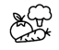  Cooking |   Textiles | 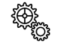  Mechanisms | 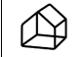  Structures | Circuits / ICT 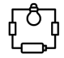
Lesson Sequence
Design |  | A plan or drawing produced to show the look and function or workings of a building, garment, or other object before it is made. Computer Aided Design (CAD) can be used to refine designs (KS2).
Make | 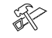 | The process of applying skills to make or produce something. This involves the use of a variety of tools and materials.
Evaluate |  | Judging the quality, value or relevance of a product through identifying improvements that could be made.

SEQUENCE OF LESSONS FOR EVERY DESIGN & TECHNOLOGY UNIT
Sequence | EYFS/KS1 | LKS2 | UKS2
Evaluate (Existing Products)  Approx. 1 lesson | Existing Products:  - Generate a design criterion through adult led discussion.  - Through adult led discussion, identify the basic purpose and features of existing products (purpose, material, user, function).  - Express likes and dislike about existing products.  - Identify some design features. | Existing Products:  - Use existing products to independently generate a design criterion.  - Identify and rate the purpose and features of existing products (purpose, material, user, function).  - Identify pros and con about a product and use to inform design choices (durability, functionality etc).  - Begin to discuss designers/engineers. | Existing Products:  - Evaluate design features in further detail.  - Discuss in further detail the designers/engineers. How, when and why particular products were made. Consider a range of materials independently.  - Understand the impact products have beyond their intended purpose.  - Develop a further understanding of how key designs can improve processes.
Design  Approx. 1/2 lessons | Planning:  - Discuss and record the stages of making.  - Select from a range of tools and equipment and begin to explain the choices.  Understand context, users and purposes:  - State what the product is and talk about the parts and how they work.  Generating, developing, modelling and communicating ideas:  - Generate ideas by drawing on their own experiences.  - Use knowledge of existing products to generate ideas.  - Develop and communicate ideas by talking, drawing and using pictures.  - Decide on resources from a given selection. | Planning:  - Discuss and reason about the order of the main stages of making.  - List and select tool and equipment choices with reasoning.  - Select appropriately from a range of materials.  Understand contexts, users and purposes:  - Identify the needs, wants, preferences and values of individuals/groups and use this to develop a design criterion.  - Use evidence to identity their own design criteria and use this to inform their ideas.  Generating, developing, modelling and communicating ideas:  - Generate realistic ideas, focusing on the needs of the user.  - Include features of existing products when generating ideas.  - Use annotated sketches and cross-sectional drawings to develop and communicate their ideas; when designing explore different initial ideas before coming up with the final design.  - Test ideas by exploring materials, components and construction kits and by making templates and mock-ups.  - Make design decisions that consider the availability of resources.  - Use ICT where appropriate, to communicate ideas. | Planning:  - Plan, discuss and reason about the order of the main stages of making.  - Explain, list and select tool and equipment choices with reasoning.  Understand contexts, users and purposes:  - Carry out research, using surveys, interviews, questionnaires and web-based resources.  - Identify the needs, wants, preferences and values of individuals/groups and use this to develop a design criterion.  Generating, developing, modelling and communicating ideas:  - Select specific features of existing products when generating ideas.  - Develop and communicate ideas through sketches which include exploded diagrams and cross sections.  - Test and adapt ideas by exploring materials, components and construction kits and by making templates and prototypes.  - Use ICT, where appropriate, to develop and communicate ideas, using measurements.  - Use CAD to demonstrate detailed design ideas and make templates for designs and cross sections of designs.
Make  Approx. 2/3 lessons | Practical Skills & Techniques:  - Follow procedures for safety and hygiene.  - Use finishing techniques, including those from art and design | Practical Skills & Techniques:  - Follow procedures for safety and hygiene.  - Alter the product from the design, as necessary.  - Use finishing techniques, including those from art and design | Practical Skills & Techniques:  - Suggest, and follow strategies & procedures for health & hygiene.  - Amend to improve the product giving reasons for the amendments.  - Finished product to a high standard, following the plan and using appropriate tools and techniques.
Evaluate  (Own Products)  Approx. 1 lesson | Own Products:  - Make simple judgements about how well their product works against small amount of design criterion.  - Start to discuss changes made during the making process. | Own Products:  - Use their design criteria to evaluate their completed product e.g. how well it met a particular purpose.  - Evaluate how they altered the product during the making process.  - Suggest some improvements and give detail about what was good and not so good about their original design. | Own Products:  - Critically evaluate the quality of the design and fitness for purpose of their products as they design and make.  - Evaluate their ideas and products against their original design specification by carrying out appropriate tests throughout the making process.  - Explain specific ways that their product could be improved.

DT skills
Cooking & Nutrition |  | Preparing food for a particular purpose and audience. Researching and considering the nutritional value of each food group.
Technical knowledge: Textiles |  | The process of weaving, knitting, sewing and joining a variety of materials such as cotton, felt, leather etc to produce a quality product with a particular purpose.
Technical Knowledge: Mechanisms |  | Combining a system of parts working together in a machine to create a quality product with a particular purpose.
Technical Knowledge: Structures |  | The process of using wood, metal, card and other materials to constructor build a product from different interrelated parts with a fixed location on the ground.
Technical Knowledge: Electrical Systems/ICT |  | Using a network of electrical components (used to supply, transfer, and use electric power) to produce a quality product with a particular purpose. CAD / Programming.

Design & Technology Progression of Learning
Technical Knowledge: Textiles | Nursery | EYFS | Y1 | Y2 | Y3 | Y4 | Y5 |  | Y6
 |  |  |  | Basket Weaving  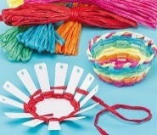  - Use a simple template.  - Join fabrics/materials by weaving.  - Decorate fabrics/materials by painting, gluing, crayons etc. | Egyptian Pharaoh Collar  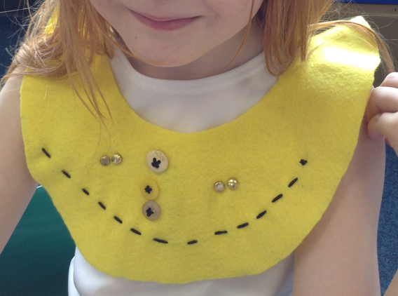  - Make and use simple paper pattern.  - Cut and join fabrics using running stitch.  - Sew a button.  - Decorate fabric by applying beads/sequins, applique or simple embroidery. |  |  | Roman Tunic  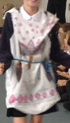  - Create own patterns and templates.  - Use a wide range of techniques to add colour, texture and pattern to fabric.  - Sew using a range of stitches including, running stitch and back stitch.  - Join fabrics in a range of different ways, e.g. buttons. | Tudor Purse  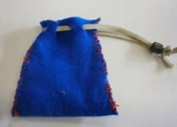  - Create my own patterns and templates that are accurately measured.  - Use different but appropriate way to join materials, e.g. glue, pins, Velcro, various stitches, buttons etc.

Design & Technology Progression of Learning
Technical Knowledge:  Food | EYFS |  | Y1 | Y2 | Y3 | Y4 |  | Y5 | Y6
 | Nursery:  - Use all their senses in hands-on exploration of natural materials. (UW)  - Make healthy choices about food, drink, activity and toothbrushing. (PSED) | Foundation:  Cress  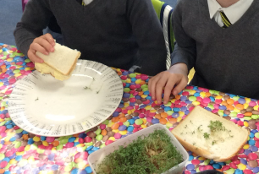  - Return to and build on their previous learning, refining ideas and developing their ability to represent them. (EAD)  - Safely use and explore a variety of materials, tools and techniques, experimenting with colour, design, texture, form and function. (EAD) ELG  - Share their creations, explaining the process they have used. (EAD) ELG | Fruit Kebabs  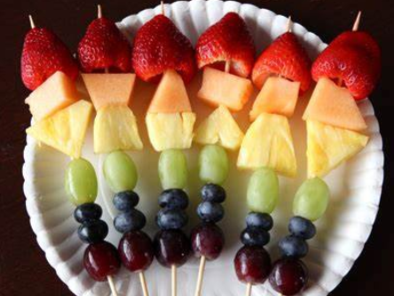  - Sort fruit & vegetables by taste, shape, size, colour and texture.  - Sort food into groups, e.g. fruit, vegetable, meat etc.  - Use basic tools to cut, shape and mix, e.g. cutters and whisks.  - Know where the foods I am cooking come from.  - Use the basic principles of a healthy and varied diet to prepare dishes. |  | Fairtrade Brownies and Lemonade  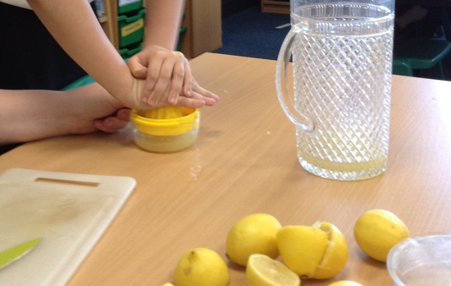  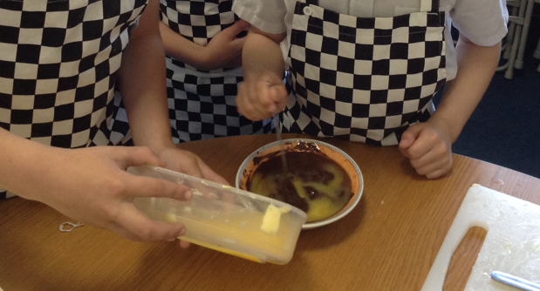  - Talk about what needs to be done in order to work safely and hygienically.  - Use simple tools e.g. hand whisk, rolling pins.  - Measure and weigh using standard units and scales.  - Talk about the way in which food processing can affect the taste, appearance, texture and colour of food.  - Know what makes a varied and healthy diet.  - Talk about where the food they are cooking comes from.  Fair Trade Brownies Recipe Sheets | Parents (teacher made) (twinkl.co.uk)  Fair Trade Lemonade Recipe (teacher made) - Twinkl |  | Roman Spelt Bread  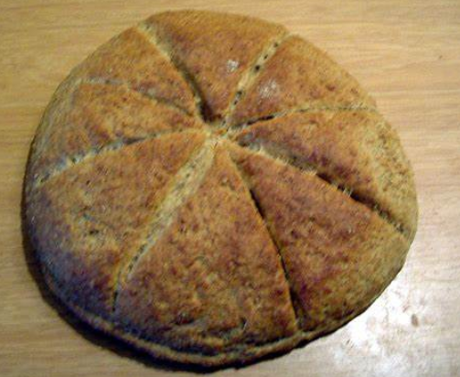  - Talk about why we need to work safely and hygienically.  - Talk about where the foods come from.  - Use knowledge of food and cooking to start generating their own recipes.  - Talk in simple terms about the physical and chemical (observational skills).  - Know how some of the ingredients are grown, reared, caught and processed.  Roman Recipes KS2 and more - Historical Recipes Pack (twinkl.co.uk) |  | Potato dishes (Food – Rationing)  - Know and understand the practice needed in terms of food hygiene and kitchen safety.  - Talk about how the properties of certain foods can affect the final product.  - Choose the appropriate methods and equipment for measuring, e.g. time, dry goods, liquids etc.  - Compare and evaluate several ideas in order to draw up a design specification.  - Compare commercial and domestic processes for producing food.  - To understand seasonality.

Design & Technology Progression of Learning
Technical Knowledge:  Mechanisms | EYFS |  | Y1 | Y2 | Y3 | Y4 | Y5 | Y6
 | Nursery:  - Use one-handed tools and equipment, for example, making snips in paper with scissors. (PD)  - Use all their senses in hands-on exploration of natural materials. (UW)  - Explore different materials freely, to develop their ideas about how to use them and what to make. (EAD)  - Develop their own ideas and then decide which materials to use to express them. (EAD)  - Join different materials and explore different textures. (EAD) | Foundation:  Junk Model Vehicles/Boats  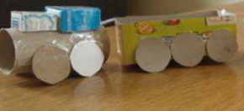  - Return to and build on their previous learning, refining ideas and developing their ability to represent them. (EAD)  - Create collaboratively, sharing ideas, resources and skills. (EAD)  - Share their creations, explaining the process they have used. (EAD) ELG | Toy Vehicle  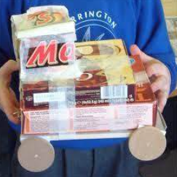  - Explore and use mechanisms [for example, levers, sliders, wheels and axles], in their products.  - Attach wheels to a chassis, with some children using an axle (cotton reels and dowl). | Moving Scene  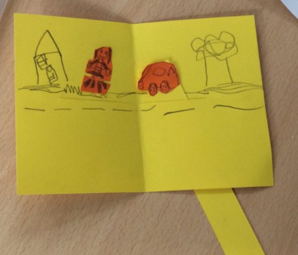  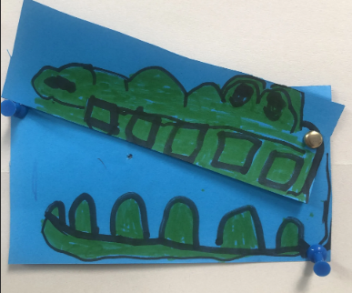  - Explore and talk about books containing moving pictures. Discuss how they move.  - Construct a simple slider.  - Make a lever by joining card strips with paper fasteners. |  | Shang Dynasty Chariot  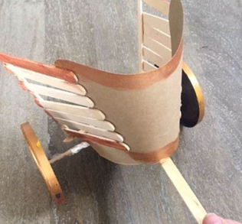  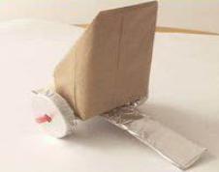  - Understand and use mechanical systems in their products [for example, gears, pulleys, cams, levers and linkages].  - Describe the way in which a cam changes rotary motion into linear motion.  - Use a range of different ways to attach an axle to a chassis, e.g. card triangles, drilled holes, cable clips and clothes pegs. Describe in how an axle and chassis help a vehicle to move.  - Identify and describe products that contain pulleys and drive belts. | Water Pulley System  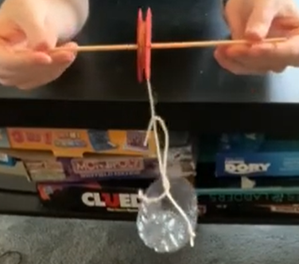  How To Make A Pulley KS2 - YouTube  - Use simple mechanisms e.g., pulleys, gears, cams, cogs. (possibly attach to motors for electrical control).  - Talk about how pulleys and drive systems can be driven by motor and computer.  - Use a range of technical vocabulary to describe the properties and functions of mechanisms.  - Generate questions to investigate.  - Know how a belt & pulley system can be used to reverse the direction of rotation.

Design & Technology Progression of Learning
Technical Knowledge: Structures | EYFS |  | Y1 | Y2 | Y3 | Y4 | Y5 | Y6
 | Nursery:  - Use one-handed tools and equipment, for example, making snips in paper with scissors. (PD)  - Select shapes appropriately: flat surfaces for building, a triangular prism for a roof etc. (M)  - Combine shapes to make new ones – an arch, a bigger triangle etc. (M)  - Use all their senses in hands-on exploration of natural materials. (UW)  - Make imaginative and complex ‘small worlds’ with blocks and construction kits, such as a city with different buildings and a park. (EAD)  - Explore different materials freely, to develop their ideas about how to use them and what to make. (EAD)  - Develop their own ideas and then decide which materials to use to express them. (EAD)  Join different materials and explore different textures. (EAD) | Foundation:  Model of home or local landmark/bug habitat/ junk rockets  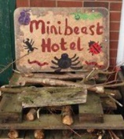  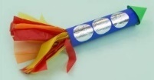  - Return to and build on their previous learning, refining ideas and developing their ability to represent them. (EAD)  - Create collaboratively, sharing ideas, resources and skills. (EAD)  - Safely use and explore a variety of materials, tools and techniques, experimenting with colour, design, texture, form and function. (EAD) ELG  - Share their creations, explaining the process they have used. (EAD) ELG | Rain Gauge  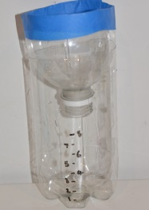  - Select from and use a wider range of tools and equipment to perform practical tasks [for example, cutting, shaping, joining and finishing.  - select from and use a wider range of materials and components, including construction materials, textiles and ingredients, according to characteristics. | Bridge  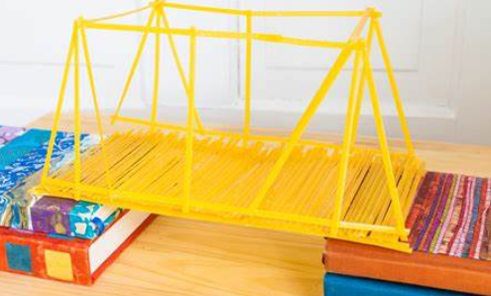  - Construct a range of structures using simple construction kits.  - Make their structures more stable by widening the base.  - Make a square frame (from strip wood).  - Make a simple card hinge.  - Make simple 3D structures using straws.  - Build buildings, bridges and towers using small-scale construction materials, e.g. Duplo. | Structure to withstand a Natural Disaster.  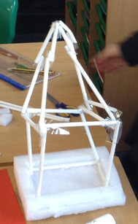  - Deconstruct and assemble the net of basic 3D shapes.  - Apply their understanding of how to strengthen, stiffen and reinforce more complex structures.  - Measure and cut accurately.  - Use a range of materials to make simple joints, glue, tape and paper clips.  - Strengthen 2D frames by adding diagonal bracing struts. |  |  | Dartmoor Bridge Challenge  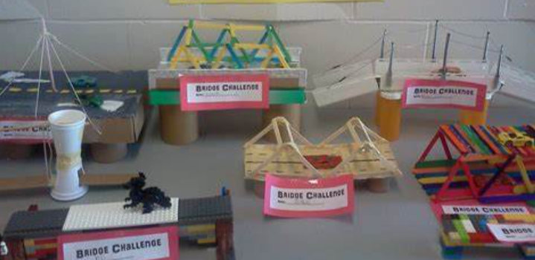  - Create nets and templates accurately in a range of sizes.  - Use a range of methods to strengthen 3D structures and frames.  - Build a range of structures using a wide range of effective materials.  - Investigate measure and record the load tolerance of different structures.  - Find ways of improving a structures load-bearing capacity.
Design & Technology Progression of Learning
Technical Knowledge:  Circuits/ ICT | EYFS | Y1 | Y2 | Y3 | Y4 | Y5 | Y6
 |  |  |  |  | Model Lighthouse (inc. a circuit)  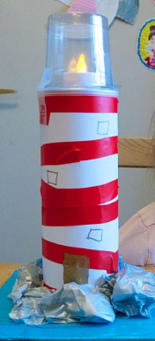  - Understand and use electrical systems in their products [for example, series circuits incorporating switches, bulbs, buzzers and motors].  - Describe how a simple battery powered circuit can be controlled by different kinds of switches.  - Create simple circuits incorporating a battery, bulb, switch and wires.  - Talk about simple electrical safety.  - Explore and describe how an electric motor can be used in a circuit. Use a remote-controlled device to switch lights on and off.  - Explore and describe materials that can be used to conduct electricity.  - Explore and explain how the direction and speed of an electrical motor can be controlled.  - Explore and program a simple control device | Program and Control a Space Buggy  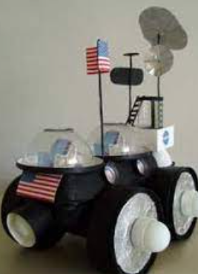  - Understand and use electrical systems in their products [for example, series circuits incorporating switches, bulbs, buzzers and motors].  - Explore and describe how electrical circuits with switches can be used.  - Use switches in a range of circuits to control components, e.g. lights in a lighthouse, a movement sensor in a burglar alarm.  - Use my knowledge of conductors and insulators when constructing circuits.  - Talk in depth about the hazard and safety issues associated with electricity.

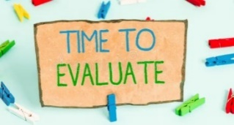
Talking/Evaluating like a Designer….

EYFS | I like this because…  I don’t like this because…  I think I can make this better by…
KS1 | The purpose of my product is…  I found the skill of…the most challenging because…  I believe this product is good/bad because…  In my opinion, I feel I can improve this by…
LKS2 | Based on my design criteria, I believe…  You could improve this product by…  I used the skill of…because…  The problems I faced were…I overcame these by…
UKS2 | Based on the design brief I have been presented with…  Possible improvements may include…  This product has met/has not met the brief because…  Alternatively, I believe the product would be more suited to…  To create my product, it was essential to…  When I began to critique my product, I found that…  The functional properties which I am proud of are…

